**REPUBLIC OF KENYA**



**COUNTY GOVERNMENT OF NYAMIRA COUNTY**

**COUNTY SECTOR PLANS FOR PUBLIC ADMINISTRATION & INTERNAL RELATIONS SECTOR**

**(2023-2033)**

# VISION

A leading sector in public policy formulation, implementation, coordination, supervision and prudent resource management

# MISSION

To provide leadership and policy direction in resources mobilization and management for quality public service delivery.

# FORWARD

The Constitution of Kenya 2010, the Kenya Vision 2030 and its Medium Term Plans, provide the foundation for the preparation of the First Sector Plans for Nyamira County. This Sector Plan, will be used to inform resource distribution, a tool of resource mobilization in the face of limited and competing priorities for the betterment of the lives of the people of Nyamira County. The Kenya Vision 2030 is the country’s development blueprint covering the period 2008 to 2030. It aims to transform Kenya into a newly industrializing, middle-income country providing a high quality of life to all its citizens by the year 2030. The County’s vision of embracing urbanization for accelerated socio- economic growth is in tandem with this overall national vision. The Sector Plans identify a number of flagship projects to be implemented across the country for all sectors. The County Government has identified county-specific flagship projects and Programmes that will be implemented at county level and work with the National Government and Key Stakeholders to ensure these projects are implemented in a responsible, transparent and cost-effective manner. The preparation of this first Sector Plan is based on the County Governments Act, 2012 section 109 which mandates every county to prepare Sector Plans. The Sector Plan is a ten-year blue print that highlights the socio-economic challenges faced by the County, strategies for resources mobilization and Programme interventions aimed at realizing our socioeconomic goals and desired impact. The preparation of the Sector plan was done through a participatory process that involved various stakeholders. The sector plans will provide a structured roadmap for planning, budgeting, implementation, monitoring, evaluation and reporting for Programmes and projects within the sector over the ten-year planning period

**CECM FINANCE,ICT &ECONOMIC PLANNING**

**CPA EMILY ONGAGA**

# ACKNOWLEDGEMENT

The 2023-2033 Public administration &internal relations Sector Plan was prepared in accordance with section 109 of the County Government Act, 2012 and is the Second version since the inception of the County Government of Nyamira .

First and foremost, I acknowledge the valuable leadership and support of H.E The Governor and The Deputy Governor. Great thanks go to all CEC Members, the County Secretary and all the Chief Officers for their overall coordination of their departments and support throughout the plan preparation process.

I would like to acknowledge the directorates in the Sector for their various contribution without which this document would not be a success. All the county directorates in the Sector were invited to contribute in the preparation of the Sector plan. This information was analyzed by the team lead by the CECMs in charge of the departments that form the sub sectors in the sector. Acknowledgement is made to the Sector Working Group members who spent significant time and effort putting together the document. Special Acknowledgement is made to the Economic Planning team led by CCO Azenath Maobe, Director Paul Onyango and Secretariat of the Sector Working Group Esther Muia for coordinating the process of preparing this Sectoral Plan,as well as Martin Ogoti from KNBS ,Rose Wakhuloba from National Population Council and the team from the National Treasury; for provision of technical backstopping in the preparation of this document. Finally, I am indebted to express my sincere gratitude to the entire staff of the Sub sectors for their dedication and commitment during the entire exercise.

**CPA Emily Ongaga;**

**County Executive Committee Member;**

**FINANCE, ICT AND ECONOMIC PLANNING**

TABLE OF CONTENTS

Table of Contents

VISION 2

MISSION 2

FORWARD 3

ACKNOWLEDGEMENT 4

LIST OF TABLES 8

LIST OF MAPS &FIGURES 9

EXECUTIVE SUMMARY 10

CHAPTER ONE 11

OVERVIEW AND BACKGROUND OF THE SECTOR 11

1.0 INTRODUCTION 12

This chapter gives the details of the sector in terms of: overview of the county,background of the sector, programme mandates, rationale for the county sectoral plan and the methodology in preparation of the sector plan 12

1.1 Overview of the county 12

Overview 18

Linkage of the CIDP with the Constitution of Kenya, 2010 18

Linkage of the CIDP with the Medium Term Plans 19

The County Government Act, 2012 20

1.4 Approach/methodology in the preparation of the sector plan 22

CHAPTER TWO 23

PERFORMANCE REVIEW OF THE PREVIOUS CIDP PERIOD 23

2.0 Introduction 23

2.1 Analysis of the sector Revenue Sources 24

Table 2: Public administration & internal relations Expenditure Analysis 25

Table 4: Sector Development issues 31

CHAPTER FOUR 100

DEVELOPMENT PRIORITIES, STRATEGIES AND PROGRAMMES 100

4.0 Introductions 101

4.1 Development Priorities and Strategies 101

4.2 Sector: PUBLIC ADMINISTARTION & INTERNAL RELATIONS 102

4.6 Flagship projects 106

Table 7: Sector Programmes 106

Table 8: Flagship Projects 128

Table 9: Cross-sectoral impacts 132

CHAPTER FIVE 133

SECTOR IMPLEMENTATION FRAMEWORK 133

5.1. Institutional Framework 134

135

Table10: Stakeholders and their roles 136

5.2Resource Mobilization and Management Framework 139

Table11: Summary of Sector Financial Resource Requirements 139

Source: Sectors 142

Table 12 Revenue Projections 142

Table 13: Resource Gaps 143

5.5 Risk Management 144

Table 14 Risk, Implication, Level and Mitigation Measures 144

CHAPTER SIX 145

MONITORING, EVALUATION AND LEARNING 145

6.2 County Monitoring and Evaluation Structure 146

6.3 M&E Capacity 146

6.4 M&E Outcome Indicators 146

Table 15: Outcome Indicator Reporting 146

6.5 Data Collection, Analysis and Reporting 147

6.6 Dissemination, Feedback Mechanism, Citizen Engagement and Learning 147

6.7 Evaluation Plan 147

Table 16: Evaluation Plan 148

ANNEX 1: COUNTY FACTSHEET 148

ANNEX 2: CIDP PREPARATION STEPS AND PROPOSED TIMELINES 168

**LIST OF ABBREVIATIONS AND ACRONYMS**

CIDP County Integrated Development Plan

HR Human Resource

HRM Human Resource Management

ICT Information and Communication Technology

IFMIS Integrated Financial management Information System

IPPD Integrated Personnel Payroll Database

M&E Monitoring and Evaluation

NEMA National Environment Management Agency

PSM Public Service Management

PFM Act Public Finance Management act

SWOT strengths, Weaknesses, Opportunities and Threats

WIBA Work Injuries Benefit Act 2007

PESTELPolitical, Economic, Socio-Cultural, Technological, Environmental and Legal**.**

IPMAFIntegrated Performance management and accountability framework

AIA Appropriation-In-Aid

CBO Community Based Organization

CEO Chief Executive Officer

CM&E County Monitoring and Evaluation

CO Chief Officer

CPSB County Public Service Board

ECM Executive Committee Member

GOK Government of Kenya.

HIV Human Immune-Deficiency Virus.

HOD Head of Department

KSG Kenya School of Government

MCA Member of County Assembly

MDG Millennium Development Goals

MTEF Medium Term Expenditure Framework

MTP Medium Term Plan

PA Personal Assistant

PPP Public Private Partnership

PSCK Public Service Commission of Kenya

TA Transitional Authority

TNA Training Needs Assessment

ADB African Development Bank

AIDS Acquired Immune Deficiency Syndrome

ECM Executive Committee Member

ICT Information and Communication Technologies

KPI Key Performance Indicator

MTP Medium Term Plan

NEMA National Environment Management Authority

NGO Non-Governmental Organization

# LIST OF TABLES

Table 11: Analysis of Sector Revenue sources

Table 12: Sector Expenditure Analysis

Table 13: Sector development issues

Table 16: Sector priorities and Strategies

Table 17: Sector Programmes

Table 18: Flagship projects

Table 19: Linkages with Kenya Vision 2030, other plans and international obligations

Table 20: Cross- sectoral impacts

Table 21: Stakeholders

Table 22: Summary of Sector Financial Resource Requirements

Table 23: Revenue Projections

Table 24: Resource Gaps

Table 25: Risk, Implication, Level and Mitigation Measures

# LIST OF MAPS &FIGURES

**Figure 1**: Nyamira County Map

**Figure 2:** Analysis of Sector Revenue Sources Chart

**Figure 3:** Organizational Chart

# EXECUTIVE SUMMARY

# CHAPTER ONE

# OVERVIEW AND BACKGROUND OF THE SECTOR

#### 

## INTRODUCTION

## This chapter gives the details of the sector in terms of: overview of the county,background of the sector, programme mandates, rationale for the county sectoral plan and the methodology in preparation of the sector plan

## 1.1 Overview of the county

Situated in the Western part of Kenya, Nyamira County has since evolved from different administrative creations and boundaries since independence. It is indeed formed part of one of the divisions of the larger Kisii district way back in 1970s. In 1987, the Nyamira as a divisional boundary was created a district which has since existed with four constituencies. The coming of the devolution in 2013, Nyamira forms part of the 47 County Governments with one extra Constituency created and 20 electoral wards.

The Gusii Community predominantly occupies the county, however, the northern and eastern parts of the County has got some different ethnic significance being Luos and Kipsigis respectively. The County Headquarter is located in Nyamira South Sub County, Township ward formerly the head-quarter for Nyamira District. It is located along Konate Junction Miruka Centre Road approximately six (6) kilometres from the Konate Junction, off the Kisii Chemosit Road.

Agriculture is the County’s economic backbone where 90% of its population is dependent on agricultural production and marketing directly and indirectly. It supports 80% of total employment opportunities in the county. Nyamira County lies in the Lake Victoria region, a region whose thirteen (14) counties have come together and formed the Lake Region Economic Bloc with the common understanding that strategic connections between Counties with shared interests seated in a desire for mutual benefit can be an effective and intelligent means of increasing the possibility of creating notable development impact across several counties. The Lake Region Economic Bloc is made up of Bungoma, Busia, Homa Bay, Kakamega, Kisii, Kisumu, Migori, Nyamira, Siaya, Vihiga, Bomet, Trans Nzoia and Kericho Counties.

The County has inter county relations; along the Homabay County (Rachuonyo) border there is ethnic intermarriages, this is evident in Miruka and Nyamusi areas that has promoted peace coexistence. Miruka and Keroka markets along the borders of Homabay and Kisii counties respectively have promoted exchange of goods and services for the people living along these borders. The existence of the tea zones in Kericho and Nyamira counties has promoted employment among the tea factories and the dwelling

Nyamira county map

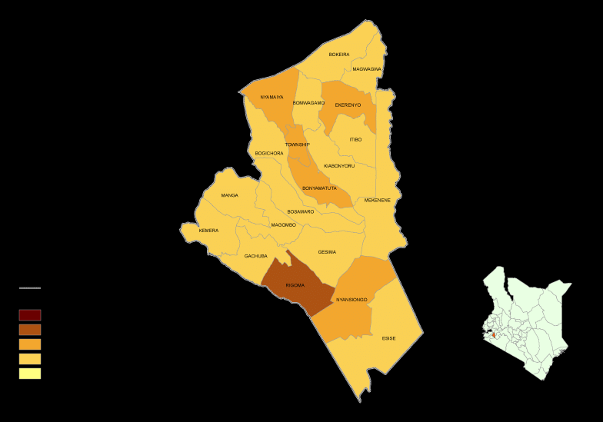

1.2Background of the sector

The department of Public Services Management formerly Public Administration and Coordination of Decentralized Units (PACDU) was established by the Governors circular, No. 1/2015 and the Kenya special Gazette Notice. The governor’s circular No. 1/2017 saw the renaming of the department. Establishment of the department is in line with the fourth schedule as provided for in the Constitution of Kenya 2010. It is also in recognition of article 235 which provides for a framework of uniform norms and standards for county governments and in furtherance of the provisions of article 10 on the national values and principles of governance in public service.

It is also imperative to note that the establishment of this department gives effect to the sections 50, 51, 52, and 53 of the County Government ACT 2012 which provides for decentralization of county government functions to the village level.

The department equally responds to the demands of article 33(1) and 35(1) of the constitution of Kenya 2010, on freedom and access to information in providing for and giving citizens the right to seek, receive or impart information.

#### Sub-Sectors And their Mandates

**Public service management**

**mandates**

* Administration, Coordination and development of decentralized support services – to administer, coordinate Decentralized Government activities.
* Human Resource Management and Development of support services– Coordination and administration of human resource policies and strategies.
* Civic Education & Public Participation. - Coordination of public participation and enhancing civic education in the county.
* Corporate Communication, public relations and support services – Dissemination of County Government information to and dealing with both internal and external publics.
* Enforcement, Compliance and support services. - Enforce compliance to County & National Government laws and regulations

County contracting and performance management support services – administration of performance contracting and management tool

* Special programs support services –coordinating activities related to specific projects, emerging and crosscutting development issues affecting the county.
* County Results and delivery support services- coordination of the implementation of county projects and policies
* County attorney and solicitor support services –provide guidance on all legal aspects affecting the county
* Finance and administration support services-prudent financial management and control of the board
* Coordination of planning, budgeting and reporting-provide leadership in policy formulation, coordination of development planning, allocation of resources, monitoring and evaluating the implementation progress and reporting for policy analysis
* Coordination and management of county executive affairs-offers secretariat and services to the county executive committee and communicate the same to departments and entities.
* Governor’s advisory and support services-coordination and supervisory of governor events
* Administration, policy and support services-
* Legal, ethics, governance and compliance-advising the board on legal issues and legislation
* Revenue administration support services

#### 

**county public service board**

**Mandates**

The mandate of the Board is provided for under Article 59(1) of the County Government Act 2010 and summarized as hereunder:

a) Establish and abolish offices in the county public service

b) Appoint persons to hold or act in offices of the county public service including in Boards of cities and urban areas within the county and to confirm appointments

c) Prepare regular reports for submission to the County Assembly on the execution of the functions of the Board

d) Promote in the county public service the values and principles referred to in Articles 10 and 232 of the Constitution of Kenya 2010

e) Evaluate and report to the County Assembly on the extent to which the values and principles referred to in Articles 10 and 232 of the Constitution of Kenya 2010 are complied with in the county public service

f) Facilitate the development of coherent, integrated human resource planning and budgeting for personnel emoluments in the county

g) Advise the County Government on human resource management and development

h) Advise the County Government on implementation and monitoring of national performance management system in the counties

i) Make recommendations to the salaries and Remuneration Commission, on behalf of the county government, on the remuneration, pensions and gratuities for county public service employees

**County Assembly Of Nyamira**

**Mandates**

**General Administration, Planning and Support Services**

To enhance professionalism, build human resource capacity and provide effective services to the Legislature to enable it meet its Constitutional mandate.

**Legislation and Representation**

To strengthen the capacity of members of County Assembly in making laws and enhance their representative capacity.

**Legislative Oversight**

To strengthen the capacity of making and oversight the county budget for optimal use of public resources and enhanced accountability in governance.

**FINANCE**

The overall mandate of the Department is “to facilitate the management of resources, coordinate the County development planning, policy formulation and implementation for economic development. Specifically these are outlined as follows:

|  |  |
| --- | --- |
| **DIRECTORATE** | **ROLES** |
| Information Communication and Technology (ICT) | To automate all County Government services for effective service delivery.   * To facilitate dissemination of information for decision making through ICT * To provide a data bank for the County Government of Nyamira * To maintain and service all ICT equipment and software in Nyamira county * To enhance internal communication through installation of Networks * To improve service delivery to Nyamira residents through use of ICT * To facilitate other Departments to be effective in Service delivery through ICT |
| Economic planning and statistics | * Coordination of the county integrated planning cyvle * Documentation and dissemination of vital planning and budgeting documents * Provison of up-todate county statistics * Carrying out monitoring and evaluation of development projects across the county |
| Finance, Accounting and Budgeting | * Disbursement of county government funds and expenditure control |
| Internal Audit and Risk management | * Asset and debt management. * Quality assurance and risk management |
| Supply chain management | * To procure goods, works and services on behalf of user departments as and when required * Prepare and publish notices of award and notices of tender acceptance; * Maintain and archive documents and records of the procurement and disposal activities for the required period; * co-coordinating all activities of Procurement committees; * Liaise with the Public Procurement Regulatory Authority and other bodies on matters relating to procurement and disposal; * Prepare and submit to the Public Procurement Regulatory Authority reports required under the public procurement law ,  Regulations and guidelines of the Authority; * Monitor contract management by user departments to ensure implementation of contracts in accordance with the terms and conditions of the contracts; * Prepare consolidated procurement and disposal plans; * Carry out periodic market surveys and due diligence to inform the placing of orders or adjudication by the relevant Accounting Officers; * Conduct periodic and annual stock taking; |
| Revenue and Resource Mobilization | * Automation of revenue collection * Development and implementation of finance Act * Administration and enforcement of revenue laws * Formulation of draft county Government By-laws * Mapping of revenue sources |

**GOVERNORS**

* To provide overall leadership and direction to the county Government as whole
* Ensuring policy implementation
* Provide cross-cutting services inclusive of Legal, Economic and political advisor

The section should cover: the sector composition in terms of sub-sectors and their mandates, and the contribution of the sector towards socio-economic development.

#### 1.3Rationale for the County Sectoral Plan

### Overview

This section discusses the County Integrated Development Plan (CIDP) linkages with the Kenya Vision 2030, the Constitution of Kenya, 2010 and other long term planning and policy documents. A brief status of Sustainable Development Goals at the County level is also provided.

### Linkage of the CIDP with the Constitution of Kenya, 2010

The Constitution of Kenya, 2010 prescribes national values and principles of governance which include sharing and devolution of power. It creates a two-tier government: a national government and 47 county governments.

The Fourth Schedule delineates the functions of the national and county governments. A total of 14 functions have been devolved to the counties. The main ones include: county planning and development; agriculture; county health services; control of air pollution, noise pollution, other public nuisances and outdoor advertising; cultural activities, public entertainment and public amenities; county roads and transport; animal control and welfare; trade development and regulation; pre-primary education and village polytechnics; specific national government policies on natural resources and environmental conservation; county public works and services; firefighting services and disaster management; control of drugs and pornography. Emphasis is also made for the counties to ensure participatory development and capacities are developed at all community levels.

The county governments are required to prepare the County Integrated Development Plans to enable prioritization of socio-economic development issues at the local level. This is mandatory before the funding of county projects and programmes. The CIDP is anchored on the county functions as provided in the fourth schedule of the Constitution.

Linkage of the CIDP with the Kenya Vision 2030

Sessional Paper Number 10 of 2012 on Kenya Vision 2030 is the National Policy Economic Blueprint that entrenches Kenya Vision 2030 as the long term development strategy. The Vision aims to transform Kenya into a modern, globally competitive, middle income country providing a high quality of life to all its citizens. Kenya Vision 2030 is a product of highly participatory, consultative and inclusive stakeholder’s process conducted throughout the country and in all sectors of the economy.

The Vision is anchored on three key pillars: economic; social; and political. The key sectors in economic pillar include: tourism, agriculture and livestock, manufacturing, wholesale and retail trade, Business Process Outsourcing (BPO), financial services, oil and mineral resources. The main sectors under the social pillar include education and training, health, water and irrigation, environment, housing and urbanization, gender, sports, youth and culture. The Political Pillar aims at realizing a democratic political system founded on issue based politics that respect the rule of law, and protects the fundamental rights and freedoms of every individual in the Kenyan society.

The three pillars are anchored on a number of foundations, which serve as enablers that create an environment that is geared towards the realization of Vision 2030. These include: macroeconomic stability; continuity in governance reforms; enhanced equity and wealth creation opportunities for the poor; infrastructure; energy; Science, Technology and Innovation; Land Reforms; Human Resource Development; Security and Public Sector Reforms. An additional enabler, national values and ethics, has been included following the passing of the Constitution of Kenya 2010.

### Linkage of the CIDP with the Medium Term Plans

The Kenya Vision 2030 is planned to be implemented in successive five year Medium Term Plans. County governments therefore must integrate the aspiration of Kenya Vision 2030 and Medium Term Plans in preparing of County Integrated Development Plans. The CIDP is envisaged to support implementation of Vision 2030 and achievement of SDGs, through different projects and programmes identified at the county level.

The Third Plan will mark the third phase of Vision 2030 whose overarching objective is to transform Kenya into “an upper middle-income rapidly industrializing country offering all its citizens a high quality of life in a clean and safe environment” by the year 2030. It will endeavor to move the economy towards a higher growth trajectory by the end of the Plan. Since the implementation of Vision 2030 began in 2008, several milestones have been achieved. These are documented in the Annual Progress and Mid-Term Review Reports for the First and Second MTPs.

The Third MTP will build on gains made so far in key sectors of the economy including completing projects initiated during the Second MTP. It will target not only increasing the level of investment but also enhancing the productivity of investment, as well as raising productivity in all sectors of the economy. The plan will also place emphasis on structural transformation of the economy in terms of increasing the share of manufacturing and productive sectors and increasing the share of exports to GDP.

The MTP III will prioritize the development of infrastructure and create an enabling environment to develop the country’s oil, gas and other mineral resources sector. It will put in place measures to facilitate development of the Blue Economy, mainstream Sustainable Development Goals (SDGs), Africa’s Agenda 2063 and climate change among other regional and international development agenda and cooperation frameworks.

The County Government will ensure that all its development priorities are aligned to the National Development Agenda. Therefore, the County Integrated Development Plan will be aligned to the MTP III. It is therefore imperative that within a context of competing priorities, all resources are aligned towards achieving core priorities that will have broad based benefits for all.

### The County Government Act, 2012

The County Government Act 2012, in fulfillment of constitutional requirement to legislate preparation of county plans, details the goals and procedures of “County Planning” (Part XI of the Act). County planners are required to prepare 5-year integrated development plans and the annual budgets to implement them.

The County Government Act, 2012, section 104 (1), states that, “a county government shall plan for the county and no public funds shall be appropriated without a planning framework developed by the county executive committee and approved by the county assembly”. It also states that the county planning framework shall integrate economic, physical, social, environmental and spatial planning. In addition to an integrated development plan, each county is expected to have the following:

* A County Sectoral Plan;
* A County Spatial Plan; and
* A City and Urban Areas Plan.

These county plans (section 107(2)) “shall be the basis for all the budgeting and planning in a county”.

Public Finance Management Act (PFMA), 2012

The Public Finance Management Act (PFMA), 2012, emphasizes what the County Government Act states but puts a slightly different emphasis on planning. Whereas the County Government Act requires a “five-year County Integrated Development Plan”, the PFMA (Part IV (126) (1)) requires both a long-term and medium term plan. According to the PFMA, a budget process for the county government in any financial year shall consist of the following stages:

Start with an integrated development planning process, which shall contain both short term and medium term plans.

Every county shall prepare a development plan as per Article 220 (2) of the constitution.

Budgets are to be based on projects and other expenditure contained in the plan.

**Integration of the Sustainable Development Goals (SDGs) into the CIDP**

The following are the Sustainable Development Goals (SDG’s);

Goal 1: End poverty in all its forms everywhere

The County will identify people living in poverty at the grass-root level and to target resources and services to help them overcome deprivation and dehumanizing poverty. It will ensure that all men and women, particularly the poor and the vulnerable, have equal rights to economic resources, as well as access to basic services, ownership, and control over land and other forms of property, inheritance, natural resources, appropriate new technology, and financial services including microfinance.

As a result, this will build the resilience of the poor and those in vulnerable situations, and reduce their exposure and vulnerability to climate-related extreme events and other economic, social and environmental shocks and disasters.

Goal 2: End hunger, achieve food security and improved nutrition and promote sustainable agriculture

The county will continue to support agricultural production and local economic growth by strengthening extension service to farmers and by providing basic transport infrastructure and markets to promote good exchange in local food chains. Further through use of healthcare services and Early Childhood Centers (ECDs) to identify and tackle child malnutrition the county will ensure that everyone can enjoy a safe, nutritious diet, all year round.

Goal 3: Ensure healthy lives and promote well-being for all at all ages

The county has a huge responsibility of ensuring the local communities have access to good quality health care and live a healthy life.

Goal 4: Ensure inclusive and equitable quality education and promote lifelong learning opportunities for all

The county is responsible for early childhood development (ECD) that form the basic foundation for education. As such, it will continue to identify and tackle the barriers to school attendance. It will also integrate technical and vocational training programmes into local economic development strategies, making sure training is valuable to labor market opportunities into account. The county will further reach out to vulnerable and marginalized individuals and communities and to ensure they have access to education and training that meet their needs.

Goal 5: Achieve gender equality and empower all women and girls

The county will continue to advocate for gender equality and the empowerment of women through non-discriminatory service provision to citizens and fair employment practices and mainstreaming of gender equality across all areas of their work in order to tackle the multiple barriers to women's empowerment.

Goal 6: Ensure availability and sustainable management of water and sanitation for all

The county is committed to ensuring access to clean water and sanitation through effective local governance, natural resource management, and local planning. Integrated water resources management will be enhanced through cooperation in planning and environmental policy between the County and National Government.

Goal 7: Ensure access to affordable, reliable, sustainable and modern energy for all

The county plans to identify gaps in access to affordable energy among vulnerable groups in the communities and address them thus contributing to energy efficiency directly by investing in energy efficient infrastructure, alternative and green energy sources.Goal 8: Promote sustained, inclusive and sustainable economic growth, full and productive employment and decent work for all.

The county will generate growth and employment from the bottom up through local economic development strategies that harness the unique resources and local opportunities.

Goal 9: Build resilient infrastructure, promote inclusive and sustainable industrialization and foster innovation

The county has continued to put more efforts in developing and maintaining infrastructure to serve local communities and link them up with their surrounding areas. This includes the promotion of small-scale industry and start-ups in their local economic development strategies, taking into account local resources, needs and markets based on the local competitive advantage.

Goal 10: Reduce inequality within and among countries

The county will build local capacities and tackle poverty and exclusion through political inclusion at local level.

Goal 11: Make cities and human settlements inclusive, safe, resilient and sustainable.

The county is in the process of developing strategic urban plans to prevent growth of new slums, and work with slum-dwellers to improve conditions and provide basic services where slums already exist.

Goal 12: Ensure sustainable consumption and production patterns.

The county will support short supply chains, thereby reducing transport and carbon emissions, through land management, infrastructure, urban planning, education and training, and public markets.

Goal 13: Take urgent action to combat climate change and its impacts.

The capacity of the county governments to deal with climate related hazards and natural disasters need to be strengthened through integration of climate change adaptation and mitigation into local planning to reduce the emissions of our cities and increase their resilience to environmental shocks.

Goal 14: Conserve and sustainably use the oceans, seas and marine resources for sustainable development

Urban sanitation and solid waste management are essential to reducing pollution in water bodies. There is therefore need for collaboration between County Government and relevant National Government Ministries, Departments and Agencies.

## 1.4 Approach/methodology in the preparation of the sector plan

A concept note was issued regarding the preparation of the sector plans, then after a circular was circulated to departments by the budgeting and planning department to carry out public participation regarding the plan.

After that the county cabinet approved the concept note, the governor went ahead to launch the exercise.

As a constitutional requirement, and advert was gazetted to give the public information on the venue, dates and issues to be discussed during public participation.

Afterward, a five-day consultation exercise to operationalize the various sector working groups was held in Best Western hotel. This forum was meant to develop the sectoral plans. Several stakeholders allied to the sectors were invited for consultations. A template for the sectoral plans was the shared by the National Treasury Planning department invited to the meeting to provide technical backstopping. The technical working group for the sector alongside the stakeholder went working into group to develop the sectoral plan. Various stakeholders were represented including the technical teams from the county government comprising the CEC Finance,Ict &Economic planning ,CCO Finance,Ict &Economic planning and County Sectorial directors.

## CHAPTER TWO

## PERFORMANCE REVIEW OF THE PREVIOUS CIDP PERIOD

## 

### 2.0 Introduction

This chapter provides a review on implementation of the previous CIDP 2018-22. It presents an analysis of county performance in terms of revenues, expenditures and key outcomes as well as the major challenges faced in the implementation of the plan.

### 2.1 Analysis of the sector Revenue Sources

Table shows the main sources of county revenue and their performance during the plan period.

Table 1: **Analysis of public administration &internal relations Revenue Sources**

|  |  |  |  |  |  |  |  |  |  |  |
| --- | --- | --- | --- | --- | --- | --- | --- | --- | --- | --- |
| **Revenue Sources** | **Revenue Projection (Ksh. million)** | | | | | **Actual Revenue (Ksh. million)** | | | | |
| **2018/2019** | **2019/2020** | **2020/2021** | **2021/2022** | **2022/2023** | **2018/2019** | **2019/2020** | **2020/2021** | **2021/2022** | **2022/2023** |
| a) Equitable Share | 820,185,757 | 827,076,355 | 843,670,936 | 898,841,921 |  | 748,704,397 | 818,198,418 | 730,231,478 | 817,542,507 |  |
| **Total** | 820,185,757 | 827,076,355 | 843,670,936 | 898,841,921 |  | 748,704,397 | 818,198,418 | 730,231,478 | 817,542,507 |  |

#### 2.1 Public administration & internal relations Expenditure Analysis

This section should provide an analysis of total budget allocation and total actual expenditure by sector. The information should be summarized as in Table 2.

### Table 2: Public administration & internal relations Expenditure Analysis

|  |  |  |  |  |  |  |
| --- | --- | --- | --- | --- | --- | --- |
| **Sector** |  | **Total Budget** | **Total Actual** | **Variance** | **Absorption** | **Remarks** |
|  | **FY** | **Allocation (Ksh in millions)** | **Expenditure (Ksh in millions)** |  | **rate (%)** |  |
|  | 2018/2019 | **820,185,757** | **748,704,397** | **71,481,360** | **91.2847353** |  |
|  | 2019/2020 | **827,076,355** | **818,198,418** | **8,877,937** | **98.926588** |  |
|  | 2020/2021 | **843,670,936** | **730,231,478** | **113,439,458** | **86.5540635** |  |
|  | 2021/2022 | **898,841,921** | **817,542,507** | **81,299,414** | **90.9550932** |  |
|  | 2022/2023 | **0** | **0** | **0** | **0** |  |
|  | **TOTAL** | **3,389,774,969** | **3,114,676,800** | **275,098,169** | **91.884471** |  |

Provide a brief discussion on budget implementation performance based on variance between actual allocations versus actual expenditures (absorption rates by each sector).

#### 2.2 Sector Programmes’ Performance Review

**General Administration Policy planning**

At the start of the planned period the sector intended to have 60 remunerations, construct 60 fully operational offices, develop 26 policies &bills .

At the end of the planned period, the sector had fully achieved 60 remunerations, constructed 50 fully operational offices ;the construction is still ongoing ,developed 20 policies &bills ;awaiting approvals from assembly.

**Economic planning, Budget Formulation and Co-ordination Support Services**

At the start of the planned period the sector intended to have 5 formulated and publicized county statistical abstracts, 5 updated county profiles, 25 established &functional CIDC and the SCIDC,5 established and functional CMEF,36Budget quarterly implementations, prepare ,3 county indicator handbook, have 4 Mid and End Term Review of the County Integrated Development Plan and its Strategic Plans, prepare 2 Long Term Development Plan 2022-2032 ,Prepare 20 Strategic Plans 2018-2022 ,5 Joint venture on Economic block,5 Quick Win programme on the SDGs, 5 Social intelligence interrogation and Reporting,5 Kenya Devolution Support Programme, prepare 25 Budget Policy Documents ( ADP, CBROP, CFSP, SECTOR REPORT AND PBB) .

At the end of the planned period, the sector had not been able to achieve the targeted 5 formulated and publicized county statistical abstracts due to inadequate funding. The sector fully achieved the 5 updated county profiles and achieved only 1 established &functional CIDC and the SCIDC because the figure was overestimated, only 1 established and functional was achieved,30 Budget quarterly implementations was achieved, the rest is still ongoing, no county indicator handbook was prepared due to inadequate funding, only 1 Mid and End Term Review of the County Integrated Development Plan and its Strategic Plans was achieved ,the rest still ongoing. No Long Term Development Plan 2022-2032 was prepared due to inadequate funding, only 12 Strategic Plans 2018-2022 were prepared

Because the no was exaggerated .5 Joint venture on Economic block fully achieved ,only 1 Quick Win programme on the SDGs was achieved the rest are ongoing, no Social intelligence interrogation and Reporting was achieved due to inadequate funding,3Kenya Devolution Support Programme was achieved, Target to prepare 25 Budget Policy Documents ( ADP, CBROP, CFSP, SECTOR REPORT AND PBB) was achieved

**County Financial Management, Budget Execution and Control Support Services**

94.6% of accounted for funds,100% of Financial and budget Execution Services to be implemented,13.4 % of Reduced audit queries. 60 Timely delivery of goods and services

90 % was achieved due to Late disbursement of funds from National Treasury,94% of Financial and budget Execution Services was implemented due to Late disbursement of funds from National Treasury, Reduced percentage of audit queries was fully achieved,

Timely delivery of goods and services was fully achieved.

**County Financial Resource Mobilization Support Services**

1.1B increased revenue collections

collected revenue of 840,346,305 which was below the set target of 1.1B,this was due to

COVID-19 Pandemic that affected revenue streams; challenges in revenue automation; over casting revenue.

**County Financial Resource Mobilization Support Services**

* There has been 60 % use of the automation of revenue
* More trainings have taken place
* Finance bill prepared and approved
* Automation of new revenue system procured and implemented
* Efficient revenue reporting and management
* Stakeholder sensitization and engagement undertaken

**ICT**

* Improvement on the internet connectivity

**County Public Service Board**

* More recruitments have taken place
* More promotions have been done
* Confirmation of staff

**Public service management**

**Staff welfare**

* Payment of arrears worth 30M to ECDE officers in the department of education
* All staff put under nssf &Nhif systems
* Improved civic education
* More HR trainings
* All staff were placed on enhanced medical cover and last expense cover, whereby they are able to choose a facility to access medical services
* Historical arrears on promotion for officers from the department of environment were cleared
* Staff welfare association approved by the cabinet and is pending registration
* Staff rationalization to ensure officers are placed in departments wher they offer their services is ongoing,70 achieved so far
* Skills Audit carried out in lands&public works to ensure all departments comply
* Filling human resource files tracing has been going on to ensure that all officers have files and those whose files were not opened are being profiled fo futher investigation in collaboration with the CPSB
* Revenue from administration and third party institutions like the payroll rose since the collection is system inbuild,we collect 100% of all process.

**Wage bill management**

Strategies in place through;

* Staff return Audit revealed 45 officers not in any departmental returns, salaries stopped to allow for investigations
* in partnership with EACC,24officers of interest were identified and salaries stopped to allow EACC complete investigation.

**Staffing**

* Recruitment of critical technical staff done for departments of environment, municipality, public works and finance &planning.PSM also recruited PWD’s for the department Health and PSM to address inclusivity.
* Training & development of about 200 staff trained under the KDSP programme
* 20 attachees trained

**Promotion and resignation**

* Over 500 officers promoted
* About 100 officers for the department of Health& PSM

**Enforcement**

* 100 enforcement received new uniforms
* Ward admin received new uniforms
* Security drills and parade training undertaken under the leadership of the newly appointed director enforcement formerly a police inspector
* Reorganization of enforcement cadre ongoing and creation of revenue enforcement wing underway

**Finance**

* Constructed &furnished offices
* Recruitment of planners /economists
* KDSP programme
* Introduced cashless systems

**2.4 Challenges**

* Staff dissatisfaction
* Inadequate office space
* Lack of technical staff at entry and middle level
* Lack of expertise in recruitment and selection
* Lack of approved staff establishment
* Haphazard designation that does not resonate to staff training and qualification
* Unfinished policy documents procedures and legislations customization of the national annex
* Inter departmental cohesion and dependence-role of PSM not fully supported by all departments
* Dysfunctional decentralized payroll management hindering staff returns reconciliations with payroll records
* Poor linkage between IFMIS and payroll controls
* Under-funding of programmes and activities
* Inadequacy in training and development for lack of funds
* Performance contracting and appraisal systems not in place
* Weak coordination, management and administration of Citizen Engagement Programmes
* Deficiencies in execution of public finance management
* Weak Monitoring and Evaluation System
* budget constraints on revenue administration and management
* poor internet connectivity
* poor record management system

**Way forward**

* Decentralize payroll management
* PSM to take its rightful position in managing public service
* Budgetary provision to be increased to enable implementation of preparing performance management and training &development
* Recruit technical staff
* Align staff to their skills set cadres for productivity and career growth
* Align departments to their core mandates and reduce duplication of roles
* Outsource non-core services where the cost implications allows.
* Induct officers on the code of conduct, public officers ethics and the impost of political neutrality in the public service
* Strengthen the administration of decentralized services and the oversight role of the sub county and wad administrators in the overall running of county affairs at their jurisdictions
* Finance and equip decentralized units to site
* Formulate, enact and implement the necessary policies, manuals, legislation and procedures for civic education
* Develop a dedicated monitoring and evaluation framework in the county as per the CIMES guidelines
* Reorganization of enforcement command protocol in the county government
* Facilitation of revenue mobilizers
* Establish and enhance record management system

2.6 Emerging issues

* Unprecedented Litigations
* Citizen apathy towards Public Participation (The unwilling public towards Public participation)
* Devastating Climate change
* Political dynamics
* Technological changes
* Communicable and non- communicable diseases
* Insecurity
* Drug and Substance Abuse

#### 2.6 Lessons Learnt

* Access to information and services to the members of the public could have been better if all critical information and services were unbundled to lower devolved units. Public participation without effective civic education and public communication is inherently weak and unproductive.
* Weak institutional policy framework hinders the implementation of county programs and activities. Developing and implementing clear policies will create accountability mechanisms and enhance clarity of roles in work assignments.
* There has been a shift in county government priorities, this therefore requires new competencies and skills . The need to merge skills and competencies to departmental tasks and outcome will demand a continuous review of the county’s human capital requirements. Further, it will be urgent to develop and implement HR strategies that are responsive to the needs of county workers and propel them towards improved service delivery.
* According to the review above, a number of observations may be made to strengthen future planning, execution, monitoring and evaluation .
* Time Management
* Professionalism
* ICT
* Value Addition
* Effective/ Structured communication

#### 2.7 Development Issues

This section should present key sector development issues and their causes as identified during data collection and analysis stage. The information should be provided as indicated in Table 4.

### Table 4: Sector Development issues

| **Major Issues/Problems** | **Causes** | **Development Objective** | **Immediate Objective** | **Existing opportunities/ strengths within the sector** | **Strategies** |
| --- | --- | --- | --- | --- | --- |
| **PUBLIC SERVICE MANAGEMENT** | | | | | |
| **PUBLIC PARTICIPATION** | | | | | |
| Weak coordination, management and administration of Citizen Engagement Programmes | Lack of Framework for accreditation, management, coordination and enabling environment for Civic Education | To establish a well-structured coordination, management and administration framework for public participation | To finalize the public participation policy  To develop a civic education curriculum  To recruit additional PP staff | There is an operational Directorate for Public Participation  Existing of CSOs for Civic Education  Existing partners supporting Civic Engagement Programmes | Formulate, enact and implement the necessary policies, manuals, legislation and procedures for civic education  Develop curriculum for civic education in collaboration with all actors and customize the same for specific needs  Establish citizen education mechanisms for the minorities and marginalised groups in line with the Constitution and other related laws  Develop and popularize Charters, specifying how, and when to participate, and the available opportunities for participation.  Ensure civic education programs promote a participatory culture driven by integrity, national values and principles of good governance;  Ensure an encompassing and continual civic education within and at all levels of government both at the county executive and the assembly.  Provision of motor vehicle for Public Participation unit |
| Non-effective public complaints handling mechanism | To Promote Complaints and Compliments Systems | Existing complaints and access to information manual | Establish and strengthen complaints and redress mechanisms and procedures that are simple, available, publicised and understandable by users;  Assist in promotion of Alternative Dispute Resolution mechanisms;  Assist in establishment of internal complaints and redress mechanisms  Ensure compliance with existing laws and complaints reporting mechanisms;  Sensitization of the public on complaints and redress mechanisms |
| Inadequate and inaccessible information on public issues in a language and format that’s easy to understand | To provide an access to information framework for the public in a timely and responsive manner | Formulate and review policies, legislation and procedures necessary to make information available and accessible  Ensure timely publication and dissemination of all information needed by the citizens for effective participation in a language(s) and media that are appropriate, including both official languages and in accessible formats for PWDs and the public;  Assist in Establishment of a user-friendly system where information requested is provided in conformity with the Constitution and other applicable laws related to access to information;  Ensure any limitation on access to information is in conformity with the Constitution and other laws related to access to information.  Ensure a collaborative approach to information sharing  Ensure that records are accurate, authentic, have integrity, are usable and recorded in a manner which facilitates the right of access to information in conformity with the Constitution and all other relevant laws. |
| Weak responsive, functional and timely feedback and reporting mechanisms | To promote responsive and functional feedback mechanism | Existence of the Governor Mashinani Programme | Establish mechanisms for timely feedback and reporting on public participation at all levels;  Review, formulate and implement plans on feedback on public participation;  Ensure that responsible entities develop guidelines on receiving and analysing feedback from citizens, sharing and incorporation into development processes.  Ensure reports provide justification for decisions made |
| Ineffective participation of minorities and marginalized groups at all levels |  | Map and identify various marginalized and minority groups for effective public participation |
| Lack of well resourced, updated and effectively implemented Monitoring, Evaluation and learning systems for public participation |  | The existing county ME directorate and structure | Establish a well-resourced and updated M&E system for Public Participation |
| **FINANCE AND ECONOMIC PLANNING** | | | | | |
| **ACCOUNTING SERVICES** | | | | | |
| Deficiencies in execution of public finance management | Weak Internal Control Systems | To ensure prudent utilization of public resources | To strengthen internal control systems | Adequate number of officers  Existing integrated management systems  Automated Payroll | Development of policies, manuals & regulations  Capacity build staff / personnel  Provision of a motor vehicle for Accounting Services  Automation of Revenue Collection  Development of an Asset Management Register  Establishment of Records Management System |
| Failure to meet deadlines for submission of statutory reports | To hasten submission of statutory reports |
| Delayed implementation and execution of budgets | To ensure timely implementation and execution of budgets |
| Unsustainable pending bills | To minimize piling pending bills |
| Delayed payments of salaries and suppliers | To ensure timely payments |
| Loss or misuse of assets | To develop an asset management system |
| Poor storage and archiving of accounting records | To ensure safety of accounting records |
| **SUPPLY CHAIN MANAGEMENT SERVICES** | | | | | |
| Deficiencies in execution of public finance management | Weak internal control systems | To ensure efficient and effective supply chain management | To strengthen internal control systems | Adequate number of officers  Existing integrated procurement management systems | Development of policies, manuals & regulations  Capacity build staff / personnel and suppliers  Establish an Asset Management Register  Establish a Records Management System  Establish a Fleet and Fuel Management System  Provision of a motor vehicle for Accounting Services |
| Inadequate knowledge of the IFMIS system by the suppliers and employees | To develop institutional capacity |
| Delay in delivery of goods | To ensure delivery of goods within set timelines |
| Poor storage and archiving of procurement records and project files | To ensure safety of procurement records and project files |
| Lack of storage facilities for goods | To ensure ease of assessment of goods |
| Poor management and tracking of assets | To ensure proper management and tracking of assets |
| Delivery of poor-quality goods and projects | To assess the quality of goods and projects delivered |
| Failure to meet deadlines for submission of statutory reports to external agencies. | To ensure timely preparation and submission of statutory reports |

|  |  |  |  |  |  |
| --- | --- | --- | --- | --- | --- |
| **Major Issues/Problems** | **Causes** | **Development Objective** | **Immediate Objective** | **Existing opportunities/ strengths within the sector** | **Strategies** |
| **MONITORING AND EVALUATION** | | | | | |
| Weak Monitoring and Evaluation System | * Culture/ Attitude in the organization leadership. * Technical expertise to carry out evaluations * Lack of resources due to financial constraints * Lack of focus due to the large volume of data/ projects available * Informing of Negative results to departments on the project progress * Inaccurate data due to wrong entry of data * Ineffective Strategies due to lack of sensitization of the M&E process. * Using of modelled Framework (The departments may wish to customize the existing framework) * Lack of stakeholders involvement in the ongoing projects | Strengthen monitoring and evaluation system | Operationalize the County Integrated Monitoring and Evaluation System (CIMES) | There is an established Monitoring and evaluation directorate with a clear operational structure | Develop a dedicated monitoring and evaluation framework in the county as per the CIMES guidelines |
|  |  |  |  |  |  |
|  |  |  |  |  |  |

|  |  |  |  |  |  |
| --- | --- | --- | --- | --- | --- |
| **Major Issues/Problems** | **Causes** | **Development Objective** | **Immediate Objective** | **Existing opportunities/ strengths within the sector** | **Strategies** |
| **ENFORCENMENT AND COMPLIANCE** | | | | | |
| enforcement officers required | Lack of recruitment of enforcement officers |  | to recall all enforcement officers carrying other roles |  | recruitment of more staff |
| enforcement offices required | lack of office space |  | The executive to allocate/avail office space at Nyamira South sub county Headquarters |  | Allocation of office space &holding yards |
| enforcement vehicles required | Lack of enforcement vehicles |  | procure Motor Vehicles |  | procurement of enforcement vehicles |
| enforcement equipment and tools procured | Shortage of equipment &tools |  | Requisitioning Of equipment and tools |  | procurement of more enforcement equipment &tools |
| band equipment | Lack of enough equipment |  |  |  | procurement of more equipment |
| staff trainings | inadequate of budgetary provision |  |  |  | provision of staff trainings |
| enforcement uniforms | insufficient provision of uniforms |  |  |  | procurement of more enforcement uniforms |
| policy documents | Lack of policy document draft |  |  |  | develop an enforcement and compliance policy |
| **Major Issues/Problems** | **Causes** | **Development Objective** | **Immediate Objective** | **Existing opportunities/ strengths within the sector** | **Strategies** |
| **INTERNAL AUDIT** | | | | | |
| Inadequate assurance audit services | Inadequate resources  Delays in access to documents | ensure value for money | Enhancing assurance | Clear legal frameworks  Audit guidelines  Audit committees  Committed and competent staff | Provision of a motor vehicle for the Audit reviews  Adequate audit budget  Provision of adequate office space  Acquire and install audit systems (Teammate)  Citizen assessment audits  Advisory audits  Sensitization forums on services offered by audit unit |
| **Major Issues/Problems** | **Causes** | **Development Objective** | **Immediate Objective** | **Existing opportunities/ strengths within the sector** | **Strategies** |
| **HUMAN RESOURCE MANAGEMENT** | | | | | |
| Delayed delivery of core managerial and leadership competencies | Inadequate policy framework  Poor Communication framework  Poor records management systems | Ensure timely delivery of core managerial and leadership competencies | Improve delivery of core managerial and leadership competencies | existence of the CPSB and PSM  Relevant committees eg CHRAC)  Good will from the top management  Professional partnerships and networking NPSB | To develop management policies, service delivery charter  Development of communication strategy  capacity building of the Board members and staff  Holding of the annual public service week  establish record management system |
| **Major Issues/Problems** | **Causes** | **Development Objective** | **Immediate Objective** | **Existing opportunities/ strengths within the sector** | **Strategies** |
| **MONITORING AND EVALUATION** | | | | | |
| * Access to information and services to the members of the public could have been better if all critical information and services were unbundled to lower devolved units. Public participation without effective civic education and public communication is inherently weak and unproductive. * Weak institutional policy framework hinders the implementation of county programs and activities. Developing and implementing clear policies will create accountability mechanisms and enhance clarity of roles in work assignments. * There has been a shift in county government priorities, this therefore requires new competency and skills requirement. The need to merge skills and competencies to departmental tasks and outcome will demand a continuous review of the county’s human capital requirements. Further, it will be urgent to develop and implement HR strategies that are responsive to the needs of county workers and propel them to high performing teams. | Lack of Monitoring and evaluation Policy  Lack Monitoring and evaluation Structure  Low Monitoring and Evaluation Capacity. | Strengthen monitoring and evaluation system | Operationalize the County Integrated Monitoring and Evaluation System (CIMES) | There is an established Monitoring and evaluation directorate. | Develop a dedicated monitoring and evaluation framework in the county as per the CIMES guidelines |
| **ADMINISTRATION AND DECENTRALIZATION** | | | | | |
| Inefficient service delivery | Inadequate policy framework  Inadequate office space  Partial operationalization of decentralized units  capacity gaps | Provide efficient services | Improved service delivery | Operational sub-county and ward administration | Establish policy frameworks  Provide adequate office space  Full operationalization of decentralized units(village units)  Establish citizen service centre  Sensitization and trainings of staff |

**CHAPTER THREE**

**SPATIAL PLAN FRAMEWORK**

**3.0 INTRODUCTION**

This section, describes the spatial framework within which development projects and programs will be implemented, establishing a broad physical and Land Use Planning framework that provides spatial planning policies to support economic and sectoral planning.

**3.1 SPATIAL DEVELOPMENT FRAMEWORK**

The County Government of Nyamira‘s transformative agenda is anchored on socio-economic transformation aimed at ensuring that the quality of life is improved throughout the County. This transformative agenda sets outs the blue print for economic growth that covers all strategic development areas within the County. This vision can only be achieved if the development is anchored in sound GIS based Physical and Land Use Planning. As such, the Vision lays emphasis on spatial reforms, with the preparation of the County Spatial Plan and various areas Local Physical Development Plans.

The role of Land use planning and indeed the CSPs is explicitly outlined in the Constitution of Kenya Article 61 and 66, further County Government Act of 2012 which under section 110 (1)(a) stipulates that the County Spatial plans shall give effect to the principles and objects of planning and development contained in section 102 and 103 of the same Act. It also outlines that the CSPs should set out the guidelines for a land use management system in the County.

As espoused in the Physical and Land Use Planning Act of 2019, the preparation and implementation of the CSP will set the momentum for prudent utilization of County space, resources and inter-ministerial coordination. Further, the plan will facilitate the achievement of the land policy principles of efficiency, equity, sustainability and productivity, and promote the attainment of social, economic and environmental goals and objectives. Further, the Plan provides strategies and policies to deal with challenges including urbanization, regional imbalances/inequalities, rural under-development, environmental degradation, and underutilization of the massive resources available in the country.

The policy framework that the preparation of the CSP alludes to include; Sustainable Development Goals, New Urban Agenda, The Kenya Vision 2030, Medium Term Plans, Urban Land Use Planning and Oversight guidelines, national land use policy, national urban development policy, national spatial plan among others.

**3.2 STATUS OF COUNTY PHYSICAL AND LAND USE PLANNING STATUS**

Since the enactment of the Physical and Land Use Planning Act and establishment of the Nyamira Municipality, through the Planning authority, the Physical and Land Use Directorate, the County has prepared Nyamira Municipality Spatial plan to preparation of the final report, subject to the County Executive Committee Members ratification, County assembly approval to the eventual ascent by H.E the County Governor of Nyamira. Alongsie the MSP, the Planning Authority have prepared 9 Local and Physical Development Plans for major urban centers within Nyamira Municipality. The towns include, Nyamaiya, Miruka, Kioge, Nyamira Township, Sironga, Konate, Kebirigo, Ting’a and Nyaramba.

It shall be noted that the county has more than 70 upcoming urban centers with either have outdated plans or no plans and notably require urgent planning intervention to ensure coordinated development and appropriate sustainable investment for the prosperity of the people of Nyamira. This shall be given priority at the completion of the CSP strategic urban areas spatial and institutional development for wealth creation. The County Spatial Plan 2022-2032, after completion of the Inception Report, The situational Analysis Report, is at its third stage of Draft Plan Formulation before preparation of the Final Plan report for approval consideration stage.

3.3 COUNTY RESOURCE POTENTIAL GROWTH AREAS.

The CSP of the Situational Analysis of the economic systems is prudent for the understanding of human interactions, growth and development of an area. Kenya’s Vision 2030 is founded on the economic, social and political pillars. Being one of the pillars identified to guide the national agenda, the economy is therefore integral to any region’s growth and development. Accordingly, Nyamira County has a rich economic base founded on agriculture, mining, tourism and hospitality, agro-based industries as well as trade and commerce. The forgoing shall transform the County wealth and economy through focus on specific thematic identified and highlighted hereunder for modelling.

**3.3.1 Physiographic Characteristics**

Physical features play a critical role in the county development. Some of the features like rivers, wetlands, forests/hills and water falls are sources of livelihoods to the county residents. The county physiographic characteristics present both opportunities and challenges as outlined below:

Map 3. Natural Features

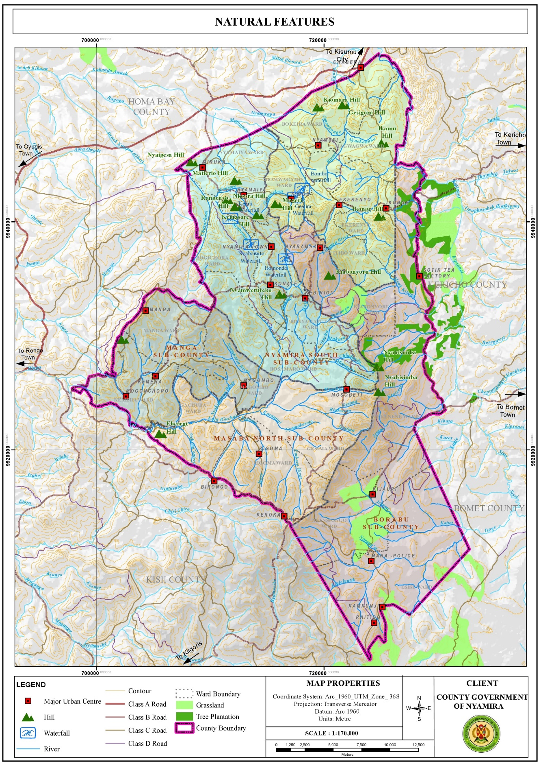

**3.3.1.1 Opportunities**

1. Hydrology: The County is adequately drained by the four main rivers and their tributaries. There are also several springs, wetlands and few water falls which sustain the county’s hydrological cycle. In addition, the high-water tables in the county have enabled the digging of shallow wells and boreholes. These water resources are the main water sources in the county, for instance, the intake for Nyamira water supply is located at River Eaka. River Sondu on the other hand has a lot of potential for hydro-electricity power generation which if tapped could contribute greatly towards the economic development of the county. The presence of numerous rivers presents opportunities for water harnessing through river obstruction.
2. Favorable Climatic Conditions for Agricultural Activities: The county has a bimodal pattern of annual rainfall that is well distributed, reliable and adequate for a wide range of crops with annual rainfall ranging between 1200 mm – 2100 mm per annum. The cold temperatures in the county are ideal for the growth of certain crops like tea and coffee which grow better in relatively cold regions.
3. Suitable Ecological Zones and Fertile Volcanic Soils for Agricultural Activities: The county is divided into two major agro-ecological zones. The highland zone (LH1 and LH2) covers 82 per cent of the County while the upper midland zone (UM1, UM2 and UM3) covers the remaining 18 per cent. These zones are suitable for growing various crops among them; tea, coffee, bananas, maize, avocado, sugarcane, pineapple, sweet potato, pyrethrum etc. These suitable ecological zones coupled by the rich volcanic soils make the county one of the main food producers in the country exporting food commodities to the regional hinterland and the country’s capital. However, the economic viability of the agricultural sector is threatened by the diminishing land sizes resulting from unregulated subdivision mainly for inheritance purposes.

**Map 4. Agro-Ecological Zones**

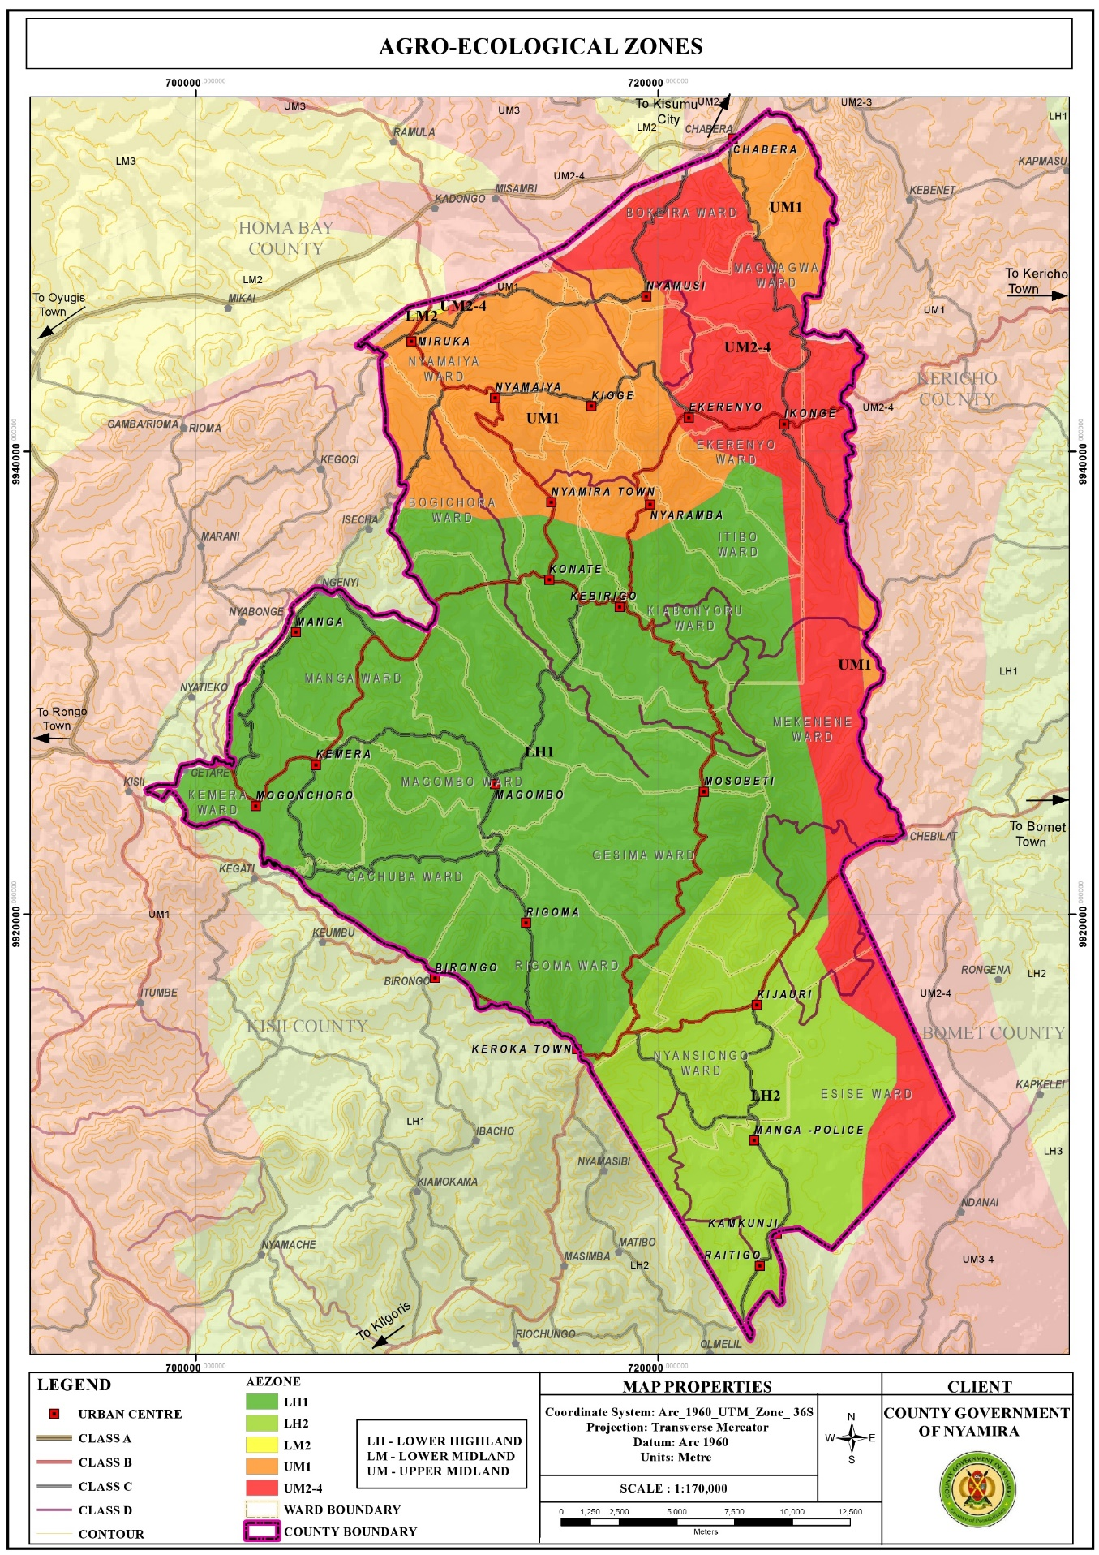

1. High Rainfall Amounts: The high rainfall patterns of between 1200 mm – 2100 mm per annum present opportunities for rain water harvesting through creation of large-scale runoff collection reservoirs and household rainwater harvesting. The harnessed water would be used during the relatively dry seasons of the year. If the harnessing is optimally undertaken, it would augment the terrain problems associated with piped water provision. Moreover, the rain water would reduce pressure on the natural water resources like springs, streams, rivers and wells which together supply water to about 80% of the population.

Map 3. Rainfall Distribution Map

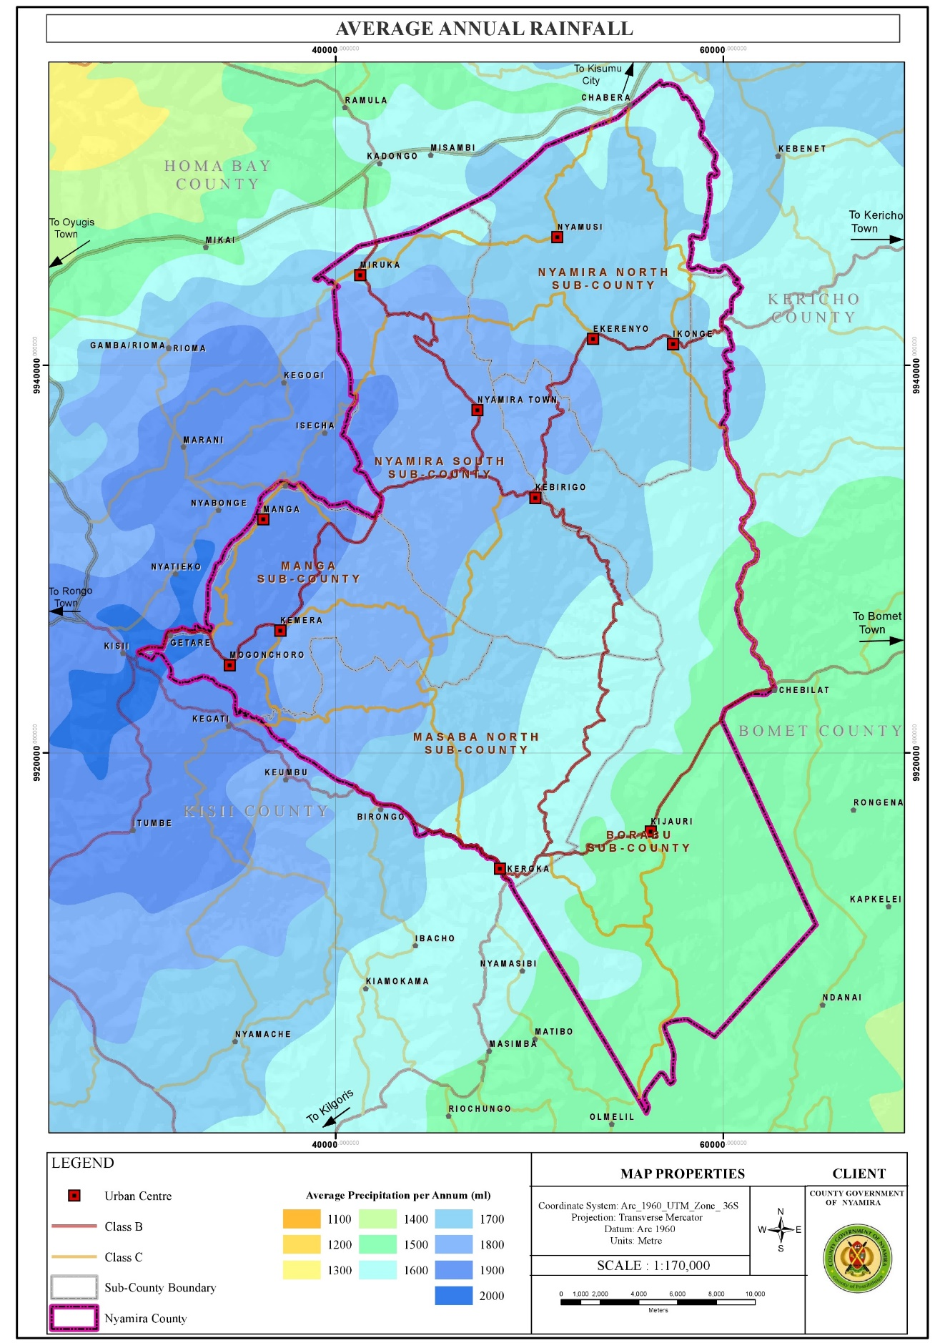

1. Renewable Energy: Harnessing like solar and wind though in small scale Nyamira County is relatively cold. However, the northern part of the county comprising of areas around Miruka, Nyamusi and Chabera have high solar potential with an annual solar photovoltaic power potential of between 1691 -1710 kWh/kWp. These areas also are the hottest with temperatures of 21.10C – 21.50C. The high temperatures in the northern part of the county coupled with high solar potential present an opportunity for solar power generation even at the household level. The county has an average wind speed of 2.46m/s which is beyond the cut-in-speed for small turbine to start generating energy which is set at 2m/s. However, the wind potential in the larger county is not at the required maximum of 10-15m/s with the exemption of the area around Manga ridge, an area near Birongo Market Centre in Masaba North Sub-County and an area near Ekerenyo Market Centre in Nyamira South Sub-County with relatively high wind power density of between 301 - 400 Watts per Square Metre. This wind power could be tapped to produce electricity.

**Map 4. Solar Potential Map**

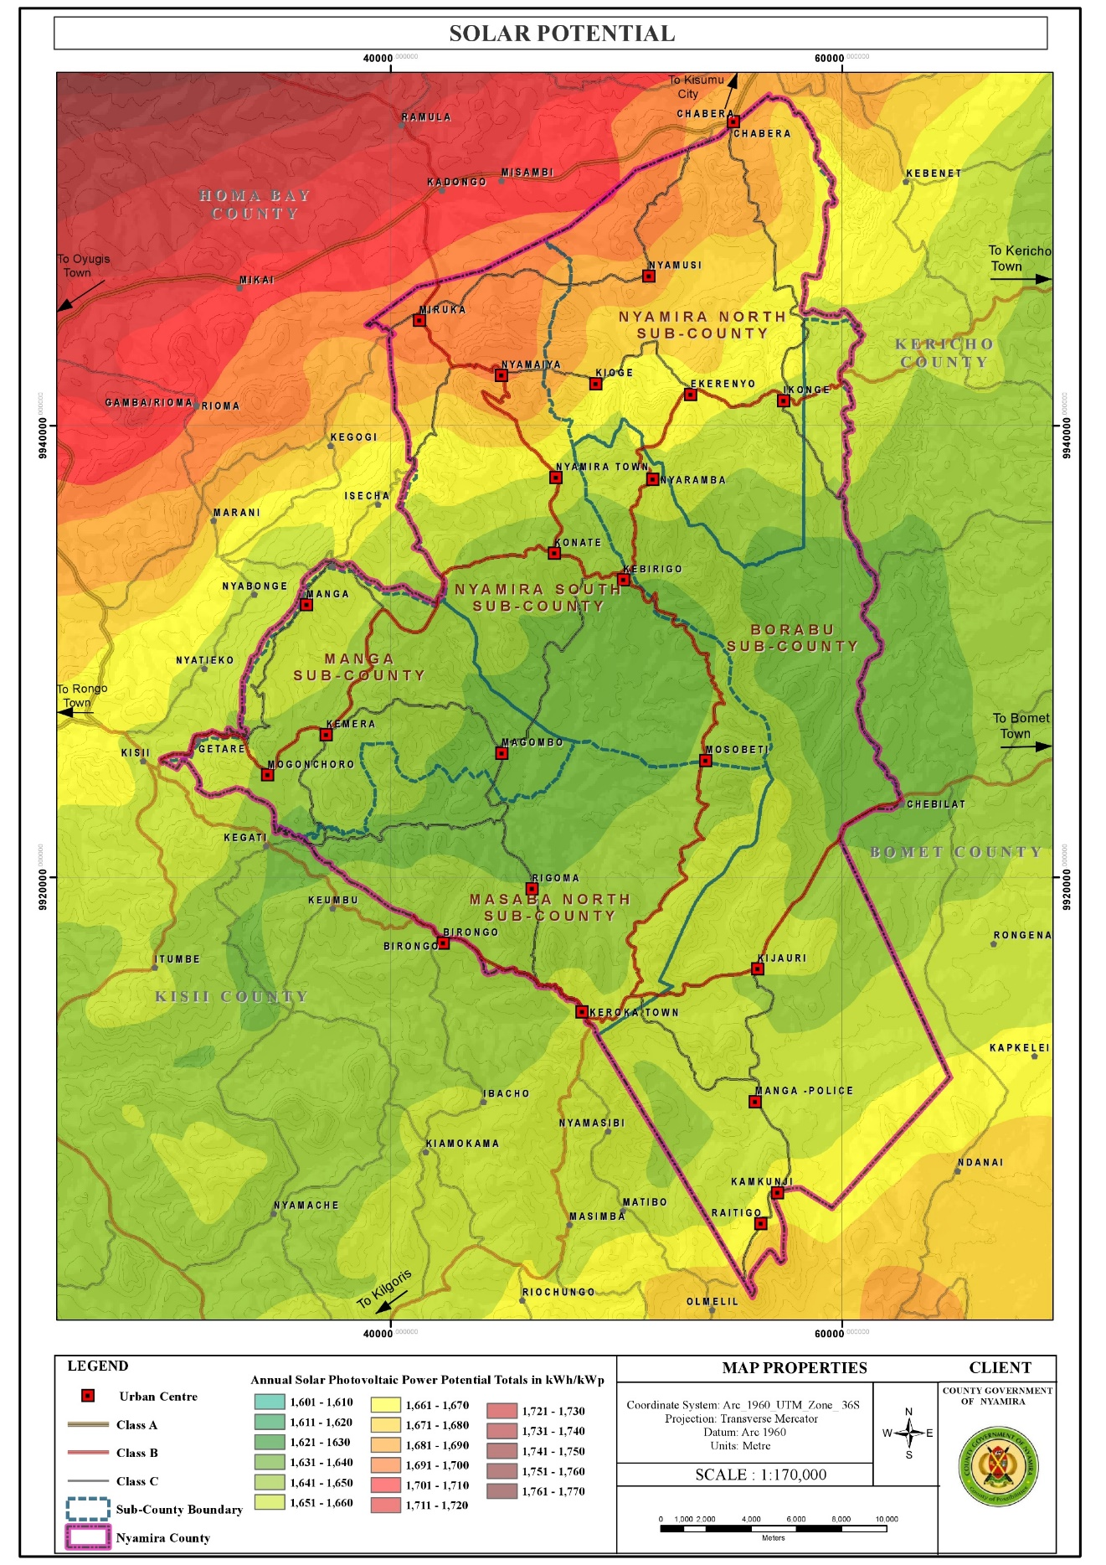

**Map 5. Temperature Distribution Map**

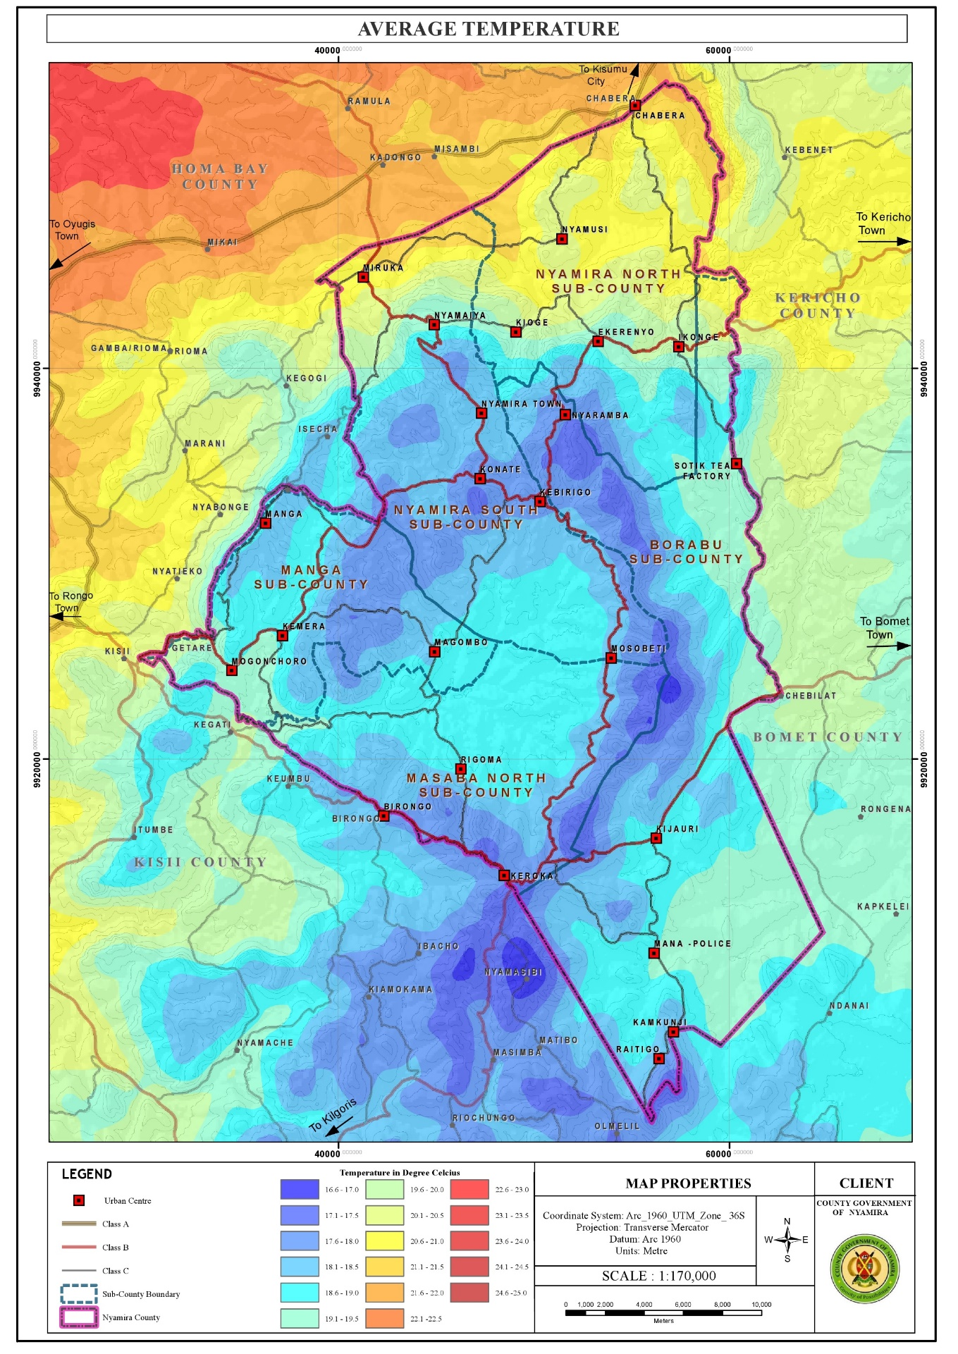

**3.3.1.2 Challenges**

1. Depression of Water Levels: The water levels in the rivers, springs, streams and waterfalls have been depressing over time a phenomenon attributable to several factors among them, planting of inappropriate tree species along the riparian reserves and water catchment areas, improper farming methods, unregulated water obstruction upstream and the negative effects of climate change. These factors have resulted to reduction of water levels in the main rivers and drying up of the streams.
2. Unfavorable topography for construction: The rugged terrain in the county makes some areas inaccessible as construction of roads to certain places especially those on the hilly areas or low lands is an expensive undertaking. In addition, piping of the water from the various water sources in the low lands to the majority of the homesteads in the hilly areas is very costly, rendering it unfeasible. This forces the residents to access the water from their natural sources (springs and rivers).

Map 6. Topography Map

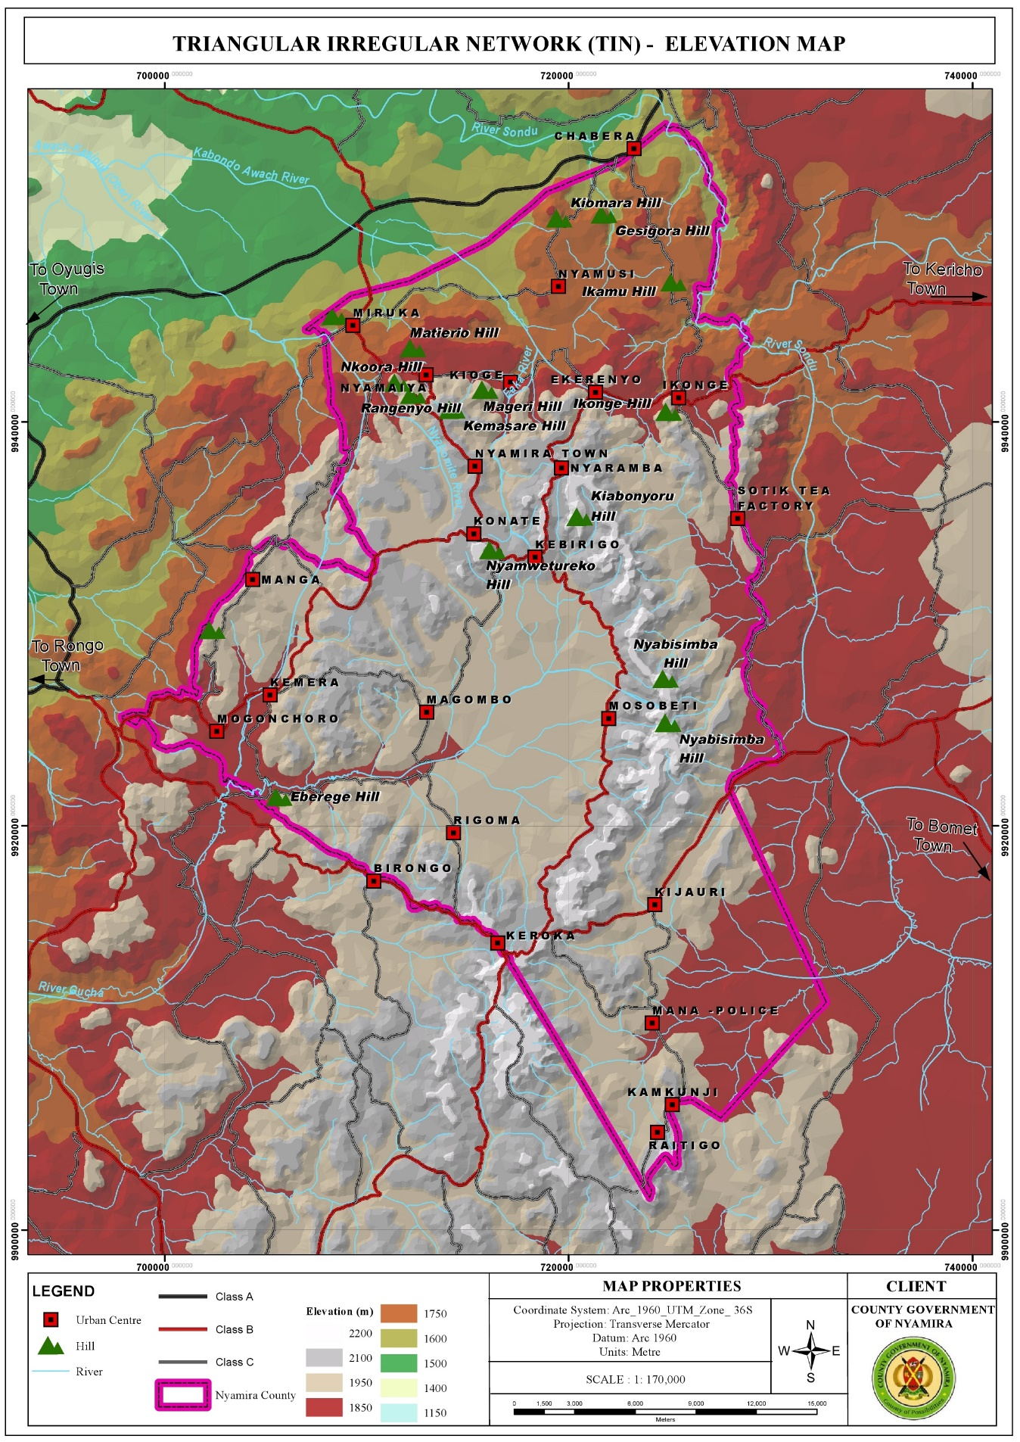

1. Poorly Drained Soils in Some Areas Resulting to Constrained Developments: A few areas in the county have poorly drained soils. These areas include sections of Magwagwa, Township, Bogichora, Bosamaro and Gesima Wards. They are characterized by red volcanic soils which are good for farming but make construction and road maintenance expensive. Thus, these areas are constrained in achieving high density developments.
2. Soil Erosion: Most of the rivers are characterized by brown waters, an evidence of soil erosion upstream. Soil erosion which displaces the fertile upper layer of the soil has negative implications on farm productivity as it results to reduced soil fertility. o High rainfall amounts The high rainfall amounts in the county coupled by increase in impervious layer make the county susceptible to flooding. The built areas especially those in the low lands face floods while the steep areas are susceptible to landslides especially in areas with loose soils.
3. Changing Weather Patterns: Changing weather patterns have affected all development sectors in the county with agriculture being the worst hit. The notable effects of this change are; delayed onset and untimely cessations of rain, skewed rainfall distribution and intensity and emergence of new pests and diseases.

**3.3.2 Population and Demography**

Population and demographic characteristics have far reaching implications on the county’s development. Various age cohorts present different needs with young population requiring the establishment of educational and health facilities. Youthful population requires focusing on youth empowerment programmes for skills and talent enhancement. To absorb the increasing labor force, investments in modern agricultural production and agro-based industries is necessary. The aged population on the other hand calls for allocation of resources for the provision of basic needs like water, food, clothing, shelter and medical services. The opportunities and challenges facing the county population are outlined below:

**Map 7. Population Density Map**

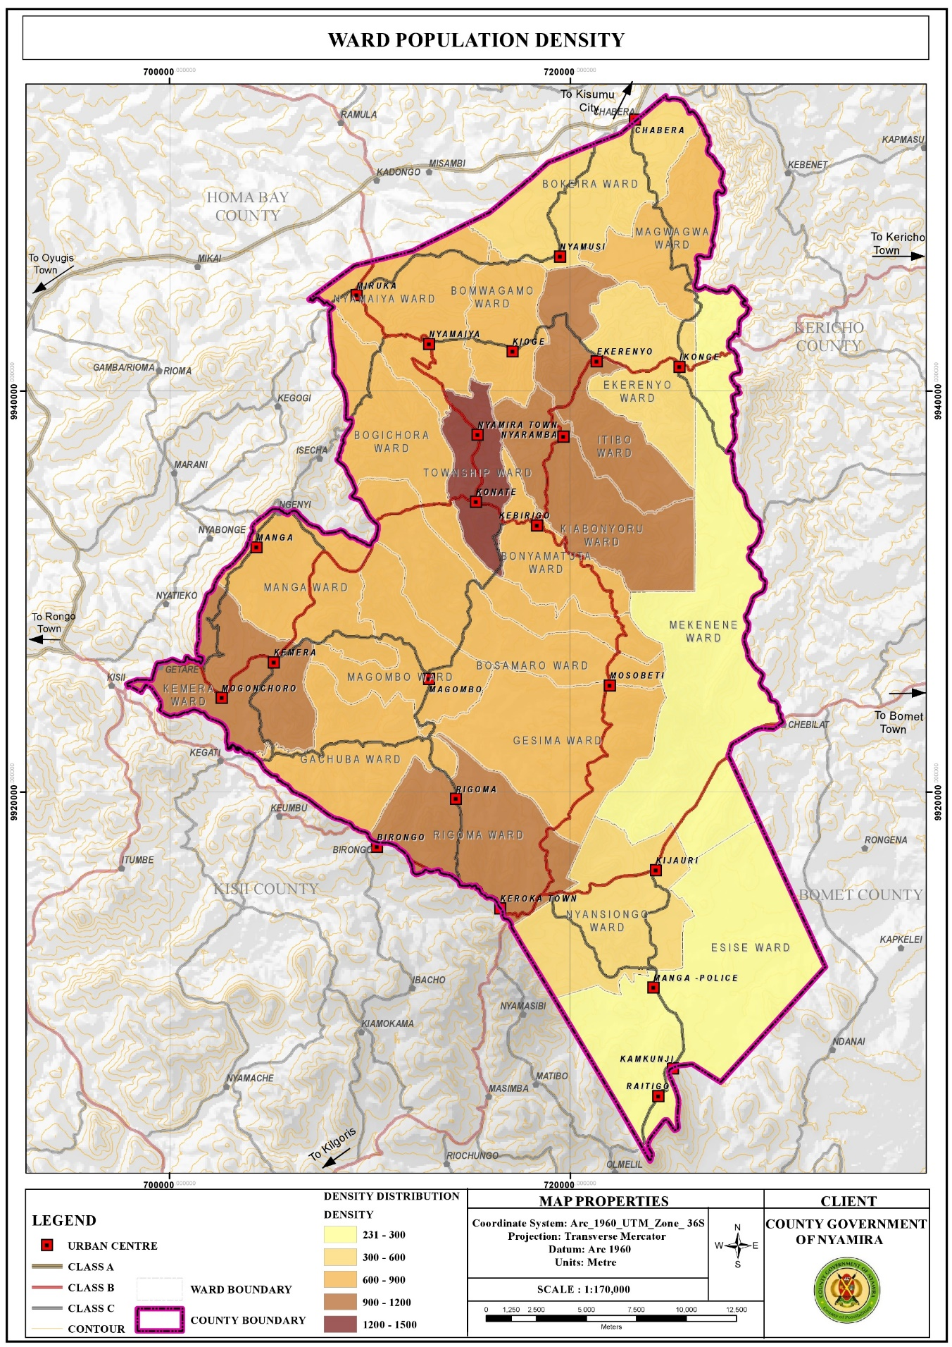

3.3.2.1. Opportunities

1. High proportion of Youthful Population: The youthful population constitutes the largest segment of the county population as 72.44% is under the age of 35 years. The youths (15-35 years) in the county account for about 33.3% of the county population. This population requires massive investment in skill development. This presents opportunities for youth empowerment Programmes for skills and talent enhancement.
2. High proportion of labor force: The labor force (15-64 years) constitutes about 55.8% of the total population. This calls for investment in diverse sectors like modern agricultural techniques and agro-based industries as well as creation of self-employment opportunities so as to absorb the increasing labor force
3. Development of Special Programmes: To address the needs of the elderly the aged population (65+ years) constitutes about 5% of the county population. This population presents opportunities in the provision of basic needs like food, water, clothing, shelter and health services so as to cater for the needs of this age group. In addition, this group presents opportunities for the development of special Programmes and strategies.
4. High Literacy Levels for Basic Education: The County has relatively high literacy levels for basic education at 91.1% compared to the national literacy rate at 81.53%. However, only a small segment of the population has attained tertiary level of education as represented by 2.5% of the population.
5. Over reliance on agriculture as a source of income presents opportunities for investment in agricultural production programs. Agriculture is the economic backbone of Nyamira County providing employment and income for a large number of the people. In addition, the county is a food basket for the region and the country supplying food commodities to the Kenya’s capital, Nairobi.
6. High population is a market for good and services the county’s population is projected to be 629,287 people as at 2021 and 691,028 people by 2030. This population constitutes the immediate consumers of the goods and services produced in the county. It gives the primary motive of production as without consumption there wouldn’t be need for production.

**3.3.2.2 Challenges**

1. Low number of population with tertiary level of education: The county has a very low proportion of the population who have attained tertiary level of education as represented by 2.5% of the population. This could be attributed to low transition levels from basic to tertiary education. Individuals with low literacy levels are more likely to experience fewer employment opportunities and outcomes thus lower incomes. As a result, they often face welfare dependency, low self-esteem and higher levels of crime. In Nyamira County, the low literacy levels in the male youths have pushed them to the boda boda sector leaving the agricultural sector with hardly no labor force. This reduces agricultural productivity. In addition, the high number of boda boda operators reduces the sector’s profit margin.
2. Overdependence in Agriculture as a Source of Livelihood: Agriculture is the main economic activity in the county employing a significant number of the population. This could be attributed to the low number of population with tertiary level of education; hence majority of the population lack the prerequisite skills to compete for the few white color jobs. The overreliance on agriculture is however not sustainable due to the diminishing and sizes resulting to uneconomical farm sizes. The reduced land sizes are as a result of population pressure especially in the denser areas as more agricultural land is being set aside for the construction of homesteads to house the growing population. In addition, intergenerational transmission of land rights that requires fathers to subdivide their property, land included to their heirs has resulted to unregulated land subdivisions. As a result, the emerging subplots are too small is some areas for any economical agricultural production. This has negative implication on individual households’ food and livelihood security.
3. High Proportion of Dependent Population: The county has a relatively high dependent population of 273,507 people as at 2021. This accounts for about 44.1% of the population and a dependency ratio of 79%. The county’s dependency ratio is relatively high compared to the national ratio of 69.8%. A high dependency ratio indicates more financial stress on working people as there is an increased burden to undertake child upbringing and pay pensions for the elderly.

**3.3 Land and Land Use**

Land and land-based resources facilitate social and economic developments as land is a requisite for all human undertakings. The opportunities and challenges regarding land are outlined below:

**3.3.1 Opportunities**

1. Large land parcels in Esise and Mekenene Wards in Borabu Sub-County Nyamira County is characterized by small scale farms with average farm sizes of 0.7Ha with the exemption of Esise and Mekenene Wards with large scale farm holdings of average farm sizes of 4 Ha. The farms in Mekenene Ward are owned by multinational companies while local individuals own the farms in Esise Ward. These large farms sizes present opportunities for large scale production hence the farmers can reap form the benefits of economies of scale.
2. High proportion of arable land The county has a high percentage of farmland as about 88.2% of the land is planted. This comprises of 64.5% under farmland and 23.7% under tree cover. This implies that, a great proportion of the county land is suitable for farming activities.

**Map 8. Land Use Classification Map**

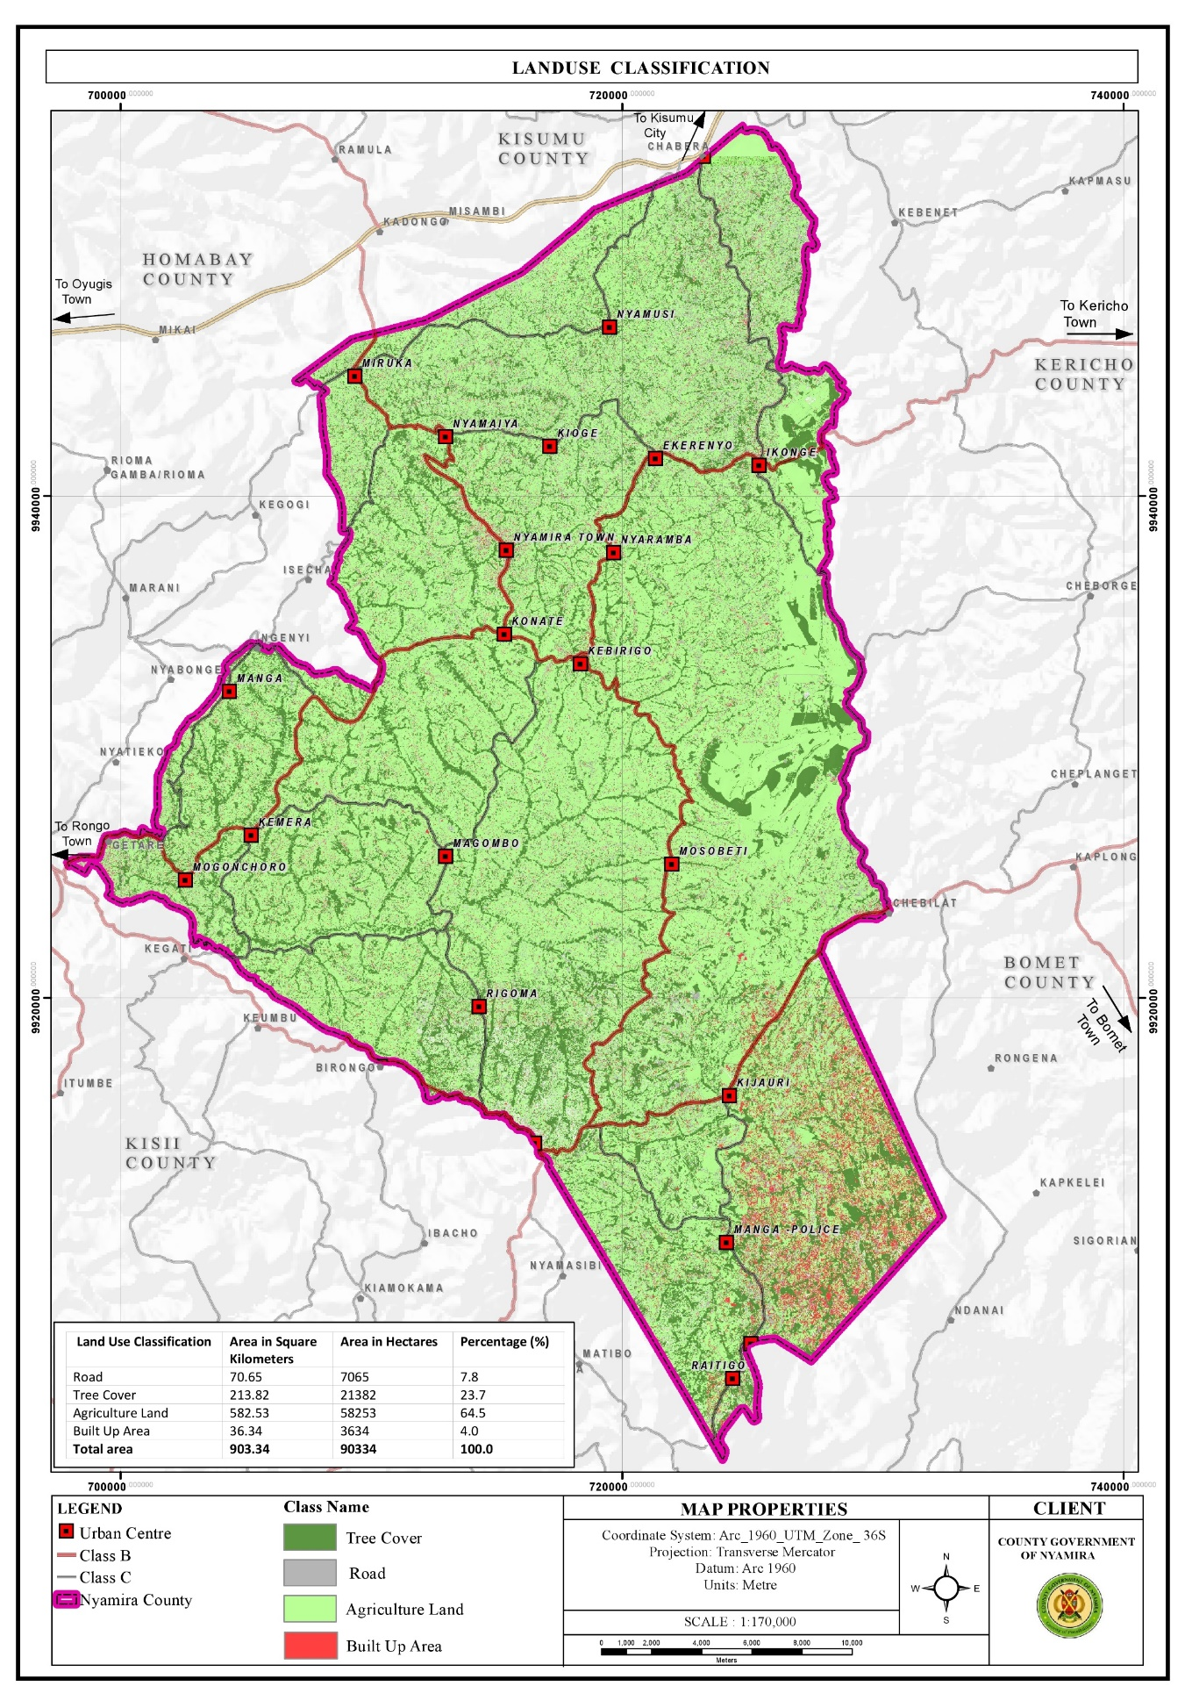

3.3.2: Challenges

1. Private land ownership: More than 90% of the county’s land is under freehold and comprises of the rural hinterland. The prevalence of private land ownership makes implementation of county development projects costly due to land acquisition and compensation costs.
2. Unregulated land subdivision: There has been significant land subdivision activities over the years mainly for inheritance purposes as the African culture and traditions dictate that fathers have to subdivide the property, land included to their heirs. Gradually, this practice coupled with population pressure has resulted to uneconomical land holdings
3. Freehold land ownership rights in most parts of the county, freehold land ownership rights are held at extended family where a family title is held in the name of the great grandparents. This poses challenges in succession, land managemet and administration.
4. Land use changes where urban developments are eating up agricultural land Changes in land use patterns are linked to a rapidly increasing population in the rural areas. This growth rate translates to an increased pressure and demand for land resources. The agricultural farms surrounding the towns and market centres are under massive pressure as the land parcels adjacent to the urban centres are gradually being converted to urban land uses. This threatens the sustainability of the agricultural sector in these areas as agricultural land use can’t be high for land as compared to commercial and residential land uses. O
5. Land fragmentation Land fragmentation in the county has been as a result of inheritance practices where all the heirs want to own land parcels both along the road and the riparian reserves. In addition, the small land sizes have forced the well up farmers to purchase or rent additional farm lots away from their original farms to add to their production levels. These fragmented land holdings have negative implications on agricultural production and food security due to the time lost accessing the fragmented parcels. There are also instances of increased disputes with neighbors.

**3.4** **Environment and Natural Resources**:

Nyamira County has several ESAs which include green and open spaces, wetlands, hills/forests and water falls. These ESAs undertake key functions in the sustainability of the environment among them provision, regulatory, economic and cultural functions. They are however threatened by several human activities among them; farming, mining and construction. Opportunities and challenges affecting the environment and natural resources in the county are outlined below:

**3.4.1 Opportunities**:

1. High tree cover: The county has a relatively high tree cover of 35% compared to the recommended national minimum cover of 10%. Trees aid in; air purification through carbon sequestration, soil stabilization and protection from soil erosion, provision of timber and wood fuel and flood mitigation as the roots help in water infiltration to the ground.
2. Availability of several natural resources: The county is endowed with several natural resources like rivers, forest/hills, wetlands and water falls which provide opportunities for conservation, eco-system service provision and promotion of tourism.
3. Conducive climatic conditions for the thriving of these natural resources: The thriving of these natural resources is facilitated by the prevailing conducive climatic conditions in the county.
   * 1. **Challenges**
4. Planting of inappropriate tree species: Majority of the riparian reserves are planted with eucalyptus trees. Eucalyptus trees are widely grown and utilized throughout the world as they are a valuable source of timber and wood fuel. These tree species however deplete groundwater, dominate other tree species and cause loss of soil fertility. They are indeed a key contributing factor to the drying up of some streams and reduction of water levels in some rivers.
5. Deforestation: Despite the high forest cover of 35%, the county suffers from significant deforestation activities. This is mainly as a result of overreliance of wood fuel and the need for other wood products like timber. The county relies mainly on wood fuel for cooking with about 84.3% using firewood and 3.5% using charcoal for cooking. Apart from household wood fuel consumption, the tea factories in the county use firewood to process the tea leaves. In addition, several institutions like schools use firewood for cooking. Furthermore, due to the population pressure in the county, individuals are clearing trees to pave way for settlements and crop farming so as to house and feed the increasing population respectively.
6. Boundary tree planting conflicts: Planting of trees along the farm boundaries is a common practice in the county. Trees are used to demarcate the farm boundaries and in some instances, due to the small land sizes, there are no land parcels left for tree planting and farmers are forced to utilize the farm edges. In addition, competition for land with other farm land use allocations pushes tree planting to the edges as the little available land is allocated to production of staple food. This practice has resulted to significant conflicts as farmers on both sides want to utilize the edges for tree planting.
7. Encroachment of riparian reserves and forests: Rapid human population growth and overexploitation of resources are the main causes of land use and land cover change along river basins. In addition, agricultural land and urban settlements have increased at the expense of forests and grasslands. The conversion of land use and land cover into agricultural land and urban settlements has resulted to various environmental consequences like loss of ecosystem integrity, ecosystem imbalance and below optimum provision of ecosystem services.
8. Poor waste management causing pollution on the rivers: Most of the market centres do not have designated solid waste collection and disposal sites. This has led to sprouting of illegal disposal sites in the market centres as well as indiscriminate waste disposal. The disposal sites are also poorly managed. The poor waste management practices in the county cause significant pollution of the rivers as the waste is swept by surface runoff into the rivers. In addition, about 95% of the households use pit latrines for human waste disposal. The use of pit latrines impacts negatively on the quality of the underground water. The threats are even higher in flood prone areas where these latrines can contaminate surface run off. The health threat of this mode of waste disposal is alarming as about 80% of the population in Nyamira County depend on springs, streams, rivers and wells as the main water sources for their domestic use.
9. Environmental degradation: Environmental degradation in the county is as a result of unsuitable farming methods, effects of climate change, poor solid waste management, soil erosion, deforestation, quarrying activities and invasive species. o Floods and landslides The county is susceptible to flooding and landslides due to the high rainfall amounts experienced in the county coupled with increase in impervious cover.
   1. **Human Settlements and Urbanization**

Human settlements play a critical role in development as they are centres of social interactions, services and utility provision. These settlements are influenced by several parameters among them climatic conditions, infrastructure networks like roads, water and electricity as well as availability and access to gainful employment. Migration of rural population to major towns in search of employment and other services like education and health has resulted to strained infrastructural facilities in these urban centres. The human settlements and urbanization trends in the county present several opportunities and challenges as outlined below:

**3.4.1 Opportunities**

1. Strategic location: The county is located within the LREB among other 13 counties with similar ecological zones, natural resources and analogous cultural histories. The county benefits from the synergist links among the other counties in the bloc. In addition, majority of the towns and market centres are situated along transportation corridors, enhancing their accessibility.
2. Dense settlements provide ready market for products and are cheaper to service Consumption is the main motivation for production, as there won’t be need for production without adequate consumption. The dense populations both in the rural and urban centres translate to demand for goods and services. These dense settlements are also cheaper to service compared to linear and leap frog developments.
3. High percentage of home ownership at 85.5% The county has relatively high percentage of home ownership at 85.5% compared to the national percentage of 61.3%. This could be attributed to the fact that majority of the population resides in the rural areas where they have constructed their homesteads within the agricultural farms.
4. Manga Sub-County is earmarked for the development of housing under the big 4 agenda. Affordable housing is one of the Government’s big 4 agenda with the others being food security, manufacturing and affordable health care. The implementation of the housing project in Manga Sub-County is expected to propel investment in other sectors and spur the area’s economic growth.

**Map 9. Urban Extents**

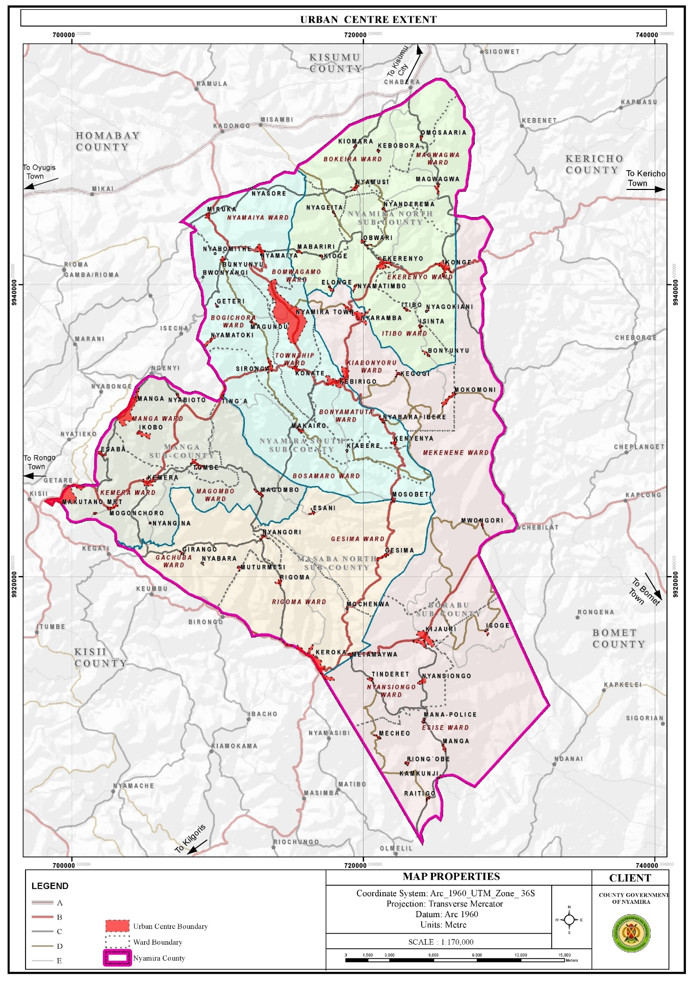

**3.4.2 Challenges**

1. Linear and leapfrog developments: Most market centres have developed along the major roads resulting to linear and leap frog developments. These developments are expensive to service.
2. Haphazard developments, urban decay and poor aesthetics of the market centres The towns and market centres in the county developed without any spatial framework to guide their development. As a result, majority of the centres are characterized by haphazard developments. In addition, the centres are not planned with the exemption of Nyamira Town, Miruka, Nyamaiya, Kioge, Ting’a, Sironga, Nyaramba, Kebirigo and Konate Market Centres though the plans are yet to be implemented. Some of the structures in the towns and market centres are in a dilapidated state as they are characterized by ugly walls and corroded roofs.
3. Poor solid waste management results to poor aesthetics in majority of the urban centres.
4. Limited accessibility and connectivity of the market centres Majority of the roads connecting the market centres are gravel and earth roads. The earth roads are in deplorable condition especially during the rainy season.
5. Inadequate land for future expansion of the urban centres as they are surrounded by freehold farm holdings. Majority of the market centres in the county were established by the former councils who identified public lands for potential growth of these centres and defined their boundaries.
6. Terrain The rugged topography in most of the urban centres has been a major limitation to their growth and development. For instance, construction of roads to certain places especially the hilly and low lands is costly and unfeasible in some areas. This renders some areas inaccessible. In addition, piping of the water from the various water sources in the low lands to the majority of the homesteads in the hilly areas is very costly, rending it unfeasible.

**3. 5 Transport, Infrastructure and Services**

Efficient transport, infrastructure services and utilities are prerequisite to socio-economic growth and development. The roads open up resource potential areas, link activity spaces and enable the circulation of goods and services. Water, ICT, energy, sanitation services and social infrastructure function towards uplifting the quality and standards of life for the county residents. This sector is presented with numerous opportunities and challenges as outlined below;

3.5.1 Opportunities

1. High connectivity of the county to the regional hinterland via the existing road network in the region: The county is well connected to the hinterland with Kisii-Chemosit road (B4) and Konate-Senta Road (B5) being the main roads connecting the county with other regions. Other roads linking Nyamira County to the rest of the region are; Narok – Kisii (B3), Kisii – Nyamira road (C21), Kisumu – Kisii Road (A1), Oyugis – Kendu Bay Road (C26), Kisii- Rongo Road, Kaplong – Chemasit – Kericho Road, Kericho – Kapsoit – Awasi – Ahero Road, Kebirigo – Ekerenyo – Ikonge – Chemosit Road, Ikonge – Magwagwa – Chabera Road among others

**Map 10: Road Network and Classification**

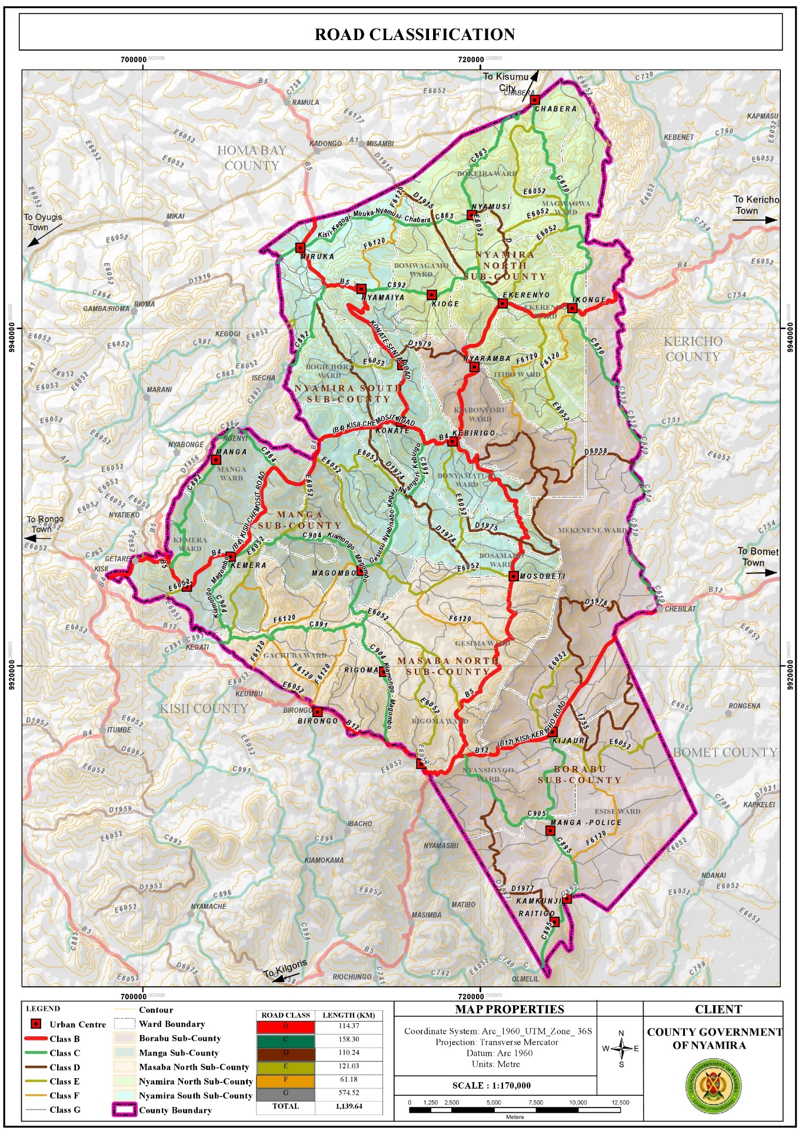

* + 1. **Challenges**

1. Poor road conditions: The county is characterized by poor road conditions with only about 20.1% of the classified roads being of bitumen surface type. About 27.6% of the roads are unclassified and are mainly earth roads. In Bosamaro Ward, for instance all the roads are earth roads. Majority of the gravel roads on the other hand are in poor condition due to poor maintenance and constant erosion of the top surface. The poor road condition especially for the earth roads renders them impassable during the rainy seasons. This poses a challenge in the transportation of farm inputs and produce.
2. Encroachment of road reserves: Majority of the road reserves have been encroached by informal businesses in the urban centres bringing about issues of space contestation between the road users, traders and customers. o Lack of bus terminus and parking spaces Most of the market centres in the county lack bus terminus with the exemption of Nyamira Town, Keroka Town and Ekerenyo Market Centre. This forces the Public Service Vehicles (PSVs) to load and offload along the roads. There are also no parking spaces in the urban centres and motorists are forced to park along the road reserves or building pavements.
3. Poor connectivity between the market centres : Despite the existence of roads connecting all the market centres, some of the roads are in a sorry state. The situation is further aggravated by missing bridges and poor conditions of the available bridges in some of the roads. This makes accessibility to some of the market centres a challenge.

**3.6 ICT**

**3.6.1 Opportunities**

1. Relatively high ICT proficient population: About 45% of the county population own mobile phones, 16% utilize the internet while 7% use laptops, tablets, computers and desktops. This presents opportunities for engagement in ICT related businesses.
2. Easier accessibility of ICT equipments : Accessibility to ICT equipment has become easier over the years since their introduction in the country. There are several electronic shops in the county headquarters (Township) where the county residents can access various devices at their convenience.

**3.6.2 Challenges**

1. Low budgetary allocation and inadequate staffing to operate the ICT infrastructure. o Inadequate skills in the ICT sector among staff in the county departments coupled by lack of training programmes to equip the staff with the required skills.
2. Low network reception in some areas, especially the low land areas as reception is hindered by the hilly areas. The residents have to move to higher grounds in search of network reception o Lack of resource centres, GIS lab and equipment for data storage and retrieving

**3.7 Energy**

**3.7.1 Opportunities**

1. Renewable energy sources: The Northern parts of the county comprising of the areas around Miruka, Nyamusi and Chabera have high solar potential that can be harnessed for solar power generation even at the household level. The area around Manga ridges, an area near Birongo Market Centre in Masaba North SubCounty and an area near Ekerenyo Market in Nyamira South Sub-County with relatively high wind power density of between 301 - 400 Watts per Square Metre are potential areas for wind power generation. There is also potential for production of biomass for cooking, though at household level. Tapping into these renewable energy sources could help minimize the negative effects of climate change.
2. Last mile connectivity : This presents an opportunity to connect other areas with electricity. 11.7.3.2 Challenges o Over-reliance on wood fuel for cooking Wood fuel is the main source of cooking energy with 84.3% and 3.5% of the population using firewood and charcoal respectively. In addition, the tea factories in the county use firewood for the processing of tea leaves. The use of wood fuel has implications on the environment as it leads to air pollution and reduction in tree cover.
3. Low electricity reticulation as some of the areas are not connected to the national grid : The current electricity coverage in the county stands at 49.5% which translates to about 85,548 connections. There are areas without electricity connectivity in the county like; Obwari, Gesura, Ensoko and Kiabora. These areas need to be connected to the national grid as electricity is a major component of socio-economic development.

Map 11: Electricity Reticulation Map

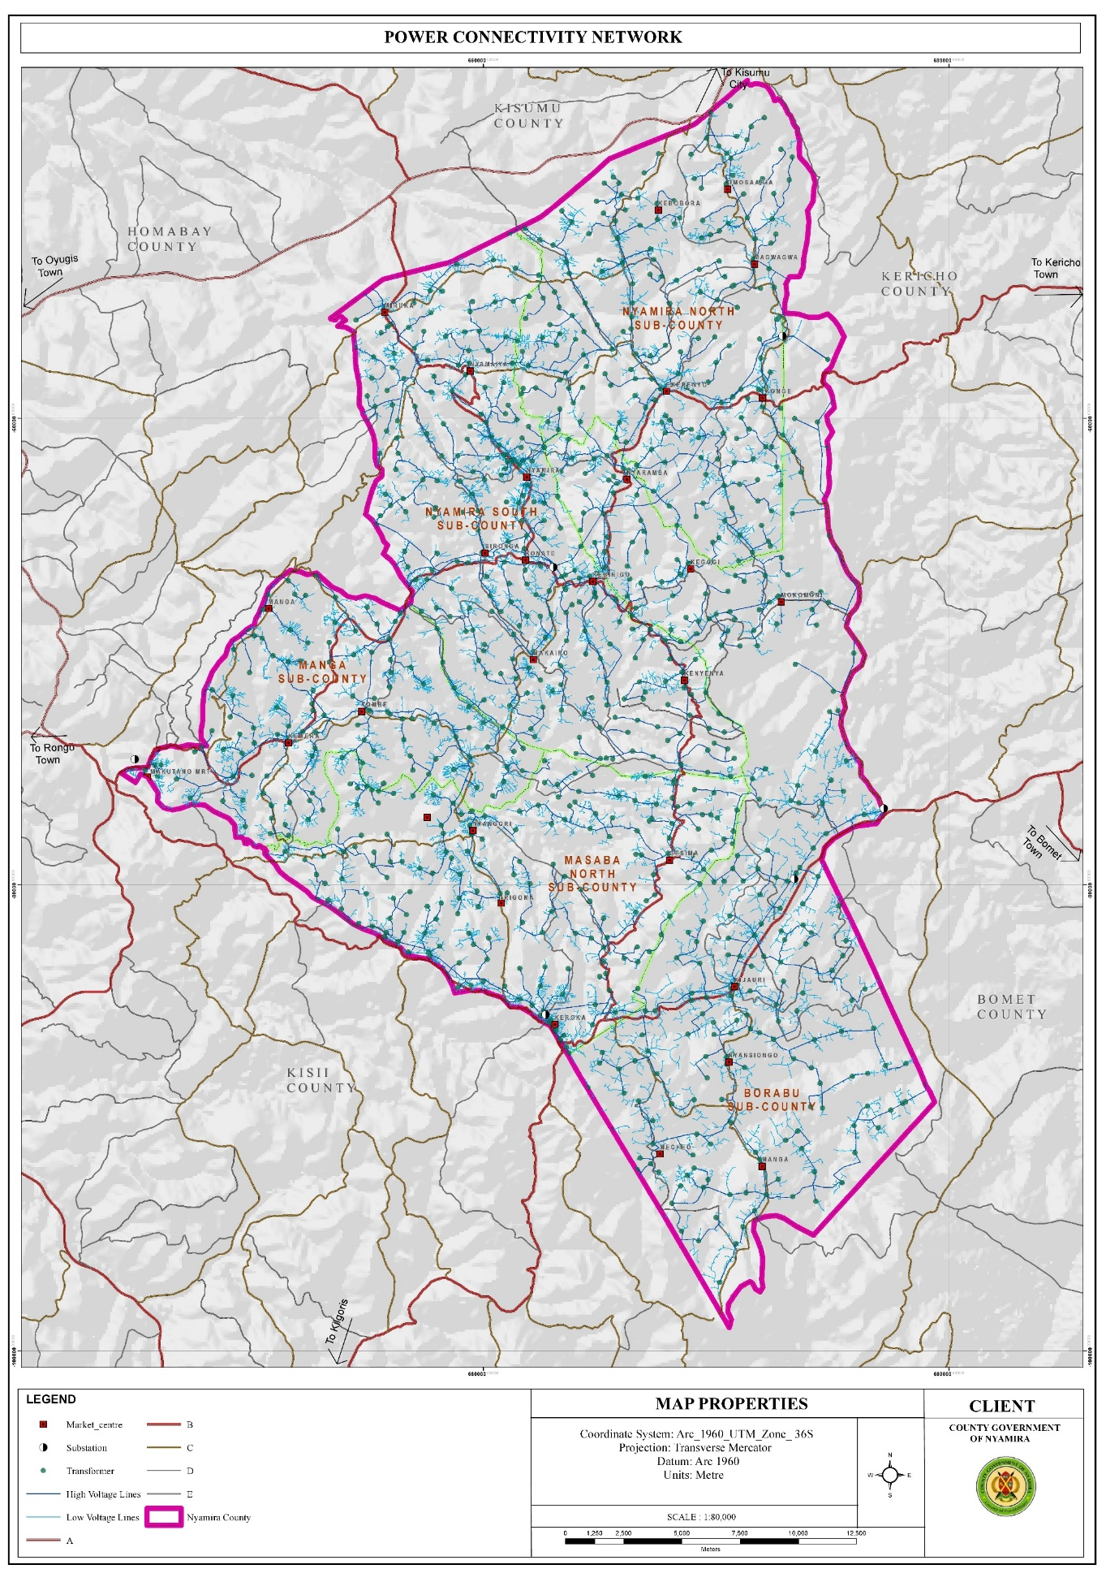

**3.8 Water and Sanitation**

**3.8.1 Opportunities**

1. Availability of water sources both surface and underground water sources : The county has about 2,021 shallow wells, 735 protected springs, 69 dams as well as over 2,790 unprotected springs and 7 permanent rivers. The availability of these water sources presents opportunities for easier access to water for both domestic and agricultural use.
2. High rainfall amounts present an opportunity for rain water harvesting The high rainfall patterns of between 1200 mm – 2100 mm per annum present an opportunity for rain water harvesting through creation of large-scale runoff collection reservoirs and household rainwater harvesting.
3. High water tables: The high-water tables in the county present opportunities for drilling of shallow wells. This explains the high number of shallow wells at the county which stands at 2,021. o Availability of waste The current solid waste generation in the county as at 2021 amounts to 104,146 tonnes and is projected to be 116,024 tonnes in 2030.

**Map 12: Water Sources**

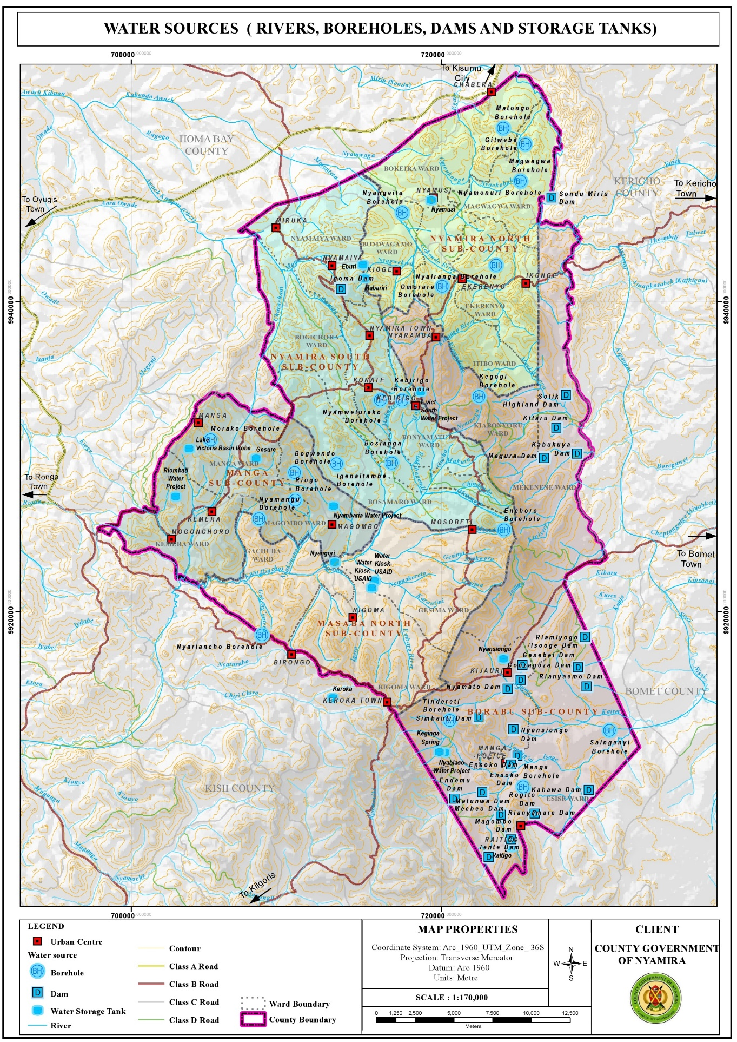

**3.8.2 Challenges**

1. Water: Over reliance on river and spring water Springs and rivers are the main water sources in the county, with about 36.6% using water from the streams/rivers while 36.4% and 9.4% utilize water from protected and unprotected springs respectively. o Inadequate water for the market facilities Water reticulation is only available in Nyamira and Keroka Towns. The rest of the towns rely on obtaining water from their natural sources.
2. Inaccessibility of water sources Despite the numerous water sources available in the county, water is not accessible to majority of the residents residing on the hilly areas as majority of the water sources are located at the low lands. The situation is further aggravated by the area’s topography which makes development of water reticulation from the low areas to the hilly areas unfeasible.
3. Poor water quality: The water quality in the county is compromised by constant pollution from the poor waste management practices carried out. Lack of designated solid waste management sites in most of the market centres has resulted to indiscriminate disposal of waste
4. Unprotected dams The unprotected dams are safety hazards to the county population as they are potential drowning areas. Siltation of some of the dams has made them dysfunctional over the years while privatization of others has made them inaccessible to the general public.
5. Rivers/springs : The rivers and springs are threatened by the planting of inappropriate tree species mainly eucalyptus trees. These tree species are a key contributing factor to the drying up of some streams and reduction of water levels in some rivers, wetlands and springs. o Lack of sewer reticulation network in the major urban centres Sewer reticulation is only available in Keroka Town. The rest of the urban centres don’t have a sewer reticulation network.

**3.9 Education**

* + 1. **Opportunities**

1. Have adequate schools: Based on the standards for the provision of educational facilities as outlined in the Physical Planning Handbook (2007), the existing educational facilities in the county are in surplus. This offers adequate learning institutions for the school going population. Presence of tertiary institutions The County has a total of 54 public TVETs spread across the county. The presence of tertiary facilities presents opportunities to further education as it offers alternatives to transition from secondary education to skill development. The student and staff population in these institutions provides a ready market for farm produce grown in the county and present opportunity for the construction of accommodation facilities.
   * 1. **Challenges**
2. Location of schools in the wetlands especially in Sironga making it difficult for infrastructure development
3. High number of pupils/students in boarding schools resulting to overstretched infrastructural facilities and services
4. Derelict infrastructural facilities in most of the public primary schools. o Poor waste management; solid waste is burnt in the open while inadequate land sizes constrain construction of additional pit latrines.
5. Poor accessibility of some of the schools within the rural areas due to impassable roads during the rainy season
6. Inadequate support infrastructure like appropriate sanitation facilities and learning materials o Delay in disbursement of funds to public schools affecting the smooth operation of school programs
7. High pupil/student teacher ratios in the public schools leading to overstretched teaching staff and poor performance of the pupils in national exams.
8. Inadequate land for the tertiary institutions as most of them are housed within primary or secondary schools land.
9. Inadequate schools for the physically challenged pupils forcing them to attend the normal schools without the prerequisite facilities for their learning.
10. Lack of water in some institutions making pupils carry water with jerricans to school. This practice is quite tiring to some of the pupils, thus affecting their concentration in class and their performance in general.

**Map 12: Distribution of Primary Schools**

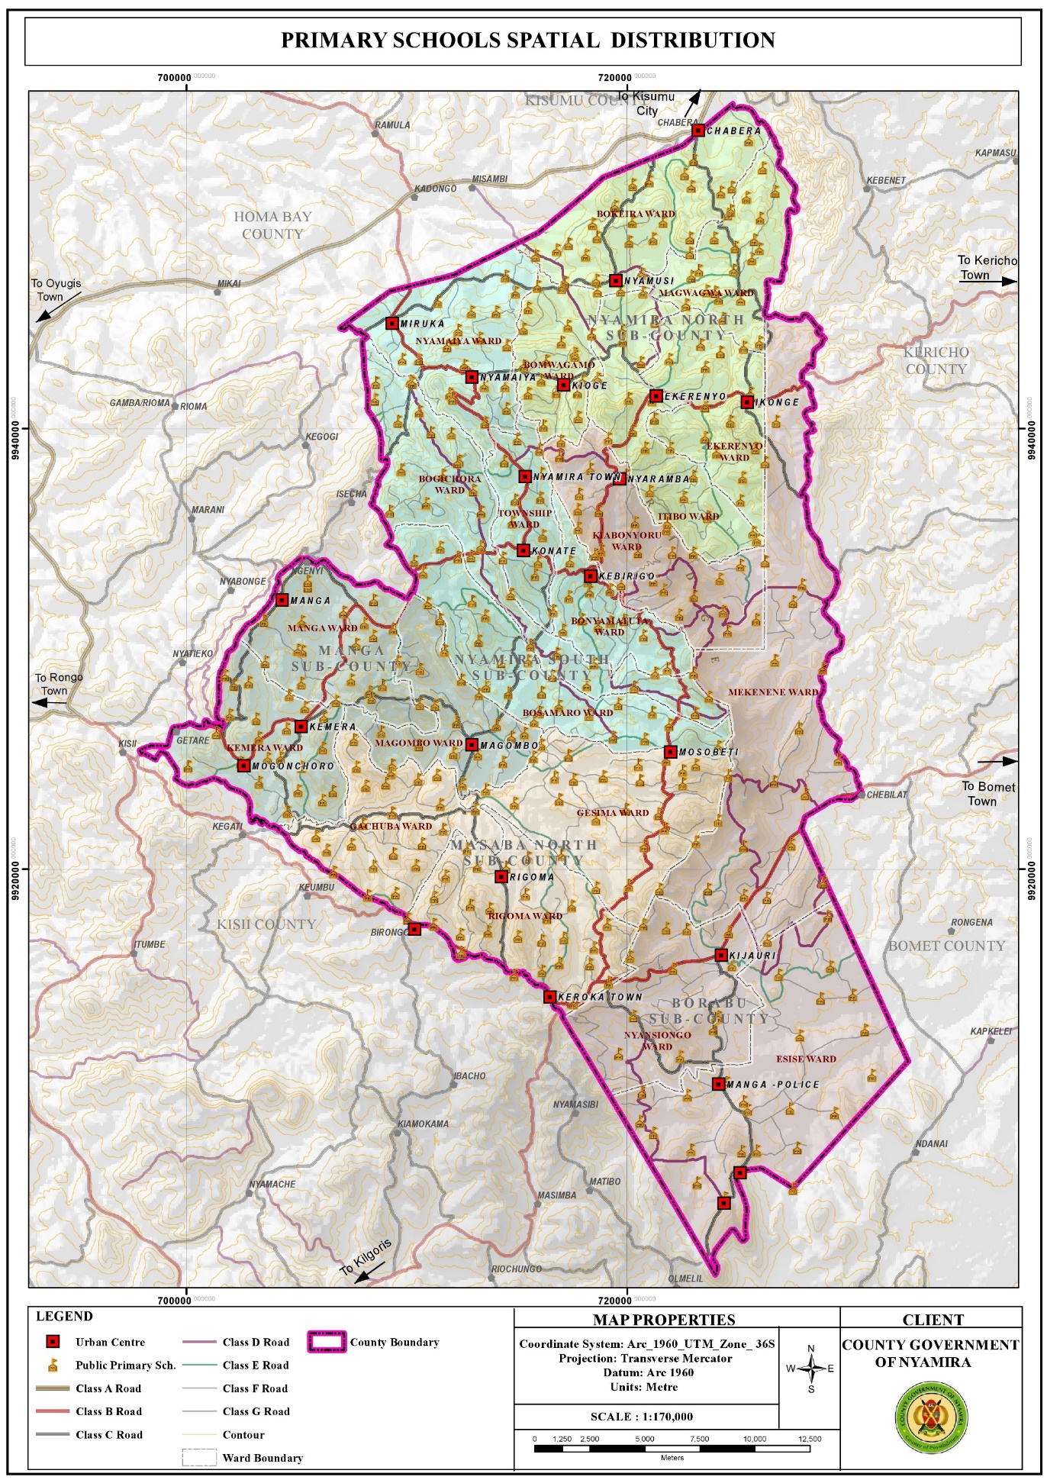

Map 13: Distribution of Secondary Schools

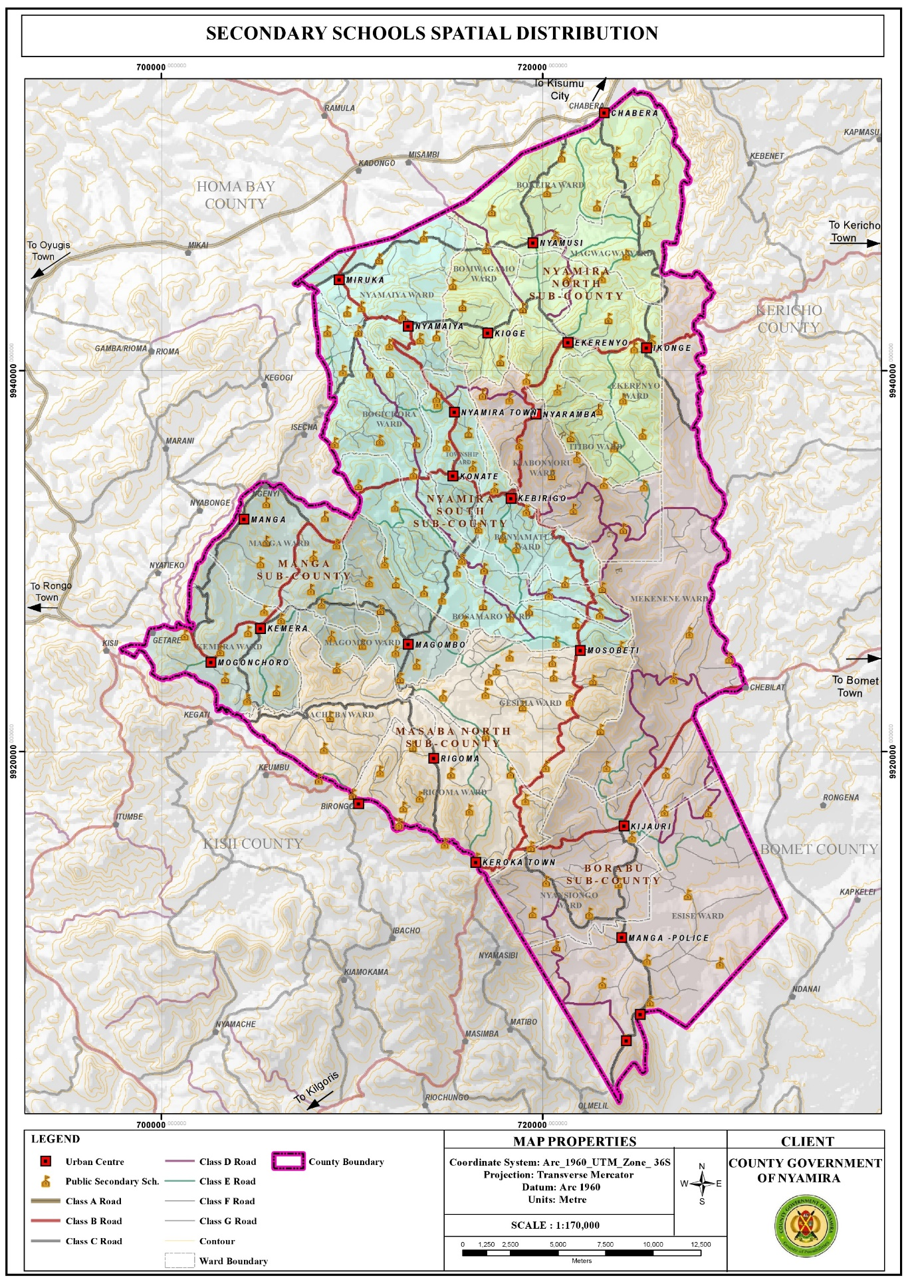

**Map 14: Distribution of Tertiary Institutions**



**3.10: Health**

**3.10.1 Opportunities**

1. Availability of county referral hospital Nyamira County Referral Hospital is a government health facility which provides comprehensive medical and surgical services. The presence of the facility within the county presents a good opportunity to the county residents to access high level medical services in close proximity.
2. Adequate health facilities based on the standards given by the ministry of health with regard to provision of health facilities versus the catchment population, the county has adequate public health facilities. However, despite the over-provision of health facilities, private health facilities have been mushrooming. This could be attributed to the deplorable state of some of the public facilities and lack of the requisite equipment and drugs.

**3.10.2 Challenges**

1. Inadequate staffing leading to overstretched medical staff. The doctor: population ratio is 1:11,906 against the Kenyan ratio of 1 doctor per 10,000 people. This indicates overstretched medical personnel. The inadequacy in staffing leads to low motivation hence low productivity. Poor accessibility of some health facilities located in the rural areas due to impassable roads during the rainy season.
2. Inadequate medical equipment, drugs and lack of specialized treatment in most public facilities leading to sprouting of private facilities.
3. Poor conditions of some of the health facilities, for instance some of the facilities are in derelict state rendering then dysfunctional.
4. Stalled projects; the construction of most of the proposed health facilities has stalled.
5. Mushrooming of private health facilities to fill in the niche as a result of poor services in the public health facilities.
6. Increased lifestyle diseases among the elderly for example high blood pressure, diabetes and arthritis hence the need for special facilities to help fight such illness.
7. Locational disadvantage of some of the health facilities like Ikonge dispensary which is located downhill making it inaccessible to majority of the residents due to the county’s rugged terrain.

**Map 15: Distribution of Health Facilities**

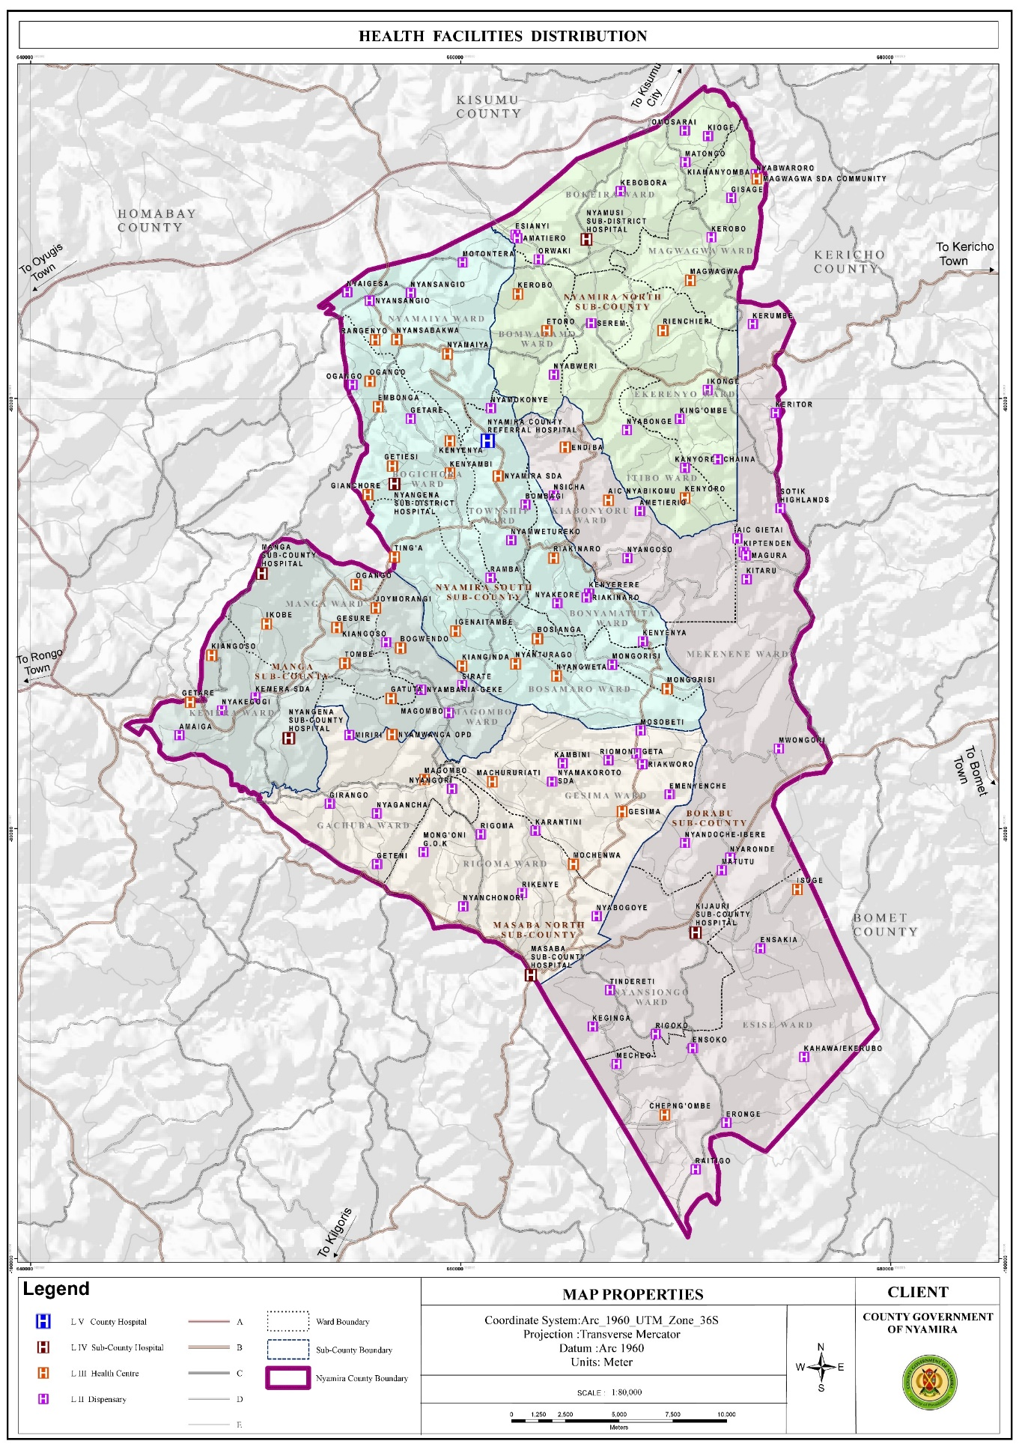

## CHAPTER FOUR

## DEVELOPMENT PRIORITIES, STRATEGIES AND PROGRAMMES

## 4.0 Introductions

**Sector Priorities and Strategies**: The sector priorities should be derived from the sector development issues documented in Chapters One and Two of the Plan. Strategies to achieve sector priorities should be proposed in relation to root causes of the development issues. Information in this section should be presented in Table 16.

### 4.1 Development Priorities and Strategies

Table 6 : **Sector Priorities and Strategies**

|  |  |
| --- | --- |
| **Sector Priorities** | **Strategies** |
| Increase of own source revenue | * proper revenue administration and management * setting revenue targets to all revenue streams * automation of revenue * continuous capacity building * revenue of finance bill annually |
| Staff welfare | * development of policies are procedures in place |
| wage bill management and control | * staff audits, recruitments and staff controls |
| training and development | * training policy and procedures in place * training inventory * training needs assessment |
| performance contracting management and staff appraisal management | * performance contracting management carried out * signed and cascaded * staff performance appraisal sensitization programme carried out * performance appraisal targets set * performance appraisal report prepared |
| work load analysis | * work load analysis carried |

## 4.2 Sector: PUBLIC ADMINISTARTION & INTERNAL RELATIONS

**4.2.1 Sector composition**

Provide the sub sectors under the sector and their key roles.

The sector is composed of the following sub-sectors; Finance and Planning, Governor’s office, County assembly, County public service board, national bureau of statistics and Public Service Management

**Public service management**

**mandates**

* Administration, Coordination and development of decentralized support services – to administer, coordinate Decentralized Government activities.
* Human Resource Management and Development of support services– Coordination and administration of human resource policies and strategies.
* Civic Education & Public Participation. - Coordination of public participation and enhancing civic education in the county.
* Corporate Communication, public relations and support services – Dissemination of County Government information to and dealing with both internal and external publics.
* Enforcement, Compliance and support services. - Enforce compliance to County & National Government laws and regulations

County contracting and performance management support services – administration of performance contracting and management tool

* Special programs support services –coordinating activities related to specific projects, emerging and crosscutting development issues affecting the county.
* County Results and delivery support services- coordination of the implementation of county projects and policies
* County attorney and solicitor support services –provide guidance on all legal aspects affecting the county
* Finance and administration support services-prudent financial management and control of the board
* Coordination of planning, budgeting and reporting-provide leadership in policy formulation, coordination of development planning, allocation of resources, monitoring and evaluating the implementation progress and reporting for policy analysis
* Coordination and management of county executive affairs-offers secretariat and services to the county executive committee and communicate the same to departments and entities.
* Governor’s advisory and support services-coordination and supervisory of governor events
* Administration, policy and support services-
* Legal, ethics, governance and compliance-advising the board on legal issues and legislation
* Revenue administration support services

#### 

**county public service board**

**Mandates**

The mandate of the Board is provided for under Article 59(1) of the County Government Act 2010 and summarized as hereunder:

a) Establish and abolish offices in the county public service

b) Appoint persons to hold or act in offices of the county public service including in Boards of cities and urban areas within the county and to confirm appointments

c) Prepare regular reports for submission to the County Assembly on the execution of the functions of the Board

d) Promote in the county public service the values and principles referred to in Articles 10 and 232 of the Constitution of Kenya 2010

e) Evaluate and report to the County Assembly on the extent to which the values and principles referred to in Articles 10 and 232 of the Constitution of Kenya 2010 are complied with in the county public service

f) Facilitate the development of coherent, integrated human resource planning and budgeting for personnel emoluments in the county

g) Advise the County Government on human resource management and development

h) Advise the County Government on implementation and monitoring of national performance management system in the counties

i) Make recommendations to the salaries and Remuneration Commission, on behalf of the county government, on the remuneration, pensions and gratuities for county public service employees

**County Assembly Of Nyamira**

**Mandates**

**General Administration, Planning and Support Services**

To enhance professionalism, build human resource capacity and provide effective services to the Legislature to enable it meet its Constitutional mandate.

**Legislation and Representation**

To strengthen the capacity of members of County Assembly in making laws and enhance their representative capacity.

**Legislative Oversight**

To strengthen the capacity of making and oversight the county budget for optimal use of public resources and enhanced accountability in governance.

**FINANCE**

The overall mandate of the Department is “to facilitate the management of resources, coordinate the County development planning, policy formulation and implementation for economic development. Specifically these are outlined as follows:

|  |  |
| --- | --- |
| **DIRECTORATE** | **ROLES** |
| Information Communication and Technology (ICT) | To automate all County Government services for effective service delivery.   * To facilitate dissemination of information for decision making through ICT * To provide a data bank for the County Government of Nyamira * To maintain and service all ICT equipment and software in Nyamira county * To enhance internal communication through installation of Networks * To improve service delivery to Nyamira residents through use of ICT * To facilitate other Departments to be effective in Service delivery through ICT |
| Economic planning and statistics | * Coordination of the county integrated planning cyvle * Documentation and dissemination of vital planning and budgeting documents * Provison of up-todate county statistics * Carrying out monitoring and evaluation of development projects across the county |
| Finance, Accounting and Budgeting | * Disbursement of county government funds and expenditure control |
| Internal Audit and Risk management | * Asset and debt management. * Quality assurance and risk management |
| Supply chain management | * To procure goods, works and services on behalf of user departments as and when required * Prepare and publish notices of award and notices of tender acceptance; * Maintain and archive documents and records of the procurement and disposal activities for the required period; * co-coordinating all activities of Procurement committees; * Liaise with the Public Procurement Regulatory Authority and other bodies on matters relating to procurement and disposal; * Prepare and submit to the Public Procurement Regulatory Authority reports required under the public procurement law ,  Regulations and guidelines of the Authority; * Monitor contract management by user departments to ensure implementation of contracts in accordance with the terms and conditions of the contracts; * Prepare consolidated procurement and disposal plans; * Carry out periodic market surveys and due diligence to inform the placing of orders or adjudication by the relevant Accounting Officers; * Conduct periodic and annual stock taking; |
| Revenue and Resource Mobilization | * Automation of revenue collection * Development and implementation of finance Act * Administration and enforcement of revenue laws * Formulation of draft county Government By-laws * Mapping of revenue sources |

**GOVERNORS**

* To provide overall leadership and direction to the county Government as whole
* Ensuring policy implementation
* Provide cross-cutting services inclusive of Legal, Economic and political advisor

4.3 Vision:

A leading sector in public policy formulation, implementation, coordination, supervision and prudent resource management

4.4 Mission:

To provide leadership and policy direction in resources mobilization and management for quality public service delivery.

**4.5 Goal(s)**

: Enhanced management of public resources, policy formulation and implementation for economic development and safeguarding of the county government interests.

Table 17: Sector Programmes

## 4.6 Flagship projects

Table 8 **Flagship projects**

##### 4.6.1 Sector Programmes

The section should provide sector programmes to be implemented within the planned period. This information should be presented in a tabular form.

### Table 7: Sector Programmes

#### Sector; Public Administration & Internal Relations

#### Sub-Sector 1; Finance & Economic Planning

|  |  |  |  |  |  |  |  |  |
| --- | --- | --- | --- | --- | --- | --- | --- | --- |
| **Programme 2:**  **Economic planning, Budget Formulation and Co0rdination Support Services** | | | | | | | | |
| **Objective: To Strengthen policy formulation, economic planning resource allocation, specialized community funding and awareness** | | | | | | | | |
| **Outcome: Improved livelihood due to proper allocation of the resources on planned programmes and their targets** | | | | | | | | |
| **Sub** | **Key Output** | **Key** | 5yr | | 5yr | | 10yr | |
| **Programme** | **Performance Indicators** |  |  |  |  |  |  |
|  |  | **target** | **cost** | **target** | **cost** | **target** | **cost** |
| County monitoring and evaluation framework and reporting | M&E Policy Developed | Number of policies developed | 1 | 3,000,000 | 1 | 3,000,000 | 2 | 6,000,000 |
|
| M&E framework developed | Number of frameworks developed | 2 | 6000000 | 2 | 6000000 | 4 | 12000000 |
| motor vehicle provided | Number of motor vehicles procured | 1 | 6000000 | 1 | 6000000 | 2 |  |
| Capacity built staff | Number of officers capacity built | 500 | 40000000 | 500 | 40000000 | 1000 |  |
| Recruited M&E officers | Number of officers recruited | 5 | 3000000 | 5 | 3000000 | 10 |  |
| M&E system in place | Number of M&E systems procured | 1 | 5000000 | 1 | 5000000 | 2 |  |
| Office space provided | Number of offices leased | 5 | 6000000 | 5 | 6000000 | 10 |  |
|  | Preparation of the progress reports | Number of progress Reports prepared | 20 | 20000000 | 20 | 20000000 | 40 |  |
|  | Prepared County indicator handbook | Number of Hand book prepared | 1 | 3000000 | 1 | 3000000 | 2 |  |
| Economic coordination and Special Funding | County statistical abstract prepared | Number of statistical abstract prepared | 5 | 5000000 | 5 | 5000000 | 10 |  |
| County profiles updated | No of county profiles updated | 5 | 5000000 | 5 | 5000000 | 10 |  |
| Quick win Projects done to fastrack the implementation of the SDGs | Number of Quick win Projects done to fastrack the implementation of the SDGs | 100 | 150000000 | 100 | 150000000 | 200 |  |
|  |  | Sensitization reports | 20 | 20000000 | 20 | 20000000 | 40 | 40000000 |
| Schedule of the persons trained |
|  |  | Mid and End Term Review of the County Integrated Development Plan and its Strategic Plans | 4 | 16000000 | 4 | 16000000 | 8 | 32000000 |
|  |  | Preparation of the Long Term Development Plan 2028-2032 (CIDP) | 1 | 30000000 | 1 | 30000000 | 2 | 60000000 |
|  |  | Preparation of the Strategic Plans 2018-2022 | 14 | 20000000 | 14 | 20000000 | 28 | 40000000 |
|  |  | Joint venture on Economic block | 20 | 20000000 | 20 | 20000000 | 40 | 40000000 |
|  |  | Social intelliegence interrogation and Reporting | 150 | 50000000 | 150 | 50000000 | 300 | 1E+08 |
|  |  | SDGS, VISION 2030, AGENDA 2026 ETC | 150 | 25000000 | 150 | 25000000 | 300 | 50000000 |
| County statistical formulation, documentation and research | Operationalization of the County Information and documentation centres | Number of the County Information and documentation centers operationalized | 25 | 25000000 | 25 | 25000000 | 50 | 50000000 |
| County MTEF budgeting and formulation. |  | Preparation of the Budget Policy Documents ( ADP, CBROP, CFSP, DMSP, SECTOR REPORT AND PBB) | 30 | 75000000 | 30 | 75000000 | 60 | 1.5E+08 |
|  | Preparation of the budget implementation reports | 20 | 5000000 | 20 | 5000000 | 40 | 10000000 |

|  |  |  |  |  |  |  |  |  |  |
| --- | --- | --- | --- | --- | --- | --- | --- | --- | --- |
| **Programme 1:**  **General Administration Policy Planning** | | | | | | | | | |
| **Objective: To enhance efficiency and effectiveness in service delivery** | | | | | | | | | |
| **Outcome: Improved services delivery** | | | | | | | | | |
| **Sub programme** | **Key Output** | **Key** | **Total** | **5yr** | | **5yr** | |  | |
| **Performance Indicators** | **Budget (KSh.** | **10 yr** | **total Budget (KSh.**  M) |
|  |  | **M)\*** | **target** | **cost** | **target** | **cost** | **target** | cost |
| General administration and Support Services |  |  |  |  |  |  |  |  |  |
| Policy development and planning |  |  |  |  |  |  |  |  |  |
| **Programme 2:**  **Economic planning, Budget Formulation and Co0rdination Support Services** | | |  |  |  |  |  |  |  |
| **Objective: To Strengthen policy formulation, economic planning resource allocation, specialized community funding and awareness** | | |  |  |  |  |  |  |  |
| **Outcome: Improved livelihood due to proper allocation of the resources on planned programmes and their targets** | | |  |  |  |  |  |  |  |
| **Sub** | **Key Output** | **Key** | **Total** |  |  |  |  |  |  |
| **Programme** | **Performance Indicators** | **Budget (KSh.** |  |  |  |  |  |  |
|  |  | **M)\*** |  |  |  |  |  |  |
| County monitoring and evaluation framework and reporting | M&E Policy Developed | Number of policies developed | 3,000,000 | 1 | 3,000,000 | 1 | 3,000,000 | 2 | 6,000,000 |
| M&E framework developed | Number of frameworks developed | 6,000,000 | 2 | 6,000,000 | 2 | 6,000,000 | 4 | 12,000,000 |
| motor vehicle provided | Number of motor vehicles procured | 6,000,000 | 1 | 6,000,000 | 1 | 6,000,000 | 2 | 12,000,000 |
| Capacity built staff | Number of officers capacity built | 40,000,000 | 500 | 40,000,000 | 500 | 40,000,000 | 1,000 | 80,000,000 |
| Recruited M&E officers | Number of officers recruited | 3,000,000 | 5 | 2,079,720 | 5 | 2,079,720 | 10 | 4,159,440 |
| M&E system in place | Number of M&E systems procured | 5,000,000 | 1 | 5,000,000 | 1 | 5,000,000 | 2 | 10,000,000 |
| Office space provided | Number of offices leased | 6,000,000 | 5 | 6,000,000 | 5 | 6,000,000 | 10 | 12,000,000 |
| **Programme 3:**  **County Financial Management, Budget Execution and Control Support Services** | | | |  |  |  |  |  |  |
| **Objective: To ensure quality financial resources enhancement, control and advisory** | | | |  |  |  |  |  |  |
| **Outcome: Better managed and controlled public financial management system** | | | |  |  |  |  |  |  |
| **Sub** | **Key Output** | **Key** |  |  |  |  |  |  |  |
| **Programme** | **Performance Indicators** | **Total** |  |  |  |  |  |  |
|  |  | **Budget (KSh.** |  |  |  |  |  |  |
|  |  | **M)\*** |  |  |  |  |  |  |
| / | Policies, Manuals and Regulations developed | Number of policies, manuals and Regulations developed | 30,000,000 | 10 | 30,000,000 | 10 | 30,000,000 | 20 | 60,000,000 |
| Accounting and control services | Capacity built staff | Number of officers capacity built | 100,000,000 | 500 | 100,000,000 | 500 | 100,000,000 | 1,000 | 200,000,000 |
|  | Revenue Collection automated | Number of Revenue collection systems automated | 50,000,000 | 1 | 50,000,000 | 1 | 50,000,000 | 2 | 100,000,000 |
|  | Assets management register developed | Number of assets registers developed | 60,000,000 | 2 | 60,000,000 | 2 | 60,000,000 | 4 | 120,000,000 |
|  | Records management system developed | Number of records management systems developed | 60,000,000 | 3 | 60,000,000 | 3 | 60,000,000 | 6 | 120,000,000 |
|  | motor vehicle provided | Number of motor vehicles procured | 6,000,000 | 1 | 6,000,000 | 1 | 6,000,000 | 2 | 12,000,000 |
| Financial and budget Execution Services |  |  |  | 0 | 0 | 0 | 0 | 0 | 0 |
| Objective Assurance/Audit Services | motor vehicle provided | Number of motor vehicles procured | 6,000,000 | 1 | 6,000,000 | 1 | 6,000,000 | 2 | 12,000,000 |
| Office space provided | Number of offices leased | 6,000,000 | 5 | 6,000,000 | 5 | 6,000,000 | 10 | 12,000,000 |
| Audit System in place | Number of systems procured | 8,500,000 | 1 | 8,500,000 | 1 | 8,500,000 | 2 | 17,000,000 |
| Audit Reports prepared | Number of reports prepared | 103,720,000 | 205 | 1,037,200,000 | 205 | 1,037,200,000 | 410 | 2,074,400,000 |
| Sensitization forums conducted | Number of forums held | 12,000,000 | 20 | 12,000,000 | 20 | 12,000,000 | 40 | 24,000,000 |
| Risk policy document developed | Number of risk policy documents | 3,000,000 | 1 | 3,000,000 | 1 | 3,000,000 | 2 | 6,000,000 |
| Audit trainings conducted | Number of officers trained | 13,800,000 | 75 | 30,600,000 | 75 | 30,600,000 | 150 | 61,200,000 |
| Subscription fees paid | Number of officers paid for | 21,825,000 | 75 | 21,825,000 | 75 | 21,825,000 | 150 | 43,650,000 |
| Supply chain management services | Policies, Manuals and Regulations developed | Number of policies, manuals and Regulations developed | 30,000,000 | 10 | 30,000,000 | 10 | 30,000,000 | 20 | 60,000,000 |
| Capacity built staff & suppliers | Number of officers & suppliers capacity built | 85,000,000 | 500 | 85,000,000 | 500 | 85,000,000 | 1,000 | 170,000,000 |
| County revenue streams created | Number of Revenue streams created | 0 | 0 | 0 | 0 | 0 | 0 | 0 |
| Revenue Collection automated | Number of Revenue collection systems automated | 50,000,000 | 2 | 50,000,000 | 2 | 50,000,000 | 4 | 100,000,000 |
| Records management system developed | Number of records management systems developed | 60,000,000 | 3 | 60,000,000 | 3 | 60,000,000 | 6 | 120,000,000 |
| Fleet and Fuel management system developed | Number of Fleet & Fuel management systems developed | 60,000,000 | 3 | 60,000,000 | 3 | 60,000,000 | 6 | 120,000,000 |
| motor vehicle provided | Number of motor vehicles procured | 6,000,000 | 1 | 6,000,000 | 1 | 6,000,000 | 2 | 12,000,000 |

|  |  |  |  |  |  |  |  |  |
| --- | --- | --- | --- | --- | --- | --- | --- | --- |
| **Programme Name:**  Resource Mobilization, Revenue Enhancement and Administration services | | | | | | | | |
| **Objective:**  Strengthening Revenue Administration and Management | | | | | | | | |
| **Outcome:** County Own source Revenue Growth | | | | | | | | |
| **Sub programm** | **Key Output** | **key Performance Indicators** | **Planned Targets and Indicative Budget (KSh. M)** | | | | | |
| **5yr total budget(Ksh.M)** | | **5yr total budget(Ksh.M)** | | **10yr total budget(Ksh.M)** | |
| **target** | **cost** | **target** | **cost** | **target** | **cost** |
| Revenue Administration policies | Revenue Administration Act. | No of Revenue administration acts prepared and approved | 5 | 1200000 | 5 | 1,200,000 | 10 | 2,400,000 |
| County By-Laws | No. of County By-laws prepared &approved | 5 | 1400000 | 5 | 1400000 | 10 | 2,800,000 |
|  | RRI Framework | No. of RRI Frameworks prepared and approved | 5 | 1,100,000 | 5 | 1,100,000 | 10 | 2,200,000 |
|  | County Valuation Roll | No. of County Valuation Roll prepared and approved | 25 | 75000000 | 25 | 75000000 | 50 | 150,000,000 |
|  | Finance Act | No. of Finance Act prepared and approved | 5 | 1500000 | 5 | 1500000 | 10 | 3,000,000 |
|  | Risk Management Policy | No. of Risk Management Acts prepared and approved | 5 | 2000000 | 5 | 2000000 | 10 | 4,000,000 |
|  | Annual Revenue Report | No of Revenue Reports prepared and approved | 5 | 500000 | 5 | 500000 | 10 | 1,000,000 |
|  | Revenue Service Charter | No. of Revenue Service Charter prepared and approved | 5 | 400000 | 5 | 400000 | 10 | 800,000 |
| Mapping and Registration of Businesses | Business Data Base | No. of Business Mapped | 3500 | 4000000 | 3500 | 4000000 | 7000 | 80,000,000 |
| Upgrade / or Procure new Revenue system | Revenue system installed and maintained | No. of Revenue systems installed and maintained | 5 | 49000000 | 5 | 49000000 | 10 | 98,000,000 |
| Capacity Building of staff | Efficient and Effective staff | No. of staff trained | 5 | 15,000,000 | 5 | 15,000,000 | 10 | 30,000,000 |
| Enhancement fleet Management | Enhanced logistics | No. of vehicles and motorbikes procured | 4 | 20,000,000 | 4 | 20,000,000 | 8 | 40,000,000 |
| Procure of ICT Revenue support tools Motivation of Staff | Real time service Delivery | No. of ICT tools procured | 20 | 4,000,000 | 20 | 4,000,000 | 40 | 8,000,000 |
| Identification cards and Uniforms | Ease of identification | No. of Identity Card and Uniforms Procured | 400 |  | 400 | 6,000,000 | 800 | 12,000,000 |
| Build /Or Renovates existing Revenue Offices | Conducive workplace Environment | No of offices Constructed or Renovated | 2 | 4,000,000 | 2 | 4,000,000 | 4 | 8,000,000 |
| Procure enough Office Furniture and Stationery | Conducive workplace Environment | No. of Office Furniture Procured | 40 | 4,000,000 | 40 | 4,000,000 | 80 | 8,000,000 |

#### Sub-Sector 2; Public Service Management

|  |  |  |  |  |  |  |  |  |
| --- | --- | --- | --- | --- | --- | --- | --- | --- |
| **PROGRAMME 1:**  **GENERAL ADMINISTRATION POLICY PLANNING** | | | | | | | | |
| **Objective: To enhance efficiency and effectiveness in service delivery** | | | | | | | | |
| **Outcome: Improved services delivery** | | | | | | | | |
| **Sub Programme** | **Key Output** | **Key performance indicator** |  |  |  |  |  |  |
| **5yr** | **5yr total budget(ksh m)** | **5yr** | **5yr total budget(ksh m)** | **10yr** | **10yr total budget(ksh m)** |
| **target** | **cost** | **target** | **cost** | **target** | **cost** |
| General administration and Support Services | Monthly payroll processed | Number of months processed | 60 | 900,000 | 60 | 900,000 | 120 | 1800000 |
|  | Number of officers capacity built | 500 | 26,000,000 | 500 | 26,000,000 | 1000 | 52000000 |
| Leased offices and equipped | Number of offices leased and equipped | 100 | 14,000,000 | 100 | 14,000,000 | 200 | 28,000,000 |
| Policy development and planning | Developed policies, service delivery charter | Number of policies developed | 18 | 36,000,000 | 18 | 36,000,000 | 36 | 72000000 |
| Developed and reviewed Strategic Plans | Number of Strategic Plans developed & reviewed | 5 | 11,000,000 | 5 | 11,000,000 | 10 | 22000000 |
| Developed Service Charter | Service Charter developed | 2 | 4,000,000 | 2 | 4,000,000 | 4 | 8000000 |
| Developed Annual Work Plan & Procurement Plan | Number of Plans developed | 10 | 10,000,000 | 10 | 10,000,000 | 20 | 20000000 |
| Ward Offices Constructed | Number of offices constructed | 18 | 128,000,000 | 18 | 128,000,000 | 36 | 250000000 |
| **coordination and development of decentralized units** | uniforms procured | number of uniforms procured | 60 | 5000000 | 60 | 5,000,000 | 120 | 10000000 |
| project/program coordination reports | Number of project/program coordination reports submitted | 80 | 1000000 | 80 | 1,000,000 | 160 | 2000000 |
| motor vehicle provided | Number of motor vehicles procured | 1 | 6,000,000 | 1 | 6,000,000 | 2 | 12000000 |
| project implementation status reports generated | number of reports generated | 20 | 2,000,000 | 20 | 2,000,000 | 40 | 4000000 |
| stake holder meetings organized and attended | no. of stakeholder meetings held | 20 | 3,000,000 | 20 | 3,000,000 | 40 | 6000000 |
| public participation & civic education forums coordinated | no of public participation forums held | 20 | 3,000,000 | 20 | 3,000,000 | 40 | 6000000 |
| field officers trained | no. of field officers trained | 30 | 2,000,000 | 30 | 2,000,000 | 60 | 4000000 |

|  |  |  |  |  |  |  |  |  |
| --- | --- | --- | --- | --- | --- | --- | --- | --- |
| **PROGRAMME 2:**  **HUMAN RESOURCE MANAGEMENT & DEVELOPMENT** | | | | | | | | |
| **Objective: To Ensure timely delivery of core managerial and leadership competencies** | | | | | | | | |
| **Outcome: Improved services delivery** | | | | | | | | |
|
| **Sub programme** | **Key Output** | **Key performance indicators** |  | | | | | |
| **5yr** | **5yr total budget(ksh m)** | **5yr** | **5yr total budget(ksh m)** | **10yr** | **10yr total budget(ksh m)** |
| **target** | **cost** | **target** | **cost** | **target** | **cost** |
| Human Resource Development | Records Management System established | Number of RMS established | 4 | 16,000,000 | 4 | 16,000,000 | 8 | 32,000,000 |
| Mental wellness & Counselling Unit established | Number of Mental wellness & Counselling Unit established | 5 | 6,500,000 | 5 | 6,500,000 | 10 | 13,000,000 |
| Departmental structures and designs reviewed | Number of departmental structures and designs reviewed | 36 | 3,000,000 | 36 | 3,000,000 | 72 | 6,000,000 |
| Performance management system developed | Number of officers on PC | 5 | 20,500,000 | 5 | 20,500,000 | 10 | 41,000,000 |
| NO. of pc reports developed | 1 | 2,000,000 | 1 | 2,000,000 | 2 | 4,000,000 |
| Staff Performance Appraisal conducted | Number of officers appraised | 5 | 8,000,000 | 5 | 8,000,000 | 10 | 16,000,000 |
| Staff welfare system developed | Number of Staff Welfare Associations established | 5 | 21,000,000 | 5 | 21,000,000 | 10 | 42,000,000 |
| Number of HIV &AIDs awareness carried out | 1 | 2,000,000 | 1 | 2,000,000 | 2 | 4,000,000 |
| Number of work environment programmes carried out | 1 | 2,000,000 | 1 | 2,000,000 | 2 | 4,000,000 |
| Employee exit management programs developed | No Employees prepared for exit | 10 | 6,000,000 | 10 | 6,000,000 | 20 | 12,000,000 |
| Annual Staff audit undertaken | Staff Audits report prepared | 5 | 18,000,000 | 5 | 18,000,000 | 10 | 36,000,000 |
| Continuous professional development program undertaken | No of officers on CPD program | 200 | 16,000,000 | 200 | 16,000,000 | 400 | 32,000,000 |
|  | Internship programme |  | 200 | 15,000,000 | 200 | 15,000,000 | 400 | 30,000,000 |
|  | Telephone bills/Cards |  | 12 | 480,000 | 12 | 480,000 | 24 | 960,000 |
|  | employee Training and development | Number of training needs assessment report | all staff | all staff | all staff | all staff | all staff | all staff |
|  | employee training on career progression process | Number of officers trained on career development process as per schemes of service | 300 | 3,000,000 | 300 | 3,000,000 | 600 | 6,000,000 |
|  | annual report on the Performance of the HR function | no of reports developed | 1 | 2,000,000 | 1 | 2,000,000 | 2 | 4,000,000 |
|  | Corruption prevention interventions and implementation of public service values and principles | no of interventions and reports prepared | 5 | 5,000,000 | 5 | 5,000,000 | 10 | 10,000,000 |

|  |  |  |  |  |  |  |  |  |
| --- | --- | --- | --- | --- | --- | --- | --- | --- |
| **PROGRAMME 3:**  **PUBLIC PARTICTIPATION** | | | | | | | | |
| **Objective: To establish a well-structured coordination, management and administration framework for public participation** | | | | | | | | |
| **Outcome:** effective public participation, framework for citizen engagement programmes | | | | | | | | |
| **Sub programme** | **Key Output** | **Key performance indicator** |  |  |  |  |  |  |
| **5yr** | **5yr total budget(ksh m)** | **5yr** | **5yr total budget(ksh m)** | **10yr** | **10yr total budget(ksh m)** |
| **target** | **cost** | **target** | **cost** | **target** | **cost** |
| Policy Planning | Developed policies and manuals | Number of policies & manuals developed | 4 | 4,000,000 | 4 | 4000000 | 8 | 8000000 |
| Developed CE curriculum | Number of curriculums developed | 1 | 5,000,000 | 1 | 5,000,000 | 2 | 10000000 |
| Management & coordination of Public Participation | Mapped marginalized and minority groups | Number of groups mapped | 100 | 6,000,000 | 100 | 6,000,000 | 200 | 12000000 |
| Developed service charters | Number of charters developed | 2 | 4,000,000 | 2 | 4,000,000 | 4 | 8000000 |
| A well-informed resident of the ward | Number of wards covered | 100 | 10,000,000 | 100 | 10,000,000 | 200 | 20000000 |
| Strengthened complaints and redress mechanisms | Number of redress mechanisms established | 17 | 2,500,000 | 17 | 2,500,000 | 34 | 5000000 |
| Strengthened feedback and reporting mechanisms | Number of feedback forums held | 100 | 10,000,000 | 100 | 10,000,000 | 200 | 20000000 |
| Published reports | Number of reports published | 20 | 5,000,000 | 20 | 5,000,000 | 40 | 10000000 |
| motor vehicle provided | Number of motor vehicles procured | 1 | 6,000,000 | 1 | 6,000,000 | 2 | 12000000 |

|  |  |  |  |  |  |  |  |  |
| --- | --- | --- | --- | --- | --- | --- | --- | --- |
| **PROGRAMME 4:SECURITY ENFORCEMENT & COMPLIANCE** | | | | | | | | |
| **Objective:** | | | | | | | | |
| **Outcome:** | | | | | | | | |
| **Sub programme** | **Key Output** | **Key performance indicator** |  |  |  |  |  |  |
| **5yr** | **5yr total budget(ksh m)** | **5yr** | **5yr total budget(ksh m)** | **10yr** | **10yr total budget(ksh m)** |
| **target** | **cost** | **target** | **cost** | **target** | **cost** |
| Policy Planning | Developed policies and manuals | Number of policies & manuals developed | 1 | 2,000,000 | 1 | 2,000,000 | 2 | 4,000,000 |
| Office space provided | Number of offices leased | 5 | 6,000,000 | 5 | 6,000,000 | 10 | 12,000,000 |
| Holding yard provided | Number of yards leased | 5 | 6,000,000 | 5 | 6,000,000 | 10 | 12,000,000 |
| Enforcement equipment & tools procured | Number of enforcement equipment& tools procured | 500 | 10,000,000 | 500 | 10,000,000 | 1000 | 20,000,000 |
| Band equipment procured | Number of band equipment procured | 200 | 6,000,000 | 200 | 6,000,000 | 400 | 12,000,000 |
| Capacity built staff | Number of staff capacity built | 500 | 22,500,000 | 500 | 22,500,000 | 1000 | 45,000,000 |
| Uniforms procured | Number of uniforms pr procured | 1290 | 15,600,000 | 1290 | 15,600,000 | 2580 | 31,200,000 |

|  |  |  |  |  |  |  |  |  |
| --- | --- | --- | --- | --- | --- | --- | --- | --- |
| **PROGRAMME 5: SPECIAL PROGRAMMES** | | | | | | | | |
| **Objective:** | | | | | | | | |
| **Outcome:** | | | | | | | | |
| **Sub programme** | **Key Output** | **Key Performance Indicators** |  |  |  |  |  |  |
| **5yr** | | **5yr** | |  | **Total budget(ksh m)** |
|  |
| **target** | **cost** | **target** | **5yr cost** | **10 yr target** | **10 yr cost** |
| special programme |  |  | 1 | 8000000 | 0 | 0 | 1 | 80000000 |

#### Sub-Sector 3; County Public Service Board

|  |  |  |  |  |  |  |  |  |
| --- | --- | --- | --- | --- | --- | --- | --- | --- |
| **PROGRAMME 1:**  **GENERAL ADMINISTRATION POLICY PLANNING** | | | | | | | | |
| **Objective: To Ensure timely delivery of core managerial and leadership competencies** | | | | | | | | |
| **Outcome: Improved services delivery** | | | | | | | | |
| **Sub programme** | **Key Output** | **Key performance** | **5yr** | **5yr total budget(ksh m)** | **5yr** | **5yr total budget(ksh m)** | **10yr** | **10yr total budget(ksh m)** |
|
| **target** | **cost** | **target** | **cost** | **target** | **cost** |
| General administration and Support Services | Office space leased | Number of offices leased | 5 | 25000000 | 5 | 25000000 | 10 | 50000000 |
|
| Capacity built staff | Number of officers capacity built | 50 | 15,000,000 | 50 | 15,000,000 | 100 | 30000000 |
| Public Service Week held | Number of Public Service Week Held | 5 | 10,000,000 | 5 | 10,000,000 | 10 | 20000000 |
|  | Established Records Management System | Number of Records management systems procured | 2 | 15,000,000 | 2 | 15,000,000 | 4 | 30000000 |
| Policy development and planning | Developed policies, service delivery charter | Number of policies developed | 15 | 30,000,000 | 15 | 30,000,000 | 30 | 60000000 |

#### 4.6.2 Flagship Projects

The section should summarize all known county flagship projects for implementation by both levels of Government and Development Partners in the county. The information should be presented in Table 18.

### Table 8: Flagship Projects

|  |  |  |  |  |  |  |
| --- | --- | --- | --- | --- | --- | --- |
| **Project Name** | **Location** | **Objective** | **Description of Key Activities** | **Estimated cost (KSh.)** | **Source of Funds** | **Lead Agency** |
|  |
| construction of sub-county offices | Nyamira north | To provide conducive work environment and ensure enhanced service delivery | to enable the sub-county admins &sub-county staff to deliver their services efficiently and effectively | 8M | GOK | PSM |
| Digitization of HR registry | Headquarters | To ease retrieval of records and management | To inform on recruitment plans | 25M | GOK | PSM |
|
| Carry out staff work load analysis | Headquarters | To determine optimal staff levels | To determine skill sets for optimal utilization of staff | 6M | GOK | PSM |
|  |  |  |  |  |  |

### 

**\*Give time frame in years, i.e., the start and end year of the project implementation period.**

Refer to the National Treasury Circular No. 1/2022 (Kenya Vision 2030 flagship programmes/projects identification criteria).

Note: The programmes and projects should mainstream cross-cutting issues such as green growth and green economy, climate change, HIV and AIDS, Gender, Youth, Persons with Disability (PWD), and Disaster Risks among others.

#### 4.7 CIDP Linkages with National Development Agenda, Regional and International

**Development Frameworks**

This section should indicate how the CIDP is linked with and is contributing towards the achievement of the following (among others):

1. Kenya Vision 2030 and its Medium Term Plans;
2. The UN 2030 Agenda and the Sustainable Development Goals;
3. Africa’s Agenda 2063;
4. Paris Agreement on Climate Change, 2015;
5. EAC Vision 2050;
6. ICPD25 Kenya Commitments; and
7. Sendai Framework for Disaster Risk Reduction 2015 – 2030.

This information should be presented in Table 19.

**Table 9: Linkage with Kenya Vision 2030, other plans and international obligations**

|  |  |  |
| --- | --- | --- |
| **National Development**  **Agenda/Regional/International Obligations** | **Aspirations/Goals** | **County Government contributions/Interventions\*** |
| Kenya Vision 2030/ Medium  Term Plan | 1. End insecurity in all its forms | By 2030, eradicate insecurity everywhere by employing more enforcement officers |
| 2.introduce revenue automation | By 2030, ensure revenue automation to increase revenue collection |
| 3**.** End poverty in all its forms everywhere | By 2030, eradicate extreme poverty for all people everywhere, currently measured as people living on less than $1.25 a day |
| 4.proper public governance system |  |
| 16th SDG | 1.Safety of citizens | ensure safety of citizens and prevent violence by other groups, set basic rights of citizens to enjoy legal identity, participate in decision making& access justice |
|  |  |

*This should be presented either as priorities and/or strategies.

#### 4.8Cross-Sectoral Linkages

This section should provide the cross-sectoral impacts of each sectoral programme and appropriate actions to harness cross-sector synergies or mitigate adverse cross-sector impacts.

* **Harnessing cross-sector synergies:** Indicate what considerations will be made in respect to harnessing cross-sector synergies arising from possible programme impacts.
* **Mitigating adverse cross-sector impacts:** State the mitigation measures that may be adopted to avoid or manage potential adverse cross-sector impacts.

The cross-sectoral impacts and the mitigation measures should be presented in the format indicated in Table 9

### Table 9: Cross-sectoral impacts

|  |  |  |  |  |
| --- | --- | --- | --- | --- |
| **Programme Name** | **Linked**  **Sector(s)** | **Cross-sector Impact** | | **Measures to Harness or Mitigate the Impact** |
| **Synergies\*** | **Adverse impact** |
| Road’s infrastructure | Trade | Connection to market centres | Pulling down of structures on road reserve | Establishment of market centres and parking bays along the roads; Develop a resettlement plan. |
|  | Environment |  | Environment pollution | Comply and enforce NEMA guidelines |
| …….. |  |  |  |  |

*Synergies – areas of collaboration between sectors for greater impact

## CHAPTER FIVE

## SECTOR IMPLEMENTATION FRAMEWORK

## 

**5.0. Overview**

This chapter should provide the county’s institutional arrangement and their specific roles towards implementation of the CIDP. In addition, the chapter should present the resource mobilization and management framework, asset management, and risk and mitigation measures.

## 5.1. Institutional Framework

This section should provide the institutional framework of the County including an organizational chart that displays the implementation the CIDP and how the County’s internal transformation needs are addressed. The framework should indicate the County Government’s institutional arrangements and demonstrate linkages with the National Government Departments at the county as well as other key stakeholders.

**Figure 3: Organizational Chart**

|  |
| --- |
| CECM |

CCO

DIR. CORPORATE COM

COM

DIR.ADM

DIR.PPCE

DIR.HR

DIR. DEVOLVED UNITS

DIR.ENFORCEMENT AND COMPLIANCE

DIR.SPECIAL PROG

DEP.DIR. HR

DE

P.DIR.ADM

DEP.DIR PP

DEP. DIR.E&C

DEP.DIR DEV.UNITS/SUB COUNTY ADM

DEP.DIR.SP

DEP.DIR. COM

ASS.DIR.PP

ASS.DIR HR

ASS .DIR.E&C

ASS.DIR. SP

ASS.DIR.COM

PPPO

PHRO

PPO

PCO

ASS.DIR. ADM.

ASS.DIR.DEV.UNITS

PE&CO

CCO

CPPO

CHRO

CE&CO

CPO

ADM.ASS

SPPO

SHRO

PDU/WARD ADM

SPO

SCO

HRO

SE&CO

CO

PPO

E&CO

VILLAGE ADM.

SPO

VILLAGE COUNCIL

The section should also indicate the specific roles of the key institutions towards implementation of the CIDP as in Table 10.

### Table10: **Stakeholders and their roles**

|  |  |
| --- | --- |
| **Stakeholder** | **Contribution** |
| County Public service Board | Recruitment of staff |
| Salaries and Remuneration commission. | Advise on salaries and remuneration  Set standards and guidelines on salary and remuneration of County Public Service. |
| Employment and labour relations court | Resolve industrial disputes |
| County Government Departments | Undertake the implementation of HR strategies and policies.  -Allocation of financial resources  -Ensure adequate staff  -Formulate policies guiding Planning process  -Establish and functionalize departmental committees.  (Departmental Human Resource Management Advisory Committee, Departmental Performance Management Committee, Departmental Training Committees)  Establish and functionalize County Human Resource Advisory Committee, County Central Training committee, County performance Management Committee. |
| Public Service Commission of Kenya | Handling Appeals, provision of technical personnel and public service manuals, guidelines and policies |
| County Assembly | Provide oversight, legislations and policy |
| National Hospital Insurance Fund. | Receiving statutory deductions for medical protection |
| National Social Security Fund. | Receive statutory deductions for social protection |
| Local Authority Pension Fund (LAPFUND) | Receive statutory deductions for social protection |
| Local Authority Pension Trust Fund (LAPTRUST) | Receive statutory deductions for social protection |
| Trade Unions |  |
| PPRA |  |
| Kenya Revenue Authority | Receive tax deductions |
| Communication Authority of Kenya | Communication regulations |
| National State Departments | Legislations and policy formulation.  Consultancy |
| The Kenya school of Government | Capacity building of the county public service. |
| Commission on Revenue Allocation | Develop formulae for resource allocations |
| National Treasury |  |
| County Treasury | Provide updated financial information.  Timely disbursement of funds.  Facilitation on field activities for the benefit of the county. |
| External Auditors | Objectively in Internal reporting |
| ICT Authority | Regulate ICT practices. |
| Professional bodies | Regulate practices and standards in the relevant professions. |
| Council of Governors (CoG) | Linkage between the County government and national government. |
| Community organizations | Increased Efficiency and effectiveness |
| Civil society | Enhanced service delivery processes |
| Other County Governments | Provision of multi-sectorial technical personnel, policy guidelines & financial resources, |
| Development partners (World Bank, IntraHealth, Danish Development Authority, Intersol) | Resources (financial and technical support) |
| Information Professionals Africa (IPA) Ltd | A consultant contracted by the World Bank to put up ICT infrastructure at Nyamira County Government. |
| Ministry of information | ICT rules and partnership |
| Media | Provides news, information and shapes attitudes and values |
| STAKEHOLDER | ASSISTANCE TO THE BOARD |
| Ministry of Devolution and Planning | Capacity Building to improve service delivery and facilitation of seconded staff in ensuring seamless transition |
| Public Service Commission | Technical assistance in minimizing appeals and creation of harmony and advisory services |
| Kenya School of Government | Offering trainings to Board members and county staff to improve service delivery. |
| Transitional Authorities | Coordination between National and County Government in ensuring seamless transition. |
| County Assembly | Legislation and oversight to enhance accountability. |
| County Executive | Technical assistance in formulation of appropriate policies |
| Citizens | Offering feedback services inorder to improve areas of weaknesses and ensuring efficiency and effectiveness in service delivery. |
| Vision 2030 National Results Partner Forum | Offering Technical support in effective function of PSB |
| Industrial Court | Resolution of labour disputes. |
| Institute of Certified Public Service Secretaries of Kenya(ICPSK) | Training and Capacity building of CPSB members and secretariat staff to improve service delivery |
| Institute of Certified Public Accountants of Kenya(ICPAK) | Training and Capacity building of CPSB members and secretariat staff to improve service delivery |
| Institute of Human Resource management(IHRM) | Training and Capacity building of CPSB members and secretariat staff to improve service delivery |

## 5.2Resource Mobilization and Management Framework

This section include the following: should provide the projected resource requirements by sector, revenue projections, estimated resource gap and measures of addressing the gaps.

5.3.1 Resource Requirements by Sector

This section should indicate the projected financial resources required for each sector during the plan period. The section should also include the percentage of the total budget for each sector. This information should be presented as in Table 11

### Table11: Summary of Sector Financial Resource Requirements

|  |  |  |  |  |  |  |  |  |  |  |  |  |  |  |
| --- | --- | --- | --- | --- | --- | --- | --- | --- | --- | --- | --- | --- | --- | --- |
| **Sector/Department Name** | **Resource Requirement (Ksh. Million)** | | | |  |  |  |  |  |  |  |  |  |  |
| **PUBLIC ADMINISTRATION &INTERNAL RELATIONS** | **FY** | **FY** | **FY** | **FY** | **FY** | **Total** | **% of total budget requirements** | **FY** | **FY** | **FY** | **FY** | **FY** | **Total** | **% of total budget requirements** |
| **2023/24** | **2024/25** | **2025/26** | **2026/27** | **2027/28** | **2028/29** | **2029/30** | **2030/31** | **2031/32** | **2033/34** |
| **PSM** |  |  |  |  |  |  |  |  |  |  |  |  |  |  |
| **Administration &decentralization unit** | **42,500,000** | **41,500,000** | **42,500,000** | **41,500,000** | **41,500,000** | **209,500,000** |  | **42,500,000** | **41,500,000** | **42,500,000** | **41,500,000** | **41,500,000** | **209,500,000** |  |
| **Human Resource management & Developments** | **9,500,000** | **19,000,000** | **7500000** | **10,500,000** | **8500000** | **55,000,000** |  | **9,500,000** | **19,000,000** | **7500000** | **10,500,000** | **8500000** | **55,000,000** |  |
| **Sucurity Enforcement &compliance** | **19,100,000** | **14100000** | **17100000** | **8900000** | **8900000** | **68,100,000** |  | **19,100,000** | **14100000** | **17100000** | **8900000** | **8900000** | **68,100,000** |  |
| **Special programmes** |  |  |  |  |  |  |  |  |  |  |  |  |  |  |
| **Public participation & communication** | **22,500,000** | **8,500,000** | **8500000** | **6500000** | **6500000** | **52,500,000** |  | **22,500,000** | **8,500,000** | **8500000** | **6500000** | **6500000** | **52,500,000** |  |
| **County Assembly** |  |  |  |  |  |  |  |  |  |  |  |  |  |  |
| **Administration** |  |  |  |  |  |  |  |  |  |  |  |  |  |  |
| **Oversight** |  |  |  |  |  |  |  |  |  |  |  |  |  |  |
| **Legislation** |  |  |  |  |  |  |  |  |  |  |  |  |  |  |
| **CPSB** |  |  |  |  |  |  |  |  |  |  |  |  |  |  |
| **Administration** | **16,010,000** | **16,000,000** | **21,000,000** | **16,000,000** | **16,000,000** | **85,010,000** |  | **16,010,000** | **16,000,000** | **21,000,000** | **16,000,000** | **16,000,000** | **85,010,000** |  |
| **Legal services** |  |  |  |  |  |  |  |  |  |  |  |  |  |  |
| **FINANCE** |  |  |  |  |  |  |  |  |  |  |  |  |  |  |
| **Administration** |  |  |  |  |  |  |  |  |  |  |  |  |  |  |
| **Supply chain management system** | **130,000,000** | **34,000,000** | **99,000,000** | **19,000,000** | **19,000,000** | **301,000,000** |  | **130,000,000** | **34,000,000** | **99,000,000** | **19,000,000** | **19,000,000** | **301,000,000** |  |
| **accounting services** | **131,000,000** | **35,000,000** | **100,000,000** | **20,000,000** | **20,000,000** | **306,000,000** |  | **131,000,000** | **35,000,000** | **100,000,000** | **20,000,000** | **20,000,000** | **306,000,000** |  |
| **resource mobilization** | **84,900,000** | **25,350,000** | **23,751,500** | **31,750,000** | **21,850,000** | **102,701,500** |  | **84,900,000** | **25,350,000** | **23,751,500** | **31,750,000** | **21,850,000** | **102,701,500** |  |
| **audit & risk management services** | **239,025,000** | **221,525,000** | **221,525,000** | **221,525,000** | **221,525,000** | **1,125,125,000** |  | **239,025,000** | **221,525,000** | **221,525,000** | **221,525,000** | **221,525,000** | **1,125,125,000** |  |
| **ICT** |  |  |  |  |  |  |  |  |  |  |  |  |  |  |
| **Finance & planning** |  |  |  |  |  |  |  |  |  |  |  |  |  |  |
| **Governors** |  |  |  |  |  |  |  |  |  |  |  |  |  |  |
| **Administration** |  |  |  |  |  |  |  |  |  |  |  |  |  |  |
| **Total** |  |  |  |  |  |  |  |  |  |  |  |  |  |  |

### Source: Sectors

#### *1-2% of the total CIDP budget should be allocated to County Climate Change Fund to enhance county resilience and mitigation to climate change (Climate Change Act, 2016)

**5.3.2: Revenue Projections**.

### Table 12 Revenue Projections

|  |  |  |  |  |  |  |  |  |  |  |  |  |  |
| --- | --- | --- | --- | --- | --- | --- | --- | --- | --- | --- | --- | --- | --- |
| Base year 2022/23 | FY | FY | FY | FY | FY | Total | Base year 2028/29 | FY | FY | FY | FY | FY | Total |
| 2023/24 | 2024/25 | 2025/26 | 2026/27 | 2027/28 | 2029/30 | 2030/31 | 2031/32 | 20232/33 | 2033/34 |
| 407,719,258 | 448,491,184 | 493,340,303 | 542,674,333 | 596,941,767 | 656,635,943 | 722,299,538 | 407,719,258 | 448,491,184 | 493,340,303 | 542,674,333 | 596,941,767 | 656,635,943 | 722,299,538 |
| 407,719,258 | 448491184 | 493,340,303 | 542,674,333 | 596,941,767 | 656,635,943 | 722,299,538 | 407,719,258 | 448491184 | 493,340,303 | 542,674,333 | 596,941,767 | 656,635,943 | 722,299,538 |

#### 5.3.3 Estimated Resource Gap

This section should highlight the County resource gap in terms of the estimated resource needs against the projected revenues as in Table 13

### Table 13: Resource Gaps

|  |  |  |  |  |
| --- | --- | --- | --- | --- |
| **FY** | **Requirement (Ksh. Mn)** | **Estimated (Ksh. Mn)** | **Revenue** | **Variance (Ksh. Mn)** |
| **2023/24** |  |  |  |  |
| **2024/25** |  |  |  |  |
| **2025/26** |  |  |  |  |
| **2026/27** |  |  |  |  |
| **2027/28** |  |  |  |  |
| **Total** |  |  |  |  |

#### 5.3.4 Resource Mobilization and Management Strategies

This section should identify the feasible resource mobilization and management strategies to address the resource gap. The section should include capital financing strategies, operational financing strategies and other strategies that will enhance cost effectiveness.

**5.4 Asset Management**

The section should discuss the measures the County Government has put in place to manage its assets.

## 5.5 Risk Management

This section should provide the key anticipated risks that may hinder the implementation of the CIDP, potential risk implications and proposed mitigation measures to enhance sustainable development. The information should be provided in the format presented in Table 14

### Table 14 Risk, Implication, Level and Mitigation Measures

|  |  |  |  |  |
| --- | --- | --- | --- | --- |
| **Risk Category** | **Risk** | **Risk Implication** | **Risk Level (Low, Medium, High)** | **Mitigation measures** |
| Financial | Inadequate financial resources | Stalled projects | Medium | Resource mobilization  Strategies |
| Technological | Cyber security  Risk | Breach of valuable information | High | Investment in cyber security risk management |
| Climate Change | Drought | Loss of livestock and reduced crop productivity | High | Climate smart agriculture practices |
| Organizational | Inadequate  Human Resource Capacity | Inefficiency in  service delivery | Medium | Timely recruitment |
| … |  |  |  |  |

## CHAPTER SIX

## MONITORING, EVALUATION AND LEARNING

**6.1 Overview**

This chapter should outline how the plan will be monitored and evaluated during and after its implementation. The M&E processes, methods and tools should be guided by Section 232 of the Constitution and all the legal provisions that provide for M&E, County M&E Policy in line with the National M&E Policy, CIMES Guidelines, Kenya Norms and Standards for M&E and Kenya Evaluation Guidelines. The chapter should highlight: The proposed M&E structure; data collection, analysis, reporting and learning; M&E outcome indicators tracking; and dissemination and feedback mechanism.

## 6.2 County Monitoring and Evaluation Structure

This section should summarize systems and structures put in place in the County to organize the M&E process for implementing the plan. This includes the institutional arrangement of the M&E function (Directorate/Unit), various committees and coordination of M&E activities i.e. departmental focal persons, champions and stakeholder engagement as stipulated in the CIMES guidelines.

## 6.3 M&E Capacity

This section should discuss M&E skills available, the resources allocated for M&E function and technological requirements for implementing the M&E function.

## 6.4 M&E Outcome Indicators

This section should present programme outcome indicators by sector as captured in Table 17 on sector programmes in Chapter Four. The information should be presented as in Table 15

### Table 15: Outcome Indicator Reporting

|  |  |  |  |  |  |  |  |
| --- | --- | --- | --- | --- | --- | --- | --- |
| **Programme** | **Outcome** | **Outcome**  **Indicator (s)** | **Baseline\*** | | **Mid**  **Term**  **Target** | **End**  **Term**  **Target** | **Reporting**  **Responsibility** |
| **Value** | **Year** |
| Rural integrated water development programme | Increased  access to  Safe water | Proportion of HH accessing safe water | 26% | 2022 | 38% | 50% | Department of  Water |
| … |  |  |  |  |  |  |  |

**\*Use most recent reliable statistics**

## 6.5 Data Collection, Analysis and Reporting

This section should provide the main methods and tools that will be used for data collection, archiving, analysis and reporting arrangements in line with the National M&E Norms and Standards. This includes development of CIDP Indicator Handbook, standard reporting templates based on the County Annual Progress Report Guidelines. The County Government should also state how they integrate technology in M&E through the use of e-CIMES. The section should also provide the types of M&E Reports to be prepared and the frequency of reporting.

## 6.6 Dissemination, Feedback Mechanism, Citizen Engagement and Learning

This section should highlight how the County Government will disseminate, get feedback, engage citizens in M&E process as well as learning. Specific means of communicating M&E information based on unique needs of various stakeholders should be identified. The section should also present how M&E reports produced should be used for evidence-based decision making (State of the County Address, peer to peer learning, presentation of the reports to Budget committees among others).

## 6.7 Evaluation Plan

This section should identify key policy/programmes/projects for evaluations during or after the plan period. This may include rapid evaluations, impact evaluations, CIDP midterm/endterm Reviews or any other type of evaluation. The evaluations proposed can be at program or sector level. Due to the cost implication of evaluations, the proposals should be limited to key priority programs/Areas (The criteria for selecting programs to include in this plan as well as template for presenting the plan are available in the Kenya Evaluation Guidelines, 2020). The Plan should be presented as in Table 27.

### Table 16: Evaluation Plan

|  |  |  |  |  |  |  |  |  |  |
| --- | --- | --- | --- | --- | --- | --- | --- | --- | --- |
| **No** | **Policy/**  **Programme/**  **Project** | **Evaluation Title**  **(**  **)**  **specify the type** | **Outcome(s)** | **Use of the**  **Evaluation**  **Findings** | **Commissioning**  **Agency/ Partners** | **Anticipated**  **Evaluation**    **start date** | **Anticipated**  **Evaluation**    **end date** | **Evaluation**    **Budget (Kshs.)** | **Source of Funding** |
| 1 | CIDP | Midterm Review of the Third Generation  CIDP | Improved implementation of the CIDP | Improve implementation of CIDP. | CEC  Planning and Finance | June 2025 | Sept 2025 | Kshs.  XX  million | GoK/ Donor |
| 2 | Health  Sector  Programs | Rapid  Evaluation of the  Health Sector program | Increased access to health  Services | Improve the delivery of  health services | CEC  Health | June 2027 | Sept 2027 | Kshs.  XX  million | GoK/ Donor |
| 3 | … |  |  |  |  |  |  |  |  |

## ANNEX 1: COUNTY FACTSHEET

(The County Factsheet should be aligned to the County Statistical Abstract)

|  |  |  |  |  |
| --- | --- | --- | --- | --- |
| **Information Category** | | | **County Statistics (as at 2022)** | **National Statistics (as at 2022)** |
| **County Area:** | | |  |  |
| Total area (Km2) | | |  |  |
| Non-arable land (Km²) | | |  |  |
| Arable land (Km²) | | |  |  |
| Size of gazetted forests (Ha) | | |  |  |
| Size of non-gazetted forests (Ha) | | |  |  |
| Approximate forest cover (%) | | |  |  |
| Water mass (Km2) | | |  |  |
| No. of rivers, lakes and wetlands protected | | |  |  |
| Total urban areas (Km2) | | |  |  |
| No. of quarry sites rehabilitated | | |  |  |
| No. of climate change adaptation projects/programmes | | |  |  |
| **TOPOGRAPHY AND CLIMATE** | | | |  |
| Lowest altitude (metres) | | |  |  |
| Highest (metres) | | |  |  |
| Temperature range: | High 0C | |  |  |
| Low 0C | |  |  |
| Rainfall | High (mm) | |  |  |
| Low (mm) | |  |  |
| Average relative humidity (%) | | |  |  |
| Wind speed (Kilometres per hour/knots) | | |  |  |
| **DEMOGRAPHIC PROFILES** | | | |  |
| Total population | | |  |  |
| Total Male population | | |  |  |
| Total Female population | | |  |  |
| Total intersex Population | | |  |  |
| Sex ratio (Male: Female) | | |  |  |
| Projected Population | | Mid of plan period (2025) |  |  |
| End of plan period (2027) |  |  |
| Infant population (<1 year) | | Female |  |  |
| Male |  |  |
| Inter-sex |  |  |
| **Total** |  |  |
| Population under five | | Female |  |  |
| Male |  |  |
| Inter-sex |  |  |
| **Total** |  |  |
| Pre- Primary School population (35) years | | Female |  |  |
| Male |  |  |
| Inter-sex |  |  |
| **Total** |  |  |
| Primary school age group (6-13) years | | Female |  |  |
| Male |  |  |
| Inter-sex |  |  |
| **Total** |  |  |
|  | | Female |  |  |

|  |  |  |  |
| --- | --- | --- | --- |
| **Information Category** | | **County Statistics (as at 2022)** | **National Statistics (as at 2022)** |
| Secondary school age group (14 - 17) years | Male |  |  |
| Inter-sex |  |  |
| **Total** |  |  |
| School Going Population as per CBC Curriculum | |  |  |
| Pre- Primary School population (35) years | Female |  |  |
|  | Male |  |  |
|  | Inter-sex |  |  |
|  | **Total** |  |  |
| Primary school age group (6-12) years | Female |  |  |
|  | Male |  |  |
|  | Inter-sex |  |  |
|  | **Total** |  |  |
| Junior Secondary School age group (13 - 15) years | Female |  |  |
|  | Male |  |  |
|  | Inter-sex |  |  |
|  | **Total** |  |  |
| Senior Secondary School age group (16 - 18) years | Female |  |  |
|  | Male |  |  |
|  | Inter-sex |  |  |
|  | **Total** |  |  |
| Youthful population (15-29) years | Female |  |  |
| Male |  |  |
| Inter-sex |  |  |
| **Total** |  |  |
| Women of reproductive age (15 - 49) years | |  |  |
| Labour force (15-65) years | Female |  |  |
| Male |  |  |
| Inter-sex |  |  |
| **Total** |  |  |
| Aged population(65+) | Female |  |  |
| Male |  |  |
| Inter-sex |  |  |
| **Total** |  |  |
| Population aged below 15 years |  |  |  |
| Eligible Voting Population | **Name of constituency** |  |  |
| 1. |  |  |
| 2. |  |  |
| 3. |  |  |
| …. |  |  |
| **Total (county)** |  |  |
| **No. of Urban (Market) Centres with population >2,000** | |  |  |
| **Urban population (By Urban Centre)** | | |  |
| Urban Centre 1 | Female |  |  |
| Male |  |  |
| Intersex |  |  |
| **Total** |  |  |
| Urban Centre 2 | Female |  |  |

|  |  |  |  |  |
| --- | --- | --- | --- | --- |
| **Information Category** | | | **County Statistics (as at 2022)** | **National Statistics (as at 2022)** |
|  | | Male |  |  |
| Intersex |  |  |
| **Total** |  |  |
| Rural population | | Female |  |  |
| Male |  |  |
| Total |  |  |
| Population Density (persons per km2) by Sub-county | Sub-county 1 | |  |  |
| Sub-county 2 | |  |  |
| Incidence of landlessness (%) | | |  |  |
| Percentage of farmers with title deeds (%) | | |  |  |
| Mean holding size (in Acres) | | |  |  |
| Labour force by sector (No.) | Agriculture: Male | |  |  |
| Female | |  |  |
| Intersex | |  |  |
| Rural self-employment: Male | |  |  |
| Female | |  |  |
| Intersex | |  |  |
| Urban self-employment: Male | |  |  |
| Female | |  |  |
| Intersex | |  |  |
| Wage employment: Male | |  |  |
| Female | |  |  |
| Intersex | |  |  |
| Unemployment levels (%) | Male | |  |  |
| Female | |  |  |
| Intersex | |  |  |
| Total | |  |  |
| Total number of households | | |  |  |
| Average household size | | |  |  |
| Female headed households (%) | | |  |  |
| Child headed households (%) | | |  |  |
| Children with special needs | Male | |  |  |
| Female | |  |  |
| Intersex | |  |  |
| Total | |  |  |
| Children in labour (No) | Male | |  |  |
| Female | |  |  |
| Intersex | |  |  |
| Total | |  |  |
| Number of PWDs | Visual | |  |  |
| Hearing | |  |  |
| Speech | |  |  |
| Physical | |  |  |
| Mental | |  |  |
| Other | |  |  |
| Total | |  |  |
| Orphans and Vulnerable children (OVCs) (No.) |  | |  |  |
| Number of street Families |  | |  |  |
| Orphanages (No.) |  | |  |  |

|  |  |  |  |  |
| --- | --- | --- | --- | --- |
| **Information Category** | | | **County Statistics (as at 2022)** | **National Statistics (as at 2022)** |
| Rescue centres (No.) |  | |  |  |
| Gender Protection Units (No.) |  | |  |  |
| Correction/rehabilitation facilities (No.) |  | |  |  |
| **POVERTY INDICATORS** | | | |  |
| Absolute poverty (%) | | |  |  |
| Rural poor (%) | | |  |  |
| Food poverty (%) | | |  |  |
| Contribution to National Poverty (%) | | |  |  |
| **HEALTH** | | | |  |
| Five most common diseases (in order of prevalence) | | |  |  |
|  |  |
|  |  |
|  |  |
|  |  |
| Infant Mortality Rate (IMR)/1000 | | |  |  |
| Neo-Natal Mortality Rate (NNMR)/1000 | | |  |  |
| Maternal Mortality Rate (MMR/100,000) | | |  |  |
| Post Neo-Natal Mortality Rate (PNNMR)/1000 | | |  |  |
| Child Mortality Rate (CMR)/1000 | | |  |  |
| Under Five Mortality Rate (U5MR)/1000 | | |  |  |
| Prevalence of stunting (Height for Age) | | |  |  |
| Prevalence of wasting (Weight for Height) | | |  |  |
| Prevalence of underweight (Weight for Age) | | |  |  |
| Life expectancy | Male | |  |  |
| Female | |  |  |
| **Health Facilities (No.)** | | | |  |
|  | | **By Sub-county** |  |  |
| Hospitals | | Sub-county 1 |  |  |
| Sub-county 2 |  |  |
| Health Centres | | Sub-county 1 |  |  |
| Sub-county 2 |  |  |
| Dispensaries | | Sub-county 1 |  |  |
| Sub-county 2 |  |  |
| Private Clinics | | Sub-county 1 |  |  |
| Sub-county 2 |  |  |
| Nursing Homes | | Sub-county 1 |  |  |
| Sub-county 2 |  |  |
| Maternity Bed capacity | | Sub-county 1 |  |  |
| Sub-county 2 |  |  |
| Youth friendly centres | | Sub-county 1 |  |  |
| Sub-county 2 |  |  |
| Health Facility Bed Capacity | | Sub-county 1 |  |  |
| Sub-county 2 |  |  |
| ICU Beds | | Sub-county 1 |  |  |
| Sub-county 2 |  |  |
| Doctor/patient ratio | | Sub-county 1 |  |  |
| Sub-county 2 |  |  |
| Nurse/patient ratio | | Sub-county 1 |  |  |
| Sub-county 2 |  |  |
| Clinical Officers | | Sub-county 1 |  |  |
| Sub-county 2 |  |  |

|  |  |  |  |  |
| --- | --- | --- | --- | --- |
| **Information Category** | | | **County Statistics (as at 2022)** | **National Statistics (as at 2022)** |
| Laboratory Technicians | | Sub-county 1 |  |  |
| Sub-county 2 |  |  |
| HIV prevalence (%) | | |  |  |
| Patients on ARVs (No.) | | |  |  |
| Average Distance to Health facility (km) | | |  |  |
| Antenatal Care (ANC) (%) | | |  |  |
| Health Facility Deliveries (%) | | |  |  |
| Registered traditional herbalists and medicine-men (No.) | | |  |  |
| Contraceptive use by women of reproductive age (15-49 yrs) (%) | | |  |  |
| Immunization coverage (%) | | |  |  |
| CHVs (No.) | | |  |  |
| Crude Birth rate | | |  |  |
| Crude death rate | | |  |  |
| **AGRICULTURE, LIVESTOCK & FISHERIES** | | |  |  |
| **Crop Farming** | | |  |  |
| Average farm size (Small scale) (acres) | | |  |  |
| Average farm size (Large scale) (acres) | | |  |  |
| **Main Crops Produced** | | |  |  |
| Food crops (list) | | |  |  |
| Cash crops (list) | | |  |  |
| Total acreage under food crops (acres) | | |  |  |
| Total acreage under cash crops (acres) | | |  |  |
| Main storage facilities (Maize cribs, store and warehouses) | | |  |  |
| Extension officer farmer ratio | | |  |  |
| **Livestock Farming** | | |  |  |
| Number of livestock | Dairy Cattle | |  |  |
| Beef Cattle | |  |  |
| Goats | |  |  |
| Sheep | |  |  |
| Camel | |  |  |
| Donkey | |  |  |
| Poultry | |  |  |
| Others | |  |  |
| Number of Ranches | | |  |  |
| Extension officer famer ratio | | |  |  |
| **Irrigation Infrastructure** | | |  |  |
| Irrigation schemes | Small (<5 Acres) | |  |  |
| Large (>5 Acres) | |  |  |
| **Type of Livestock, Population and Value** | | |  |  |
| Dairy cattle | | Quantity (Total Population) |  |  |
| Value (Kshs.) |  |  |
| Beef cattle | | Quantity (Total Population) |  |  |
| Value (Kshs.) |  |  |
| Goat | | Quantity (Total Population) |  |  |
| Value (Kshs.) |  |  |
| Sheep | | Quantity (Total Population) |  |  |
| Value (Kshs.) |  |  |

|  |  |  |  |  |
| --- | --- | --- | --- | --- |
| **Information Category** | | | **County Statistics (as at 2022)** | **National Statistics (as at 2022)** |
| Camel | | Quantity (Total Population) |  |  |
| Value (Kshs.) |  |  |
| **Livestock Products and Their Value (Annual)** | | |  |  |
| Milk | | Quantity (kg.) |  |  |
| Value (Kshs.) |  |  |
| Beef | | Quantity (Kgs) |  |  |
| Value (Kshs.) |  |  |
| Mutton | | Quantity (Kgs) |  |  |
| Value (Kshs.) |  |  |
| Chicken meat | | Quantity (Kgs) |  |  |
| Value (Kshs.) |  |  |
| Honey | | Quantity (Kg.) |  |  |
| Value (Kshs.) |  |  |
| Hides | | Quantity (kg.) |  |  |
| Value (Kshs.) |  |  |
| Eggs | | Quantity (Trays) |  |  |
| Value (Kshs.) |  |  |
| **FISHERIES** | |  |  |  |
| Fish traders (No.) | |  |  |  |
| Fish farm families (No.) | |  |  |  |
| Fish ponds (No.) | |  |  |  |
| Fish Tanks (No.) | |  |  |  |
| Area of fish ponds (m2) | |  |  |  |
| Main species of fish catch (list with tonnage) | |  |  |  |
|  |  |  |
|  |  |  |
| Fishing nets (No.) | |  |  |  |
| No. of fish landing sites | |  |  |  |
| No. of Beach Management Units | |  |  |  |
| **OIL AND MINERAL RESOURCES** | | | |  |
| Mineral and Oil potential (explain) | | | |  |
| Ongoing mining and extraction activities (Quarry, sand harvesting, cement etc.) | | | |  |
| **FORESTRY** | | |  |  |
| No. of gazetted forests | | |  |  |
| No. of non-gazetted forests | | |  |  |
| No. of community forests | | |  |  |
| Main forest products (Timber, fuel and poles) | | | |  |
| Forestry products’ value chain development | | | |  |
| Incidences of environmental threats (Loss of biodiversity, drought, floods, Forest fires, Deforestation) | | | |  |
| No. of people engaged in forestry | | |  |  |
| Seedling production | Forest Nurseries (No. of seedlings) | |  |  |
| Private Nurseries (No. of seedlings) | |  |  |
| Quantity of timber produced(m³) | | |  |  |
| **EDUCATION AND TRAINING** | | | |  |
| **Pre-Primary School** | | |  |  |
| No. of ECD centres | | |  |  |
| No. of ECD teachers | | |  |  |
| Teacher/pupil ratio | | |  |  |
| Total Enrolment | Girls | |  |  |
| Boys | |  |  |

|  |  |  |  |  |
| --- | --- | --- | --- | --- |
| **Information Category** | | | **County Statistics (as at 2022)** | **National Statistics (as at 2022)** |
| Average years of attendance (years) | | |  |  |
| **Primary Schools** | | | |  |
| Number of primary schools | | |  |  |
| Number of teachers | | |  |  |
| Teacher/pupil ratio | | |  |  |
| Total enrolment | Boys | |  |  |
| Girls | |  |  |
| Dropout rate % | | |  |  |
| Enrolment rate % | | |  |  |
| Retention rate % | | |  |  |
| Proportion of community nearest to public primary school | | 0 – 1Km |  |  |
| 1.1 – 4.9Km |  |  |
| 5Km and more |  |  |
| **Special Needs Schools** | | | |  |
| Number of Special Needs Schools | | |  |  |
| No. of Integrated Schools | | |  |  |
| Number of teachers | | |  |  |
| Teacher/pupil ratio | | |  |  |
| Total enrolment | Boys | |  |  |
| Girls | |  |  |
| Dropout rate % | | |  |  |
| Enrolment rate % | | |  |  |
| Retention rate % | | |  |  |
| **Secondary Schools** | | | |  |
| Number of secondary schools | | |  |  |
| Number of teachers | | |  |  |
| Teacher/student ratio | | |  |  |
| Total enrolment | Boys | |  |  |
| Girls | |  |  |
| Dropout rate % | | |  |  |
| Enrolment rate % | | |  |  |
| Retention rate % | | |  |  |
| Proportion of community nearest to public secondary school | | 0 – 1Km |  |  |
| 1.1 – 4.9Km |  |  |
| 5Km and more |  |  |
| Vocational Training Centres | | No. |  |  |
| Enrolment |  |  |
| Attendance |  |  |
| Tertiary Education (accredited public and private) | | No. of TVETS |  |  |
| No. of universities |  |  |
| Enrolment (desegregate by sex) |  |  |
| Attendance |  |  |
| Adult Literacy | | Number of adult literacy centres |  |  |
| Enrolment |  |  |
| Attendance |  |  |
| Literacy rate (%) | | Male |  |  |
| Female |  |  |
| Total |  |  |
| Ability to read | | Can read (%) |  |  |
| Cannot read (%) |  |  |

|  |  |  |  |
| --- | --- | --- | --- |
| **Information Category** | | **County Statistics (as at 2022)** | **National Statistics (as at 2022)** |
| Ability to write | Can write (%) |  |  |
| Cannot write (%) |  |  |
| Ability to read and write | Can read and write (%) |  |  |
| Cannot read and write (%) |  |  |
| Percentage of schools with access to: | Electricity |  |  |
| Internet |  |  |
| Computers |  |  |
| **TOURISM AND WILDLIFE** | |  |  |
| Hotels by category (No.) | Five star |  |  |
| Four star |  |  |
| Three star |  |  |
| Two star |  |  |
| One star |  |  |
| Unclassified |  |  |
| Hotel bed capacity by category (No.) | Five star |  |  |
| Four star |  |  |
| Three star |  |  |
| Two star |  |  |
| One star |  |  |
| Unclassified |  |  |
| Animal Types ((No.) | Elephants |  |  |
| Rhino |  |  |
| Lion |  |  |
| Leopards |  |  |
| Others |  |  |
| Number of Wildlife  Conservation Areas (No.) | Game parks |  |  |
| Reserves |  |  |
| Conservancies |  |  |
| Game ranches |  |  |
| Number of tourists visiting attraction sites, annually (No.) | Domestic |  |  |
| Foreign |  |  |
| Museums (list) | | |  |
| Heritage and Cultural sites (No.) | |  |  |
| **Social amenities** | |  |  |
| Talent Academies (No.) | |  |  |
| Sports stadia (No.) | |  |  |
| Libraries /information documentation centres (No.) | |  |  |
| Social halls/Recreation Centres (No) | |  |  |
| Public Parks (No) | |  |  |
| **FINANCIAL SERVICES** | |  |  |
| **Number of co-operative societies** | |  |  |
| Active cooperative societies (No.) | |  |  |
| Dormant cooperatives societies (No.) | |  |  |
| Collapsed Cooperatives (No.) | |  |  |
| Total Registered Membership (No.) | |  |  |
| Commercial banks (No.) | |  |  |
| Micro-finance Institutions (No.) | |  |  |
| Mobile money agents (No.) | |  |  |
| Village Savings and Loan Associations (No.) | |  |  |
| **Community Organizations/Non-State Actors** | | |  |
| Public Benefits Organizations (PBOs) | NGOs |  |  |
| CBOs |  |  |

|  |  |  |  |
| --- | --- | --- | --- |
| **Information Category** | | **County Statistics (as at 2022)** | **National Statistics (as at 2022)** |
|  | FBOs |  |  |
| special interest groups |  |  |
| **BLUE ECONOMY** | |  |  |
| Total Area under marine protection | |  |  |
| Total area of marine reserves | |  |  |
| **ENVIRONMENTAL MANAGEMENT** | |  |  |
| Volume of solid waste generated: Daily/Annual | |  |  |
| Volume of solid waste collected & Disposed: Daily/Annual | |  |  |
| Proportion of waste recycled | |  |  |
| No. of Material Recovery Facilities | |  |  |
| No. of Waste Management Facilities | |  |  |
| **WATER AND SANITATION** | |  |  |
| Households with access to piped water (No.) | |  |  |
| Households with access to portable water (No.) | |  |  |
| Permanent rivers (No.) | |  |  |
| Shallow wells (No.) | |  |  |
| Protected springs (No.) | |  |  |
| Un-protected springs (No.) | |  |  |
| Water pans (No.) | |  |  |
| Dams (No.) | |  |  |
| Boreholes (No.) | |  |  |
| Distribution of Households by  Main Source of water (%) | Piped into dwelling |  |  |
| Piped |  |  |
| Rain/harvested |  |  |
| Borehole |  |  |
| Protected well |  |  |
| Protected spring |  |  |
| Unprotected well |  |  |
| Unprotected spring |  |  |
| Stream |  |  |
| Water Vendor |  |  |
| Dam |  |  |
| Pond |  |  |
| Lake |  |  |
| Water supply schemes (No.) | | |  |
| Average distance to nearest water point (km) | |  |  |
| Households distribution by time taken (minutes, one way) to fetch drinking water: | 0 |  |  |
| 1-4 |  |  |
| 5-14 |  |  |
| 15-29 |  |  |
| 30-59 |  |  |
| 60+ |  |  |
| No. of Water Resource User Associations (WRUA) established | |  |  |
| Households with latrines | Flush toilet |  |  |
| VIP Latrine |  |  |
| Uncovered Pit Latrine |  |  |
| Bucket |  |  |
| None |  |  |
| Community distribution by type of waste/garbage disposal (percent): | Collected by local Authority |  |  |
| Collected by Private firm |  |  |

|  |  |  |  |
| --- | --- | --- | --- |
| **Information Category** | | **County Statistics (as at 2022)** | **National Statistics (as at 2022)** |
|  | Garbage pit |  |  |
| Burning |  |  |
| Public garbage heap |  |  |
| Farm Garden |  |  |
| Neighbourhood Community group |  |  |
| **ENERGY** | |  |  |
| Households with electricity connection (prop.) | |  |  |
| % of trading centres connected with electricity | |  |  |
| HHs distribution by main cooking fuel | Electricity |  |  |
| Gas (LPG) |  |  |
| Biogas |  |  |
| Solar |  |  |
| Paraffin |  |  |
| Firewood |  |  |
| Charcoal |  |  |
| HHs distribution by main lighting fuel | Electricity |  |  |
| Gas (LPG) |  |  |
| Biogas |  |  |
| Solar |  |  |
| Paraffin |  |  |
| Tin lamp |  |  |
| Fuel wood |  |  |
| **HOUSING** |  |  |  |
| Type of Housing | Permanent (%) |  |  |
| Semi-permanent (%) |  |  |
| Roofing material | Iron Sheets (%) |  |  |
| Grass thatched (%) |  |  |
| Tiles (%) |  |  |
| Housing wall | Bricks (%) |  |  |
| Mason stones (%) |  |  |
| Mud (%) |  |  |
| Floor type | Cement (%) |  |  |
| Earthen (%) |  |  |
| Clay (%) |  |  |
| **INFRASTRUCTURE** | |  |  |
| **Road Length** | |  |  |
| Bitumen surface (km) | |  |  |
| Gravel surface (km) | |  |  |
| Earth surface (km) | |  |  |
| Railway line (km) | |  |  |
| Railway stations (No.) | |  |  |
| Major bus parks (No.) | |  |  |
| Lorry parks (No.) | |  |  |
| Operational Airports (No.) | |  |  |
| Operational Airstrips (No.) | |  |  |
| **Telecommunication** | |  |  |
| Number of telephone connections  % of county covered by CDMA wireless | |  |  |
| Mobile network coverage (%) | |  |  |
| Proportion of population with internet/broadband connectivity | |  |  |
| **Information Category** | | **County Statistics (as at 2022)** | **National Statistics (as at 2022)** |
| Private couriers (No.) | |  |  |
| Post Offices (No.) | |  |  |
| Licensed stamp vendors (No.) | |  |  |
| **TRADE AND INDUSTRY** | |  |  |
| Trading centres (with >2000 population) (No.) | |  |  |
| Registered retail traders (No.) | |  |  |
| Registered wholesale traders (No.) | |  |  |
| Jua kali Associations (No.) | |  |  |
| Major industries (No.) | |  |  |
| Micro, Small and Medium Enterprise (No.) | |  |  |
| Flood lights/street lights (No.) | |  |  |
| No of Market Stalls | |  |  |
| **Disaster Management** | |  |  |
| Fire engines (No) | |  |  |
| Fire stations (No) | |  |  |
| Fire fighters (No) | |  |  |
| Ambulance (No) | |  |  |

# ANNEX 2: CIDP PREPARATION STEPS AND PROPOSED TIMELINES

|  |  |  |  |  |
| --- | --- | --- | --- | --- |
| **Step No.** | **Description** | **Details** | **Time Frame** | **Responsibilities** |
| 1. | Preliminaries | * Concept Note * Circular * CIDP Technical Team * SWGs * Sensitization | 30th June,  2022 | * County Executive Committee Member   (CECM) Economic Planning   * County Secretary (CS) |
| 2. | Data Collection and Analysis | * Review * Priority setting and public participation forums * Sector policies * Governor Manifesto | 31st July  2022 | • (SWG, CIDP TEAM) • Economic and  Planning Director |
| 3. | Development of  Objectives and  Strategies | * Vision * Mission * Objectives * Strategies | 31st July,  2022 | * CECM Economic   Planning   * County Chief Officer(CCOs) * Economic and   Planning Director |
| 4. | Formulation of  Programmes and  Projects | * Programmes * Sub programmes * Projects * Resource Mobilization * Risk Management | 31st August  2022 | * CECM Economic   Planning • CCOs   * Economic and   Planning Director |
| **Step No.** | **Description** | **Details** | **Time Frame** | **Responsibilities** |
|  |  | • Development of  specific sector priorities |  |  |
| 5. | Preparation of  the Draft CIDP | * Shared * Peer Review | 30th  September  2022 | • CIDP Technical Team |
| 6. | Validation | • Stakeholders workshop | 30th  November  2022 | * CECM Economic   Planning   * Economic and Planning Director * Principal Secretary, State Department for   Planning[1] |
| 7. | Adoption and Approval | * County Executive committee member * County Assembly | 30th  November  2022 | * Governor * CA Speaker |
| 8. | Launch and  Dissemination | • Printing of Final Draft | 9th December  2022 | * CECM Economic   Planning   * County Secretary |
| • Launch forum | 12th  December 2022 | • Governor |
| * Stakeholders’ forums * Websites * Print/electronic media | January-  March 2023 | * CECM Economic   Planning   * County Secretary |

1. *Refer to Resolution of IBEC Meeting of November 2019*. The State Department for Planning to review and give comments within two weeks of receipt of the Draft CIDP.